NaTIEng: New Technologies of Information and Communication
in the Teaching of Engineering

Edson Pereira Cardoso, Crediné Silva de Menezes, Jaime Roy Doxsey

Abstract -- Education in general and, in particular Higher Education, faces today a great challenge to form a citizen that will live appropriately in a society of knowledge. The pedagogic approaches (learning and evaluation) and the educational technologies have been shown as inadequate, thus motivating research efforts at the international level. In this article we present a project for insertion of new technologies of information and communication (TIC) in the modernization of the engineering courses of the Technological Center of the Federal University of the Espírito Santo (UFES). The project contemplates all the courses and will have a hybrid vocational capacity to assist not only the students and basic disciplines, as well as the professional disciplines, in respect to the use of modern technologies of information. It will also attempt to facilitate the students' integration in the community, to create the conditions for the practice of learning and of cooperative work and to support the traditional classroom teaching through the use of virtual learning environment.

Index Terms: distance education, Internet and education, virtual learning environment

Introduction
Education in general and, in particular Higher Education, faces today a great challenge to form a citizen that will live appropriately in a society of knowledge. The pedagogic approaches (learning and evaluation) and the educational technologies have been shown as inadequate [1], thus motivating research efforts at the international level.
In Brazil, these concerns are constant, which can be verified by the appearance of projects as Program REENGE (CAPES, FINEP, CNPq), created in 1996, whose conception can be summarized in the following way:

REENGE has a main objective to restructure higher education, motivating the accomplishment of different teaching experiences such as the implantation of virtual learning modules, the use of computer resources, research activities and experimental development, in the constant requalification of professionals. The main motivation for the reformulation of the Engineering curriculum was the rapid speed of the technological progress and the growing computerization of the means of production. [2]
In the REENGE project, the Technological Center of The UFES had significant participation, through six sub-projects intertwined by the conjugated effort in the appropriation and use of computer systems [3], [7].
More recently, those concerns are present in the higher educational system, as in the case of a recent proclamation of the National Fund of Telecommunications (FUNTTEL) where the higher education institutions are invited to form competence nets in the Information and Communication Technologies, in association with companies of the telecommunications section [4].
In the ambit of the Federal University of Espírito Santo (UFES), there is a growing concern with the use of these new technologies to amplify the potential of the University as an agent of State development, as exemplified by the creation of its Center for Open and Distance Education, which will make intensive use of the Communication and Information Technologies in a proposal to expand free public higher education throughout all municipalities in the state [5].
Within this context, the Technological Center of the UFES decided to participate, institutionally, in the collective effort of discussion and development of methodologies for learning and evaluation. It therefore instituted the NaTIEng project, designed to focus on research and development of pedagogic practices mediated by telematic platforms. The project seeks not only the insertion of these new technologies but also the evaluation of the impacts of the pedagogic results of the implantation of those learning platforms.
The project contemplates all the courses at the Technological Center: Civil, Mechanical, Electrical Engineering, Computation Sciences, and also the Masters Program in Computation Science and the Mechanical Technology Course. It will have a hybrid vocational capacity to assist not only the students and the basic disciplines, as well as the professional disciplines. It also should facilitate the students' integration in the professional community. The project intends to create the conditions for the practice of learning and of cooperative work and to support the traditional classroom teaching through the use of virtual environment of learning.
This article presents the conception of the project and its current stage of development.
The Information Society: Pedagogies and Technologies
The exercise of the professions, considered in this project, is understood as a group of intellectual activities that can be grouped in the following categories: analysis, modeling, simulation, project and calculations. Underlying all these activities is the manipulation of a valuable that we denominate as information.
For information we can understand the description of facts (the weight to be calculated for concrete structures, for example), scientific laws, processes (the sequence of steps to project a thermal machine), diagnoses (the identification of flaws in a system of energy transmission) and description of engines (the architecture of a computer, the project of a machine, the plan of the first floor of a building, etc.).
According to Dertouzos [6], we are entering an information era based on 5 pillars, of the which the first three are:
- The information can be represented by numbers;
- Any number can be represented by sequences of 0 (zeros) and 1 (one);
- The computers transform the information when treating those numbers arithmetically.
The growing and accelerated increase of the complexity of problems treated by the different areas of engineering, turns undesirable and, who knows in a very close future, until impracticable, engineering practices without the presence of modern tools for the treatment of the information for which the computer is the base.
The remaining pillars are:
- Communication systems transport the information when moving those numbers;
- Computers and communication systems combine to form networks of computers. Those networks constitute the base of the infrastructure of the information of the future.
The appearance of these networkss created what we call the information community. A community of information can be understood as a group of individuals that use the resources of the network to change correspondence, to buy or sell services, to cooperate to diagnose a problem, to project an engine, etc. These communities create the conditions for a new praxis of social production, at the same time cooperative and distributed and, theoretically on planetary scale. It is predictable, therefore, that the treatment of great problems can accomplished more and more in a distributed way. The engineer today needs to be prepared for a reality where the cooperative and distributed work prevails. He/she must be capable of freeing him/herself of temporal and space limitations.
On the other hand, recent discoveries within the sciences of cognition reveal the most varied cognitive profiles of students. Different profiles imply the need for different learning practices that, certainly, are unattainable for the classic pedagogic strategies centered in the class room. We maintain that the teacher's work will be much more effective if it can be facilitated, in different academic practices, through the use of the computer and of the technologies associated to the computer.
The act of learning is a complex process that is developed by means of: the observation of phenomenon, the collection of data, analysis, synthesis, formalization and validation. Each learner builds his knowledge within the rates and strategies of his own reasoning. Therefore, in a group, each student will execute all the above stages differentially over time, that is to say, each learner in his own rhythm. The impossibility of corresponding to that demand by the teacher, contributes to a treatment of students in a standardized and canonical way, which unavoidably leads to the construction of a not very flexible knowledge with relationship to its use in the resolution of problems and the development of a learner with few creative resources, essential for a more autonomous learner.
There are innumerable tools that we can use in education mediated by computer. The tools for analysis, simulation, synthesis and communication deserve proeminence. The three first give support to the learning activities cited above. They can be used individually or in groups. Those of the last type facilitate the practice of the “inquiry pedagogy”. They make cooperative learning possible and facilitate the extra-class attention and interaction. Besides giving them a dimension which is not face-to-face and asynchronous, those tools, when endowed with resources of artificial intelligence, allow the reintroduction of work/tasks produced previously.
Today there are countless possibilities for access to knowledge. We lived immerged in a world of information and, therefore, constantly we learn through a processing of what we are presented by different agents. These sources are more attractive and overcome the traditional school in the dispute for our attention.
The school we know today, which limits physically and in time a section of the teaching-learning process, has inherited the practices of a time in which the source of information was centered principally on the figure of the teacher.
The education needs to appropriate of the modern instruments of the generation and diffusion of information so that it can also integrate itself into the daily reality. We estimate that only in that way education can appropriately play its part in the preparation of the individual for a critical exercise of his or her activities in an economic society more and more centered in the services sector.
It is in this direction the world net of computers (Internet), becomes as indispensable partner. With the network we can build telematic supports which activate our classroom-based courses and, at the same time, prepares us, teachers and students, for the use of information technology as a mechanism which mediates of distance education. The Internet integrates the different well-known media and adds to them the capacity of processing of information, what activates and stimulates the teacher-student interaction. We know this interaction is fundamental in the teaching-learning process, and does not manifest itself adequately through the isolated use of the other media.
Education without Distances
The insertion of the computer in the pedagogic practices is being pointed out as a powerful instrument capable to reduce many difficulties found in general in education and, in particular, in higher education. Today, countless universities of recognized quality at the national and international level [8] seek the introduction of information and communication technologies to revitalize their courses. The forms of usage, in spite of many diversities, concentrate in two main groups: tools to support the interaction with objects of the knowledge (simulation, conceptual maps etc.) and tools to support the social interaction, indispensable for the construction of the individual and collective knowledge.
Social interaction from the educational point of view are the interactions that an individual accomplishes with partners in a learning community (teachers, classmates, former classmates, monitors, projects colleagues, people from the community). This interaction has as its main objectives – clarification and the exercise of critical observations, fundamental activities for the development of intellectual abilities of the student. The students' need, as soon as possible, to enter the labor market hinders the exchange of experiences among colleagues. In spite of not lacking free time for studies, study activities happen in different times and places for each individual. Those circumstances contribute to an increasing decline in the quality of learning and even in the increase of dropout rates.
The use of a cooperative environment for support of learning, made possible by networks of computers, and globally practiced through the Internet, has been show as effective in the recuperation of the practices of social interactions, reducing barriers imposed by time and geography [9]. Today we can say that the telematic ambient of a group is its encounter point, where those interactions can be practiced in a synchronous and asynchronous form, resulting in what comes being called education without distances.
From a general point of view, we seek the study, planning and insertion of new pedagogic approaches (learning and evaluation) supported in the Information and of Communication Technologies. We therefore understood the necessity for training and awareness of students and faculty in an integrated and critical use of TIC in their respective professional life and learning practices.
Within this viewpoint, we are developing the following actions:
- Production and availability of instructional material in digital media, besides the new forms of content presentation such an as hypertext and conceptual maps;
- Production and availability of support tools for simulation and the construction of the knowledge;
- Support for extra-class attendance which facilitates that teacher-student and student-student interaction take place, in a distance and asyncronous mode, mediated by telematic support;
- Support to the student and teacher integration with the greater community (society).

Actual practices
In one way or another, students and teachers from the Technological Center already use the Internet, including in their school activities. We needed to identify these pedagogic practices, to systematize them, to compare them with those practiced in another institutions and re-elaborate them in a collective way, thus building a modern approach more tuned in with the peculiarities of our institution. With this purpose in mind, we carried out two diagnostic activities. Initially, involving the coordinators of each course and department chairperson, interviews were realized in an attempt to capture the institutional feeling with regard to the main problems encountered in the development of the undergraduate courses. Later we conducted a survey of professors in the use of TIC in their classroom and laboratory procedures.
As a result of the interviews with the coordinators and department chairpersons, it was verified that there is an growing concern with the evaluation of the current methodological aspects of the engineering teaching and with the transformation of the students' profile in regard to the use of the information and communication technologies. In addition, it was noticed that great importance is given to the incorporation of TIC in the learning process, as element that can result in improvements in the quality of the learning.
From the collected data with professors regarding of use of TIC in the engineering teaching, we can verify that there is a moderate use of the e-mail for attending to student needs outside of class and the availability of didactic material through personal web pages. It was verified, however, a low use of virtual environment for the cooperative work or learning. We also could verify that all the respondents use the e-mail for its personal communication and about 90% demonstrated interest in participating of the NaTIEng Project. In our understanding these two aspects are fundamental for the success of the proposal.

CT-Online: A virtual Learning
Environment
Based upon the information collected regarding the identified practices a initial structure for the CT-online was conceived - a virtual environment for support to the didactic activities of the courses of graduation of the Technological Center.
In this conceived learning environment we give emphasis to the following elements:
- public communication, by the professor for the students, through a bulletin-board of announcements;
- public communication, among all the participants, through virtual forums;
- private communication, through e-mail;
- digital library, that promotes available didactic materials (texts, computer programs, orientations, etc);
- webliography, that allows the cataloguing of references of interest for each discipline;
- posting of the students' production.
We highlight three aspects, which are understood as representing a great differential from other similar proposals. In the CT-Online, the participants can access the complete bibliographical material, independent of the class group in which that are registered and the professors possess a free access to all the ongoing forums and discussions. In addition, the materials stay in the system, as long as they demonstrate importance, giving therefore a sense of continuity to the academic life, instead of reducing it to each new scholastic period.
The learning platform was materialized through a tool produced by MEC (Brazilian Educational Ministry), denominated eproinfo [10], which has been used in courses for teachers qualification, in the distance modality. In the Figure 1 we can observe a list of course offered by UFES using the eproinfo environment.

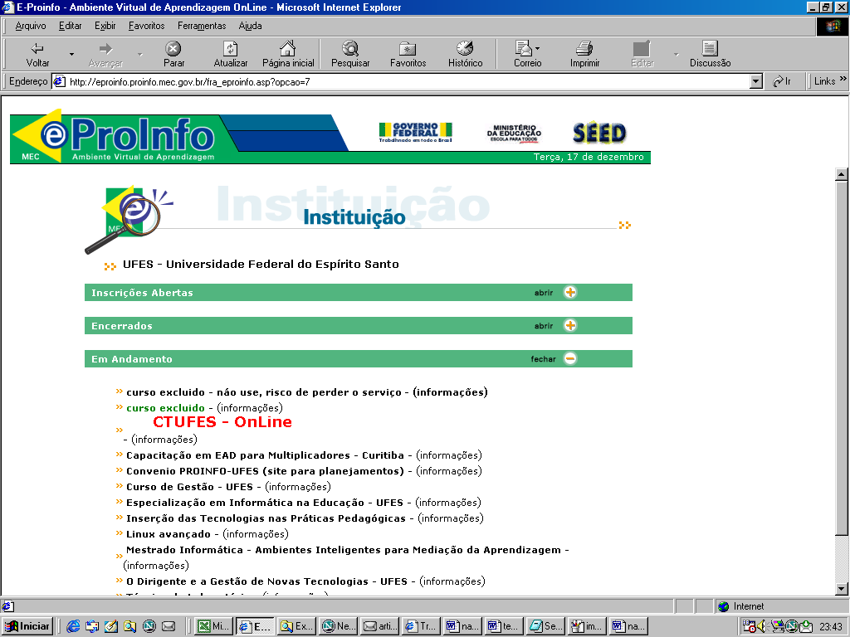
Figure 1: A list of courses offereded by UFES

In the Figure 2 we can observe the list of lesson groups established in the CT-Online environment. The students can access their groups just clicking in the group name.

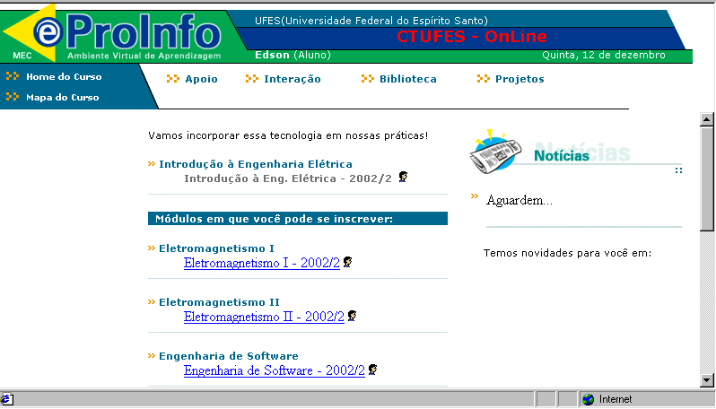
Figure 2 : List of lessons groups at CT-Online

In the figure 3 is showed a forum page for a specific group. The forum is organized by theme and sub-themes. To each topic of interest the teacher starts a new theme.

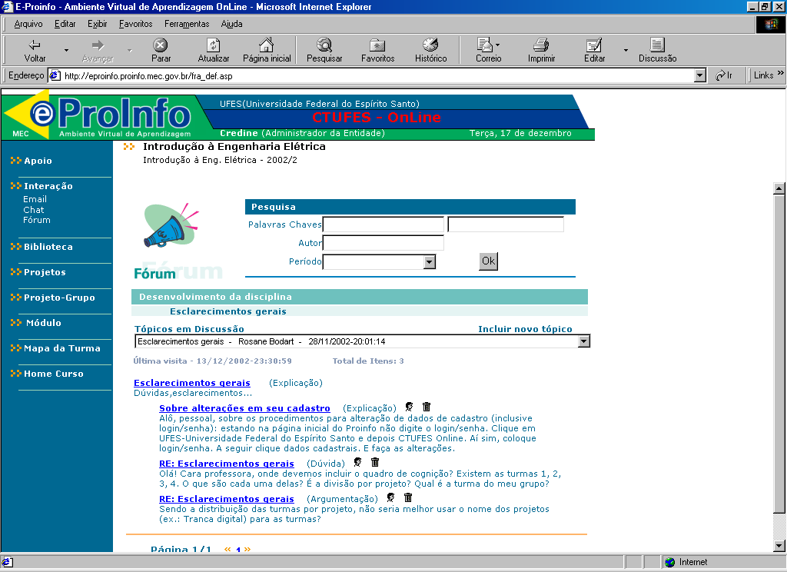
Figure 3: The forum for a specific lesson group

The students can publish their productions using a a file system with an special interface. The teacher can access the student assignment just clicking in their names, at the list of student ilustred in Figure 4.
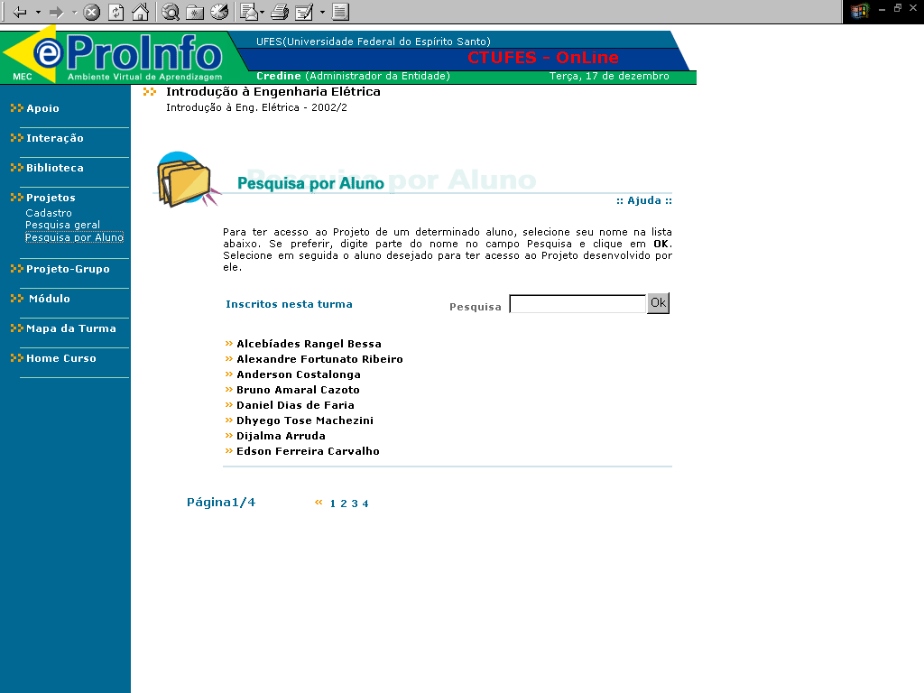
Figure 4: A list of students name for an specific lesson group

Final considerations
The system is in operation since the second semester of 2002 and the strategy that we adopted is to begin with a promotion of the professor’s awareness. The results of the survey of the pedagogic use of telematic practices are being introduced to the teachers through specific meetings, when we also present the CT-online. The insertion of a new discipline in the learning platform is made by the teacher's adhesion, accomplished by a request to the coordination of the project.
During this first semester of system use, we are collecting data to carry out a quantitative and qualitative evaluation of the use of the platform. Platform improvements will be made through this evaluation.
It is desirable also that the activities of the courses in the virtual environment come to involve, besides professors and students, former-students of the discipline, other teachers and the professionals in most the diverse companies which apply the knowledge organized in the discipline. Conviviality in the virtual environment, therefore, will constitute a new learning practice where students of the most varied levels and styles cooperate for improve their knowledge and understanding. This, certainly, will plant the seeds of a culture of permanent and integrated education in the CT-UFES, through virtual learning communities. We already have experiences with teacher qualification courses where students from several places, at different levels of knowledge, cooperate using eproinfo environment. In Figure 5 we presents a page of a work group which develops a learning project.
The use of virtual learning platforms and the knowledge built through them can contribute to improve the opportunities in the on-campus, face-to-face courses. On the other hand, the use of the CT-online can hopefully contribute to the creation of a culture of distance education that will allow to evaluate, plan and adopt this education modality, at the undergraduate and masters level, when there are evidences of the advantages that distance education and the new technologies can proportion.

Bibliographical references
[1] Novak, J. D.; Learning, Creating and Using Knowledge; Lawrence Eribaum Inc.; USA; 1998.

[2] http://www.unicamp.br/prg/reenge/reenge.html, accessed 12/7/2002

[3] http://server.npd.ufes.br/~ctufes/reenge/, accessed 12/7/2002

[4] Edital para formação de Redes de Desenvolvimento de Competências em Tecnologias da Informação e da Comunicação,
http://www.cnpq.br/resultadosjulgamento/resultado_redes.htm, accessed 12/7/2002

[5] Núcleo de Educação Aberta e a Distância da UFES, http://www.neaad.ufes.br, accessed 12/7/2002

[6] Dertouzos, M.; O que será – Como o novo mundo da informação transformará nossas vidas, Companhia das Letras, 1997.
[7] Gava, T. B. S., Menezes, C. S.; Moonline: Um sistema multiagentes baseado na WEB para apoio à aprendizagem In: XI Simpósio Brasileiro de Informática na Educação, 2000, Maceió, Alagoas.

[8] Proceedings of the IEEE; Special Edition on Eletrical and Computer Engineering Education; vol. 88, no. 1, jan 2000.

[9] Lévy, P.; Cibercultura, editora 34, 1999.

[10] eproinfo, Um ambiente virtual para aprendizagem cooperativa, http://eproinfo.proinfo.mec.gov.br accessed 12/7/2002

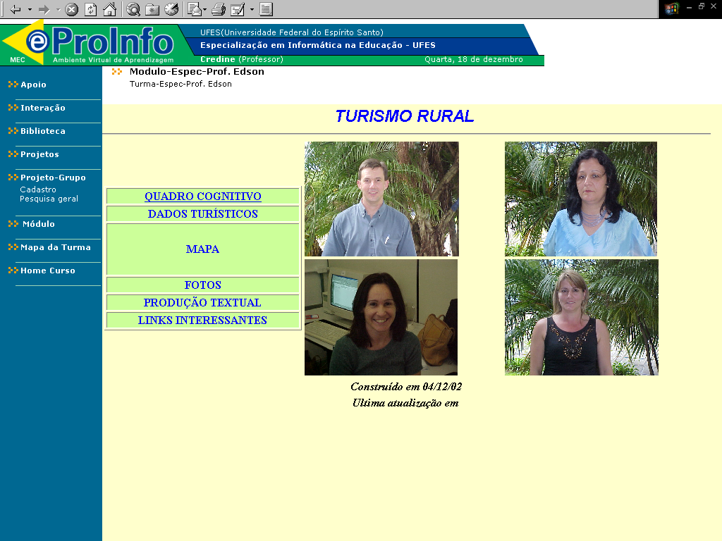
Figure 5: A group of teacher attending a qualification course at UFES

Edson Pereira Cardoso, PPGEE, Universidade Federal do Espírito Santo, Campus de Goiabeiras, Vitória-ES, CEP 29060-900, edson@ele.ufes.br
Crediné Silva de Menezes. PPGEE, Universidade Federal do Espírito Santo, Campus de Goiabeiras, Vitória-ES, CEP 29060-900, credine@inf.ufes.br
Jaime Roy Doxsey. PPGE, Universidade Federal do Espírito Santo, Campus de Goiabeiras, Vitória-ES, CEP 29060-900, jaime@npd.ufes.br

