FAmCorA: A Framework to Construct
Intelligent Learning Environments on the Web
José Marques Pessoa, Hylson Vescovi Netto and Crediné Silva de Menezes

Abstract ⎯ The development of new virtual learning environment demands such an amount of resources which makes it very difficult for innovative proposals to arise. As a consequence there is a huge gap between the theoretical conceptions and the actually implemented work.
The present job presents a framework proposal to develop applications of the CSCL type. Be it by the reuse of the service providers(web services), implemented in the framework, or be it done by the sharing of applications among many systems.

Index Terms ⎯ Virtual Environment to Learn, Cscl, Cscw, Framework, amcora, Application Composition.

Introduction
Telematic environments to support collaborative learning, consist of one of the most prominent innovations due to modern information technology and communication. The computer networks, particularly the internet, have broaden the possibilities to construct cooperative environments, in which researchers, teachers and students relate to each other aiming to exchange and acquire knowledge.

According to Bonk & King, referred in [1] a network can: i)change the way learners and teachers interact; ii) enhance the opportunities to the collaborative learning; iii) facilitate discussions; iv) shift the process of study from an isolated one to a more sociable and dynamic activity.

Even so, in the nowadays state of the art, the development of learning environment of CSCL type on the web, has been proving to be a complex task, either for the theoretical point of view, or to the technical one. And of an extremely high cost to most the institutions/schools intentions, which are interested in the use and exploration of this new technology into the teaching and learning process.

According to [2] from the theoretical point of view “the collaborative learning variables have been extensively studied, however, it is safe to say that we are still on the first step towards the design and development of CSCL-Computer-Supported Collaborative Learning”. Cook [3] has written: “We still don’t have enough detailed knowledge about the relations between theory, empirical work and the implementation of leaning environment”.
In practice, it is possible to observe, in [1,2,4,5], that typical telematic environment of web learning backing, support a standard set of functionality: hypertext, specific areas for file sharing (upload/download), messages distribution (email), synchronous conversation (chat), discussion forums, boards (advice boards), news notification service, presence notification to exchange instant messages (IM) and a Frequently Asked Questions Service (FAQ). No doubt, there are still many other functions belonging to each system.
Despite the clear intercession of the basic set from the tool/ application used in these systems, due to technological issues and to the scope of the problem domain, the construction of a new environment almost always requires the re-implementation of each of those tools. This work proposes a framework to the development of cscw/cscl applications, emphasizing the reuse of ready to run applications, and not of source code (beans, activex, etc). The purpose is to make cscl/cscw portals creation on the web an authoring activity within the grasp of educators and teachers in general, instead of being an exclusive expert-programmer job.

The text is organized like this: Section 2 presents a brief introduction to some technologies of reuse; Section 3 treats the motivation of this work; Section 4 talks about the aims of the cscls environments; Section 5 discusses the aspects which must be solved on a reuse-based architecture; Section 6 proposes an architecture based on the composition of applications, the FamCorA; Section 7 consider the implementation of the proposal and last, but not least, Section 8 presents the conclusions and perspectives.

Web Environment Development
Reuse Technologies
The technologies to develop groupware applications on the web, emphasizing the reuse, have been indicating three directions: Components (modules pre-compiled), class library and service composition (web services).

Component Based Solutions
[6] presents a methodology to develop groupware environment based on pre-fabricated components. Such components are understood as self-contained elements, with well defined objectives and with the capacity to be used both isolated as well as in composition with other components. Likewise [7] presents the COGAM (Component-based Groupware Architectural Model) architecture constructed specifically to the Windows plataform and its COM objects (Common Object Mode l).
Programming Environment Based Solutions
Some frameworks are specific to a certain programming environment, for example, GroupKit [8] offers a developing framework to groupware environment, based on the Tcl programming language. Habanero [9] is a Java language based framework.
Service Based Solutions
A service oriented architecture (SOA)[10] combines the ability to invoke remote objects and functions (called "services") with tools for dynamic service discovery, placing an emphasis on the interoperability. Examples of service-oriented architectures include HP's E-Speak, Sun's Jini and ONE and Microsoft .NET. Recently such technologies have been converged to a W3C standard called Web Services[11].

What those three approaches have in common is the fact that the proposed reuse occurs in relatively low level, in all of them, because class libraries, pre-fabricated components (building blocks), and services are the pieces of software which still require a meaningful implementation struggle to the “gluing” of the various parts which will result into a cscl/cscw application ready do run! And in this sense, far from the [12]’s request: “what we need to reuse is the actual stuff of which our products are made: executable software”.

Revisiting the Web: Hyperlink Application Composition
In this work we advocate a solution which observe the necessary reuse of the available services on the web, but that goes far beyond, when proposing the reuse of entire applications, including their interfaces.
Considering the hypertext paradigm on the web and taking App1, App2 and App3 as typical applications used in virtual learning environments, picture 1 presents a possible composition of those applications, giving birth to a learning support portal.

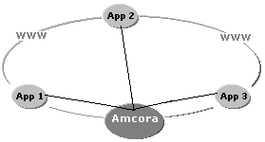
Picture 1. Amcora’s composition.

At the most hyperlink web style, the Amcora application (a acronym for Cooperative Learning Environment) is a unification spot (Thus the name portal) for the access to the App 1, App 2 and App 3 services.

However, in real situations, the nowadays technologies and paradigms used in the development of general web applications, the complexity, and the domain needs of the support environment to the cooperative work (CSCW), specially of those aiming the teaching and learning process (CSCL), make the construction of new environments, with the simple reuse of hypertext model on the web, impossible.
Computer Supported Collaborative Learning
To [13], the computer supported collaborative learning environments were greatly benefited by the internet. Such environments have proven to be very expressive, as much on the cognitive as on the social aspects.

According to [14] the CSCL environment type shall give support to:
- Communication/interaction between participants;
- Information Sharing and
- Tasks / Interactions analysis;
Aiming to help the collective knowledge construction.

Nevertheless, as [15] enphasizes “there are few resources which provide insights (both technical and theoretical) to the development of such an environment”.
Aspects of CSCL
The web allow us to talk about a FOA/applications oriented framework, going beyond the code based, components, and even service paradigm. However, as in the objects oriented modeling, the complexity in relation to the system/domain partition, remains. In general, a partition aims to establish the responsibilities of each piece of the system in a certain domain of the problem. Nevertheless, it is observed that some properties of the system “cross-cutting” many parts of them. In AOP-Aspect Oriented Programming such proprerties are called aspects [16].

To the purposes of this work, a survey of the cscl/cscw aspects to be considered, is presented.

Community Organization Aspects

In the modeling of cooperative/collaborative learning and working support environment, the following aspects must be observed:

Portal: The term “Portal” is used to designate a comprehensible spot of access to the information (categorizing and seeking), applications (desktop integrated) and people (collaboration) in a virtual community on the web.
Authentication: Most of the cscl environments require that the user identifies himself.
Group: [17] mentioning (Johnson & Johnson) says that “the basic component of the collaborative learning is the group learning”.
Role: The capacity of an application to adapt to the role performed by the user in the environment. Which besides being an organizational aspect, opens excellent pedagogical opportunities.

Interoperability Among Applications Aspects

The following interoperability aspects are required in cscl environment:

Notification: Aiming to have the applications and their users updated about facts, preferences, incidents and events which occur in the environment the cscl/cscw systems implement some notification mechanism.
log: [14] argues it is essential that the virtual learning environments store the history (log) of the individual and the group activities, in order to help the analysis and coordination of the job.
Composition: The composition concerns the connection between an application and the framework, and a plug-in-agent and a application. A plug-in-agent, together with the role, open opportunities to the adaptation/specialization of an application to the pedagogical needs.

Picture 2 shows the “orthogonality” among those aspects and the applications in a cscl environment.

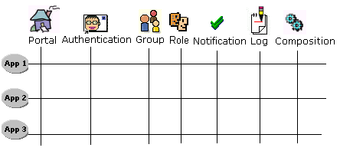
Picture 2. Aspects x Applications in CSCL/CSCW environment

According to [18] there are three basic approaches to addressing the process of separation of concerns : i) On the linguistic approach, relevant concerns are identified at the problem domain and are translated to aspectual constructs and later integrated with the functionality-decomposed program via well-defined interfaces; ii) Within the OO view, two main alternatives for handling aspects are frameworks, where concerns are materialized as aspectual classes either at the framework level or at the user-application level and reflective architectures; iii) the architecture-oriented approach, followed in the present work, proposes an early identification of concerns using architectural organizational models. In this approach concerns are initially mapped to architectural constructs, instead of coding them using framework or language constructs.
FAmCorA Architecture
The FAmCorA treats the aspects issues from the architecture point of view. Picture 3 presents a macro vision of the FAmCorA. The architecture concerns three kinds of users: application developer, portals author and end user. The mediation between the framework and its users is done through the web. The application programmer uses an assistant (Applications Register Wizard) to register applications and plug-in-agents. The portals author uses the information basis (Applications Register, Applications Functionalities Register e Functionalities Plug-ins Register) and an assistant (Portal Builder Wizard) to construct teaching and learning support environment on the web (Portal Application) in such a direct way as in those offered by environments called RAD (Rapid Application Developer). The end-user is the uppermost beneficiary of this construction endeavor.
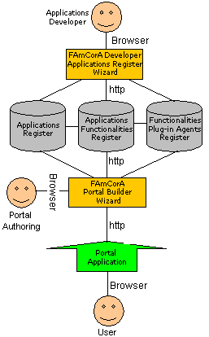
Picture 3. FamCorA Architecture.

In picture 3, the Portal Builder Wizard module is the responsible for the portals catalog (portal aspect). The Portal Application module is responsible for the group catalog (group aspect), users (authentication aspect) e roles (role aspect). The aspects related to the interoperability (notification, log) are solved through communication protocols. A notification is sent through Passport Protocol and the Log of activities through xLidex (Extensible Learning Interactions Data Exchange Protocol). The composition between an application and the framework is given through an application class interface. Yet the composition between an application and a plug-in-agent occurs through the Plug-in-agent Protocol.
A FAmCorA Implementation
An implementation of the ideas discussed here is under development in the GAIA’s laboratory (Computer Learning Application Group) from the Federal University of Espírito Santo, Brazil. The main concern of the project is to make the development of cscl environments an easy task, avoiding the need of expert programmers and turning it into an authoring assignment, giving educators and teachers the opportunity to create virtual environments to support the teaching and learning process.

The authoring of an educational portal in the FAmCorA is attended by a wizard, following the RAD paradigm. A mouse-click generates the basic nucleus of the system, instantly installed and ready to work on the web portal.

As the portals author logs on the environment, picture 4, he already has three groups at his disposal to administer: “Community” which is the portal’s master group, where all the users are filed. The “Individual_Space” which is a template that concerns the personal space of each future user from the portal. When active, this space is assigned by the icon (Ayrton Senna’s helmet – the F1 pilot) and has the same name as the user’s email. In our case it refers to the author’s cockpit, already equipped with two basic tools: xLidexManager, assigned by the icon (mobile-phone), it is a mechanism which communicates with all the FamCorA application, through the xLidex protocol, searching information about the users activities in the environment. GroupManager, assigned by the icon (wheel), it is the basic tool to drive around the portal, with it the author can: 1) create groups and their roles; 2) choose which tools will be available to the group users , according to the role taken by each one of them; 3) Include new users in a group.

To create a new group, using the GroupManager, the author just have to select a “father group”, afterwards he edits the name of the new group, for instance ICECE2003, and the roles of the individuals in this group, in the example “researcher” and “student”.

Still on the GroupManager, the author uses a list to select, among the many tools, made available by the FAmCorA developers community, those which will be in the work area (windows desktop) of the new group, when the user is, for example, a “researcher”. When the author chooses a tool, for instance “ExpressCalculator”, he is offered the opportunity to customize or adapt its use, through a menu which presents the many available functionalities. To each functionality, a plug-in-agent may be selected, or not.

As an example, ExpressCalculator is a conventional application of general purpose, able to evaluate math expressions. However, as any well designed FAmCorA application, its performance might be adapted, depending solely on a plug-in-agent existence. In particular, the functionality “NewExpression” can be configured to generate typical expressions of some knowledge area as Physics, Chemistry, etc.

After the application, the functionality, and the adaptation (plug-in-agents) have been set to each role in the group, there is only the task of registering the users to turn the portal useful, picture 4.

Picture 5, presents the login of the user “credine@inf.ufes.br”, newly registered with the role as a researcher in the group ICECE2003.
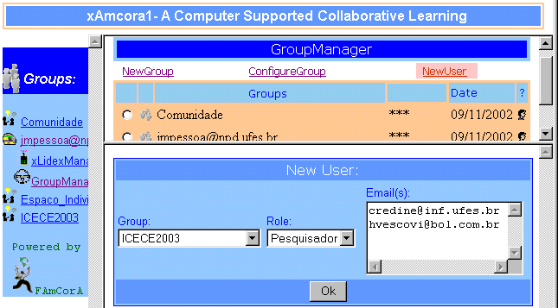
Picture 4. Cockpit and GroupManager

See, in picture 5, how a plug-in-agent choice has changed the specialized calculator ExpressCalculator into Uniformly Varied Movement Formulas (Physics), for the users whose role is to act as researchers in the ICECE2003 group.

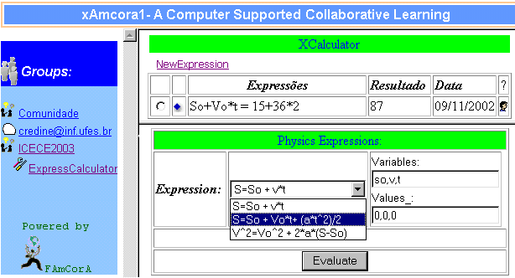
Picture 5. An adaptive Calculator.
Perspectives and Conclusions
The Group Construction Support System, the so called e-groups, are not new on the web. Anyway, as being of general purpose, they lack convenient requisites and applications to the cooperative work activities required in cscw/cscl environments. They still miss intelligent and adaptive mechanisms to keep track, help and notify the interactions/tasks developed by the individuals in the various roles.

The FAmCorA architecture focus the resuse and the interoparationability among applications. In our point of view this has an important meaning: An application or a plug-in developed to a portal can be used in others, just by pointing it to a link. This strategy is crucial for the arising of new approaches to the educational environment, simply because now we can easily construct them, through means of application composition already existing in different domains, under different pedagogical conceptions.
References
- Lehtinen, Erno; Hakkarainen, Kai; Lipponen, Lasse; Rahikainen, Marjaana and Muukkonen, Hanni Computer Supported Collaborative Learning: A Review. www.comlab.hut.fi/opetus/205/etatehtava1.pdf
- Rowley, Kurt. A design approach for the engineering and construction of CSCL-ITS environments. In proceedings of the AI-ED 97 Workshop on Computer-supported collaborative learning environments and AI, Kobe, Japan, August 20, 1997.
- Cook, John. The Role of Dialogue in Computer-Based Learning and Observing Learning: an evolutionary approach to theory Journal of Interactive Media in Education. http://www-jime.open.ac.uk/
- Jermann, Patrick; Soller, Amy; Muehlenbrock, Martin . From Mirroring to Guiding: A Review of State of the Art Technology for Supporting Collaborative Learning in Euro-Cscl-2001 www.mmi.unimaas.nl/euro-cscl/Papers/197.pdf
- Koschmann, T. CSCL: Theory and practice of an emerging paradigm. Mahwah, NJ: Lawrence Erlbaum, 1996.
- Farias C. R. G.; Pires, L. F.; Sinderen, M. A Component-Based Groupware Development Methodology .In Proceedings of the 4th International Enterprise Distributed Object Computing Conference (EDOC), Japan, 2000.
- Rees, Michael J.; Herring,Charles. A Component-Based Groupware Architecture Model (COGAM) http://comet.it.bond.edu.au/borg
- Roseman, M. and Greenberg, Building Groupware with GroupKit. In M. Harrison (Ed.) Tcl/Tk Tools, O'Reilly Press.
- Chabert, A., Grossman, E., Jackson, L., Pietrowicz, S., and Seguin, C., Java Object-Sharing in Habanero. Communications of the ACM, Vol. 41 # 6, June 1998.
- Agrawal R., Bayardo Jr. R., Gruhl D.,Papadimitriou S Vinci: A Service-Oriented Architecture for Rapid Development of Web Applications Computer Networks ,v. 39, Elsevier Science, 2002
- www.w3.org/2002/ws/
- Meyer, Bertrand. Object-Oriented Software Construction, second edition, Prentice Hall, 1997.
- Menezes, Crediné S., Cury, Davidson, Tavares, Orivaldo L., Campos, Gilda H. B., Castro Jr., Alberto N. An Architecture of an Environment for Cooperative Learning (AmCorA). In ICECE-2000
- Stahl, Gerry Contributions to a Theoretical Framework for CSCL in CSCL-2002, http://www.cscl2002.org/proceedings.html
- Mcnaught, Carmel and Amory , Alan. Collaboration, Design, and Technology: Themes in the Architecture of Interactive Learning Environments. Journal of Interactive Learning Research , 2001.
- Elrad, T.; Filman,Robert E. and Bader A.; Aspect-Oriented Programming . Communications of the ACM Vol. 44, No. 10, October, 2001
- Jianhua, Zhao; Kedong,Li; Chong,Ng S. T. and AKAHORI, Kanji. Peer Modeling and Its Application in Web-Based Intelligent Collaborative Learning Systems in ICCE-2001, www.icce2001.org/P04.html
- Pace, J. A. D. and Campo, M. R. Analyzing Role of Aspects in Software Design . Communications of the ACM Vol. 44, No. 10, October, 2001

José Marques Pessoa, ICLMA – UFMT, Rodovia MT 100 km 4, 78600.390, Pontal do Araguaia, MT, Brasi and PPGEE/UFES, Av. Fernando Ferrari, S/N, 29060-900, Goiabeiras, Vitória, ES, Brazil, jmpessoa@npd.ufes.br
Hylson Vescovi Netto, PPGEE/UFES, Av. Fernando Ferrari, S/N, 29060-900, Goiabeiras, Vitória, ES, Brazil, hvescovi@bol.com.br
Crediné Silva de Menezes, PPGEE/ UFES, Av. Fernando Ferrari, S/N, 29060-900, Goiabeiras, Vitória, ES, Brazil, credine@inf.ufes.br

