FACIO: An integrated proposal to virtual learning environment interactions

José Marques Pessoa, Hylson Vescovi Netto and Crediné Silva de Menezes

Abstract ⎯ This work presents a proposal of an interface to virtual learning environments, no matter the general communication tools. It also presents a prototype called FACIO, which gather the most outstanding functionality from the general tools, present on the main CSCL environments. FACIO provides an integrated vision of the synchronous interactions, aiming to stimulate the participation and facilitate the coordination of activities in the virtual learning environments, without taking the possibilities of the asynchronous discussion away.

Index Terms ⎯ integration of Interface, Coordination, Interaction, Learning Virtual Environment.

Introduction
The learning tasks are usually a collective labor. With the introduction of the computer network in the teaching and learning process, the students’ and teachers’ localization ceased to be a limitation and gained completely innovative aspects. Now it is already possible to talk about distance learning without renouncing cooperation, collaboration and collective strength to construct knowledge. However, to make these dreams come true, we have to turn them available, in a synchronous as well as asynchronous way.
The experiences indicate that the students learn better and more enthusiastically when they interact to one another and it is critical for the computer systems which support collaborative learning to have environments that make these interactions easy [8], [11].
Virtual learning support environments have been basically using general purpose communication tools, such as: email, discussion forum, chat, bulletin board and instant messages. While the use of these tools have been reported by its positive aspects [16], [10], an inadequate use might be observed: the lack of integration. It means that to interact with any of these tools, the learner must switch over many different applications, one at a time, with their own usage peculiarities. Such procedure makes it difficult for the people to participate, besides making the interaction flow also more difficult, and as a consequence dispersion occurs and the production of the collective knowledge gets shackled.
This work presents the proposal of an interactive interface independent of the general communication tools. The proposal comes true with FACIO, a communication tool which seeks to reunite some performances from the most popular applications, such as: email, discussion forum, chat, bulletin board, and instant message in one single application. The prototype was constructed to experience and validate the ideas discussed herein.
Therefore, the text is organized like this: Section 2 discusses the role of the communication on the learning process; Section 3 presents the most used communication tools in the virtual learning environments; Section 4 presents an integrated proposal of communication, based on the main conceptual elements; Section 5 presents FACIO, a prototype constructed to materialize, experiment and validate the ideas; Section 6 shows the internal architecture of the system and Section 7 makes the conclusions and indicates the perspectives of the future researches.

Communication, cooperaation and Apprenticeship
According to Piaget, cooperation is an essential element to learning. The constructivism, proposed by him, highlights the learner interaction with objects of knowledge and with other individuals as the key element to construct knowledge. Still according to Piaget, cooperation is indispensable to reach intellectual abilities of higher level. Thus, cooperate is not goodwill, but before it is an essential attitude to take better advantage of our potentials.
In his many works, Pierre Lévy, a sociologist of the CIT (Communication and Information Technology), points out the fundamental role of the internet in order to produce a learning revolution. Lévy emphasizes that human intelligence depends greatly on the technology we use to register the knowledge and from this, make new inferences. To illustrate his point of view, Lévy, remind us of the advances that humanity has obtained on the intellectual field by the time the printing-press was invented. Still according to him, we are ready to a new revolution, able to overcome the previous ones.
The importance of the communication in the learning task has been reported in many works from the CSCL area (Computer Suported Collaborative Learning). Just to illustrate, the following opinions are shown below:
In [4] it is possible to read: “Computers provide the opportunity to learn to communicate, as well as they make it possible for communication to improve the learning experience.”
To [11], the apprenticeship is stimulated by communication and the computers may help in three ways: making human-to-human communication easier, stimulating the production of ideas and helping to organize them.
[5] adds that “the verbalization growth compels the cognitive restructuring”, essential to the individual and collective construction of the knowledge.
[3] indicates that “the encouragement of the discussions between pairs in real as well as in virtual situations reinforce the apprenticeship” quoting accounts from many researches.
Therefore, learning is not just an active task, in the sense of doing it alone, but before it is an interactive, in the sense of doing it together [7]. Yet, [15] points out that the social interaction in virtual environment cannot be taken for granted. After all, it is not guaranteed even in the real world! It is up to the learning support computational environments a much more important role. One which goes beyond the grasp of mere facilitators of social interaction. And, for sure, it is necessary to stimulate those interactions.
Next the most used communication tools in the learning support telematic environment are briefly discussed.

Usual Communication Tools
Collaboration and communication are the main objectives of the virtual learning environments [11]. To make them feasible a variety of tools, synchronous and asynchronous, of general purpose, are being used for such environment. With this it becomes possible to have the communication, the experience exchange, and the interaction among students and knowledge mediators. Such tools might be divided, according to its return time, into synchronous (when the communication return is immediate, also called “alive communication” or online ) and asynchronous (when the communication return can delay for an indefinite time.

Asynchronous Communication Tools
The most used asynchronous communication tools in virtual learning environments are: electronic mail (email), thematic discussion forum, bulletin board (mural) and FAQ.
- Electronic Mail (e-mail)
It is a messages and documents transmission service between individuals. An extension of this concept is the discussion group (mailing list/e-group) in which a group of individuals subscribe in order to receive and send messages to the same group.
- Discussion Forum
In an discussion forum, the messages about a certain topic/issue keeps organized under hierarchical order, showing the chained-answer tree, making it easier to browse.
- FAQ (Frequently Asked Questions)
Frequently asked questions. Site with a list of questions and its respective answers, related to the most common doubts about a certain subject.

Synchronous Communication Tools
The most used asynchronous communication tools in virtual learning environments are: Chat and Instant Messages.
- Chat (Internet Relay Chat)
It is a virtual meeting room where people get together in order to talk in real time (online). It allows a message to be sent to a person or to all the people in the chat room.
- Instant Messages
The instant message services, ICQ for instance, make it possible that online meetings occur occasionally, while the users just have to be online at the time of the conversation. The service will take care of notifying each of the participants about each others’ presence, allowing sudden meetings on real time.

Conclusions of the Section
The use of this variety of applications for communication reveals that none of them satisfies the needs of virtual learning environments alone, thus justifying the use of them all by the important differentiation that each one has and which sums up to the whole process of social interaction aiming the collective construction of the knowledge. It is important to point out that the set of those applications does not configure one single educational environment. They came up at different times, according to the available technology and imitating existing metaphors. Moreover, if they get summed up to a use, in cyberspaces, they tend to bring about knowledge dispersion and cognitive overload.
The cognitive overload goes through the choosing of the tools to be used, the theme to be discussed and the best pair of students to interact to one another.
The knowledge dispersion might be characterized as built-in an specific tool, for example, the message exchange among the various pairs (be it in a chat, or in an instant message) often suffers the lost of context [14], because of the lack of connection in-between the subjects and the visibility, due to privacy with which the conversations are held between pairs. But dispersion can also be explicit when the same subject/theme is treated/discussed simultaneously in different spaces and tools.

An integration proposal for communication in virtual environments
In the virtual learning environments communication is the social interaction way which contributes to knowledge construction. Here knowledge construction is understood as a continuous process which stands on the existence of an environment to encourage people to communicate and take part of it. A communication can be synchronous or asynchronous, taking effect through a means of communication, among a group of people (participants) who are transmitters and/or receivers. It is a public broadcast, when the transmitter addresses to all the receivers. Or a restrict one, when the transmitter restrict to a set of receivers. A communication is based on the context (theme/subject). The subject of a communication might be a text, a sound, a image, or even a combination of those formats. A text message might incorporate an speech act [1], [17].
We propose to gather the outstanding functionalities from some conventional tools, like the theme based discussion, presence notification and exchange of synchronous and asynchronous in a single application. The proposal goes far beyond when it allows an innovative view of the synchronous interactions what, according to accounts from [6] and [2], “multiplies participation and make the coordination of the activities on the virtual learning environment easier”, without taking the chances of asynchronous discussions away.
Picture 1 presents a map of the main conceptual elements identified on the communication process.
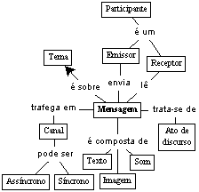
picture 1
conceptual map

On the map, we used the following conceptions: theme, channel, participant and messages, with the following meaning:
Theme: Relates to the subject which is being discussed. A theme might be created by any participant. The theme is discussed by a group of participants, synchronously as well as asynchronously. A theme can be inspected so that it is possible to know what happened there at the last hour, day or week. It is also possible to relate a theme to a set of images or sounds or even to a bulletin board (mural).
Participant: Individual who takes part of the discussions of one (or more) themes. The participant is associated to his profile and also to a picture of his. The center of attention might be focused on a participant, in order to get his last hour, day or week interactions better known.
Channel: means of communication to transmit the message between the sender and the receiver. A channel can be synchronized so that it is possible to know its content at that very moment, or it can be inspected in order to know what might have happened there during the last period of time (i.e. on the last hour, last week, etc.).
Message: The content of a communication unit. It can be a text, a sound, an image, or even the combination of these formats. A text message might incorporate an speech act (information, opinion, suggestion, etc.).
FACIO –The Prototype
FACIO is an application that runs on web browsers, developed with an applet technology (java language).
interface elements with the user
Picture 2 presents FACIO’s interface. The black numbered spots indicate the main interface elements.

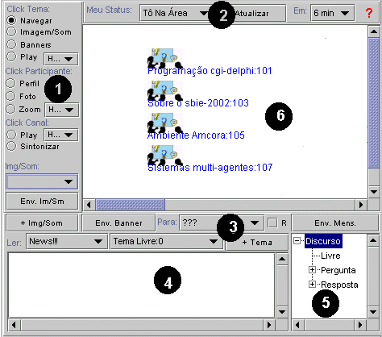

PICTURE 2
FACIO

On panel 1 there is an option menu which sets the mouse-click function over the interaction view panel (Panel 6). On panel 2, the first list offers a user’s status option (I’m free for chat, I’m away, I’m busy, etc.). Each status has a corresponding icon. The “Refresh” bottom updates the screen information and the following list manually configures the interval of refreshments of the view panel (panel 6). Panel 3 presents the reading and exchange messages controls (From, To, Theme, Send, Reserved). Panel 4 is the editing and reading space of the messages. Panel 5 configures the speech connotation elements (Free, Question, Answer, etc. ), clues that may be used by intelligent routines in order to automatically extract the knowledge [17]. Panel 6 allows the access to the content about a theme previously discussed and also to the participants interaction diagram, with a click of the mouse.
Utilization Scenarios
FACIO’s basic utilization scenarios follow the conceptual elements: Theme, Participant, and Channel.
Executing a theme (Theme/Play)
The discussion of a theme might be tracked since the last hour, day, or week. Picture3.
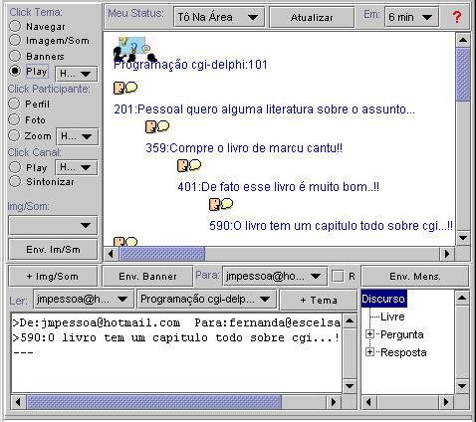
Picture 3
discussed content on a theme
A theme being discussed by a Group (browse)
Configuring the mouse-click to Theme/Browse and by clicking on a certain theme it is possible to see the group of participants who are performing the discussion. Picture 6.
Each icon represents an individual participating on the discussion theme and the lines between the icons indicate the conversation channels. An user may configure his icon to denote his status on that very moment, like: “I’m free to chat.”, “I’m out.”, “I’m busy.” Etc. So that the other participants can understand his disposition to participate on any synchronous discussion [9].
Tuning in to a Channel (Channel/Tuning)
A discussion channel between two participants can be tuned in, so that it becomes possible to attend or even participate to the conversation. A reserved message keeps its content secret, but the interaction is always public. Picture 4.
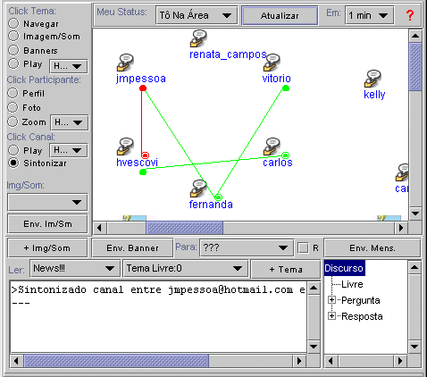
picture 4
Tuning a communication channel
Still, a channel may be run (Channel/Play) in order to know the content of a conversation which happened there on a certain time intervale (last hour, day, or week.).
Broadening the interactions with a participant (Participant/Zoom)
The participant grasp can be broadened over many subjects and themes. Picture 5 presents a Zoom on the participants interaction.
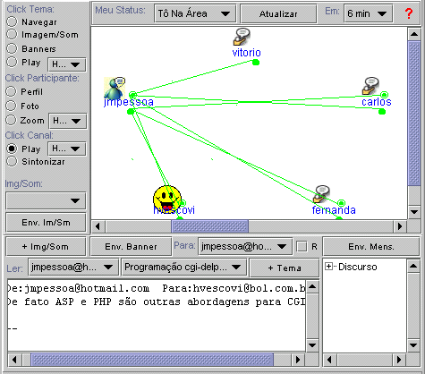
picture 5
The interactions diagrams of a participant

Under any circumstance in which a conversation is going on line (happening), the other participants may tune in to it, in order to attend and/or take part of the discussion.
Sending and receiving messages
FACIO automatically notifies the user about new income messages and to each opened message, it synchronizes the theme and the addresses to the answers. A message might be sent with “reserved” or “public” status and still it may incorporate a speech act.
FACIO’s internal architecture
FACIO is a www application based on the browser-host web paradigm. The client is a java applet who communicates, over the internet with a CGI application, data server. Picture 6 illustrates this architecture.
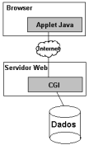
picture 6
FACIO’s internal architecture
Future Perspectives and Conclusions
This work has presented an integrated communication proposal, made come true by communication tools which aims to put some functionalities of the most popular applications, such as: email, discussion forum, chat, bulletin board, instant message together in one single application. FACIO tries to put the outstanding devices from those tools together, but it goes beyond when it allows an innovating view of the synchronous interactions, aiming to stimulate the participation and making the task coordination on virtual learning environments easier, although without taking the possibilities of asynchronous discussion away.
At the moment our researches are focusing the FACIO’s integration with the AmCorA environment [12]. That means we intend to make FACIO a single interface to the various communication spaces used nowadays. This includes the integration of conventional services such as: forum, chat, instant messages, bulletin board (mural) and FAQ, together with the intelligent addressing service Qsabe [13]. Thence we expect to correct some dispersion aspects of the knowledge and stimulate the interactions.

References
- Austin, J.L. How to Do Things With Words. Harvard University Press, 1961.
- BENTLEY R., APPELT W. , BUSBACH U.; HINRICHS E.;KERR D.; SIKKEL K.; TREVOR J, and WOETZEL, G. Basic support for cooperative work on the World Wide Web. Int. J. Human Computer Studies (1997) .
- Clark, Jim. Stimulating collaboration and discussion in online learning environments. The Internet and Higher Education, Vol 4, Issue 2 , 2001.
- George, Sébastien Leroux,Pascal. Project-Based Learning as a Basis for a CSCL nvironment: An Example in Educational Robotics. http://www-ic2.univ-lemans.fr/~george
- Graves,David; Klawe, Maria Supporting Learners in a Remote CSCL Environment: The Importance of Task and Communication. In anais Computer Support for Collaborative Learning '97 http://www.oise.utoronto.ca/cscl/papers/graves.pdf
- Guzdial, Mark. Information Ecology of Collaborations in Educational Settings: Influence of Tool http://guzdial.cc.gatech.edu/papers/infoecol
- Hiltz, Starr Roxanne. Collaborative Learning in Asynchronous Learning Networks: Building Learning Communities in anais "WEB98" Orlando Florida, November 1998.
- Jeong, Heisawn; Chi, Michelene T. H. Construction of Shared Knowledge During Collaborative Learning. Proceedings of Computer-Supported Collaborative Learning'97. http://www.oise.utoronto.ca/cscl/papers/jeong.pdf
- Kreijns, Karel; Kirschner, Paul A.; Jochems, Wim The Sociability of Computer-Supported Collaborative Learning Environments . Educational Technology & Society 5 (1) 2002.
- Laurillard, D.. Computers and the emancipation of students: giving control to the learner. In P. Ramsden (Ed.), Improving learning: new perspectives. London: Kogan Page, 1988.
- Lehtinen, Erno; Hakkarainen, Kai; Lipponen, Lasse; Rahikainen, Marjaana and Muukkonen, Hanni Computer Supported Collaborative Learning: A Review. www.comlab.hut.fi/opetus/205/etatehtava1.pdf
- Crediné S. Menezes, Davidson Cury, Orivaldo L. Tavares, Gilda H. B. Campos, Alberto N. Castro Jr. An Architecture of an Environment for Cooperative Learning (AmCorA). ICECE – International Conference on Engineering and Computer Education, São Paulo, Brasil 2000.
- José M. Pessoa and Crediné S. de Menezes. QSabe II: A Cooperative Service for Knowledge Appropriation and Diffusion Using the Internet. ICECE – International Conference on Engineering and Computer Education, São Paulo, Brasil 2000.
- Pimentel, M. G., Sampaio, F. F.; Análise da Conversação nas sessões de bate-papo; In: Simpósio Brasileiro De Informática Na Educação (Sbie); Vitória; Brasil, 2001.
- Rourke, L. (2000). Operationalizing Social Interaction in Computer Conferencing. In Proceedings of the 16th Annual conference of the Canadian Association for Distance Education. Quebec City, 2000.
- Smith C. D.;Whiteley, H. E.; Smith S. Using email for teaching. Computers & Education, Vol 33, August/1999
- SOLLER AMY L. Toward an Intelligent CSCL Communication Interface in Proceedings of Workshop IV, 8th World Conference on Artificial Intelligence in Education (AI-ED 97), Kobe, Japan. 1997.

José Marques Pessoa, ICLMA – UFMT, Rodovia MT 100 km 4, 78600.390, Pontal do Araguaia, MT, Brazil; PPGEE/UFES, Av. Fernando Ferrari, S/N, 29060-900, Goiabeiras, Vitória, ES, Brazil, jmpessoa@hotmail.com
Hylson Vescovi Netto, PPGEE/UFES, Av. Fernando Ferrari, S/N, 29060-900, Goiabeiras, Vitória, ES, Brazil, hvescovi@bol.com.br
Crediné Silva de Menezes, PPGEE/UFES, Av. Fernando Ferrari, S/N, 29060-900, Goiabeiras, Vitória, ES, Brazil, credine@inf.ufes.br

