Applying Concept Maps in Education as a
Metacognitive Tool

Tânia Barbosa Salles Gava and Crediné Silva de Menezes

Abstract ⎯ This paper discusses the use of concept maps as a metacognitive tool in the educational context. It makes use of a reflection on ideas manifestation and its representation as maps. Besides it suggests three applications: 1) concept map as a tool for indexing contents of a virtual learning environment 2) as a support to bibliographic review, and 3) as a support to the development of learning project. Moreover, we point out some other possible applications where concept maps would bring good contributions by reducing the cognitive overload and amplifying our cognitive abilities.
Index Terms ⎯ concept maps, knowledge organizers, computer in education.

Introduction

The teaching-learning process is carried out through several phases such as the student contact with the existing knowledge about his object of study (usually called content), the study and the analysis of that content, and the externalization of the student knowledge on a given subject. The student knowledge externalization is a process of changing his tacit knowledge into explicit knowledge. Because tacit knowledge is very difficult to be formalized, its transmission and sharing is also problematic. For example, conclusions, insights, and hints. On the other hand, the explicit knowledge refers to that knowledge easily transmissible in some formal or systematic language (NONAKA & TAKEUCHI, 1997).
The knowledge externalization may be done by different means as, for instance, the making of a synthesis where the student expresses his knowledge, reflections, and conclusions about the subject in question. There are many languages to represent knowledge but usually knowledge is represented in the form of a text. Concept map is another possible form to represent knowledge. We consider that in certain situations like, for instance, during the making of a synthesis, the use of concept maps has some advantages if compared with the classic text. The making of a text usually demands high cognitive overheads because it requires, besides the knowledge itself, sequential organization, adoption of a style, grammatical rules observance, care about form (font type, color, and size) etc. Moreover, its fragmented nature makes tacit knowledge very resistant to sequential organization.
This article presents our research path on the use of concept maps as a tool to support the knowledge verbalization. We are particularly interested in its pedagogic use.

What is a Concept Map?

Concept maps, as developed by Joseph Novak, are a tool to organize and to represent knowledge (NOVAK, 1977). They are used as a language to describe and to communicate concepts and their relationships. They were originally developed to give support to the Meaningful Learning Theory (AUSUBEL, 1968). Concept maps can, for example, be used to explain and to describe ideas people have about a given subject. They are graphic representations of concepts, similar to diagrams, in a specific domain of knowledge and constructed in a way that makes concepts and their relations very evident. In other words, they represent concepts and their links in a graph manner so that the points are concepts and the edges are relationships. These relationships are nominative, i.e., each relationship between two concepts forms a proposition. For example, in the sentence whales are mammals, “whales” and “mammals” are concepts that are connected by the relation “are”. The simplest concept map would be constituted of two points connected by a link representing a proposition, i.e., “Bees visit Flowers”. The Figure 2.1 shows the simplest form of a concept map, just as it defines what nodes are, what links are and the relationships between two concepts.
Concept representado pelo nó
Relationship between two concepts
Flowers
Bees
visit
Link connecting two nodes
Node
FigurE 2.1
The simplest Form of Concept map

Note that in this case the preposition is a simple sentence. But it is not always like that. Sentences and prepositions are different things. It may happen a case of a sentence embodying many propositions. For example: “whales live, like fishes, in the water, but they are mammals. From this unique sentence we can take the following propositions: 1. Whales are mammals. 2. Whales live in the water. 3. Fishes live in the water. 4. Animals 4) Animals can be mammals. 5. Animals can be fishes. Although the examples above show us very simple kinds of maps, they can be very large and may have a structure very personal to who is building it. Figure 2.2 presents one of a series of maps of the NASA’s MARS 2000 project, developed by the Institute for Human and Machine Cognition – IHMC (http://www.coginst.uwf.edu).

Editing Maps

Like in a hypermedia document, to each node (concept) we can associate different medias related to the concept, as long as we use suitable tools to map making. Two of these sort of tools are CMap Tool (http://www.coginst.uwf.edu), a map editor developed at the Institute for Human and Machine Cognition that allows to associate a node of a given map to other maps, to text, audio and video files, images and web pages. The Software Inspiration (http://www.inspiration.com) is another map editor with facilities to draw concepts, mapping thoughts, make diagrams, program studies and other activities, all that using a multimedia visual language that fosters creativity, lateral thinking, and user’s productivity. It was designed for the work with children. Figure 2.3 shows a map built with the CMap Tool.

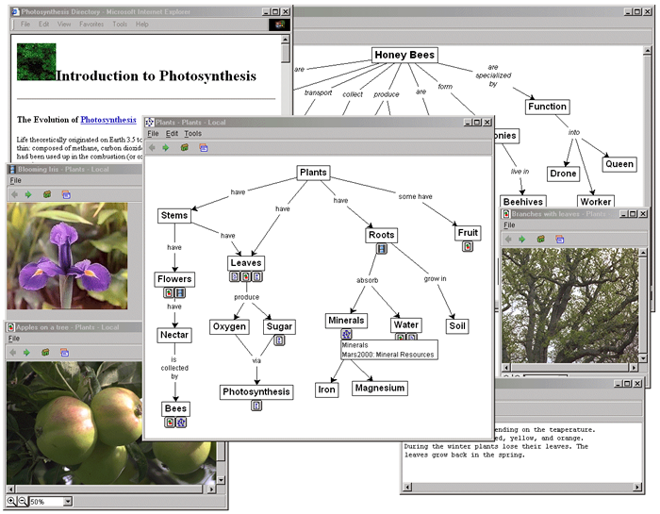
FigurE 2.2
Concept Map built using The CMap Tool software

Another important feature that must be observed when building concept maps is the inclusion of cross-links. They are relations between concepts of different sub-domains of knowledge of the map. Cross-links help us to see how some sub-domains represented in the map relate to one another. The following Figure shows an example.

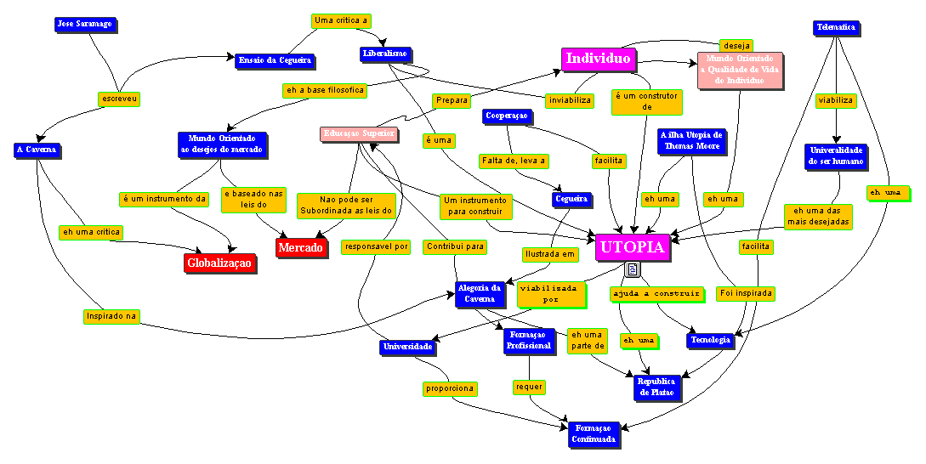
FigurE 3.7
Concept Map with Cross-links
A Cross-link

Expressing Ideas

When we are in a learning process, in several situations and in different moments, we need express our ideas (knowledge externalization). This task could be done in an oral way but usually it is necessary and important to record it. Recording can be done by different means such a text, a graph, an image, or a concept map. The expression of ideas may be to make a synthesis of a text, paper or article, to record any process such as a learning or research project, to produce texts that express our understanding of a given subject, or even to produce a speech. Regardless of the means to be used all demand a specific cognitive effort. But what is most remarkable is the fact that in all these situations there are important points, which we must highlight. In other words, we want to express the important concepts that were identified and the relations among them.
In such context we visualize the use of the maps to represent knowledge. As knowledge organizers, maps are represented by the concepts and their relationships identified in a subject. We understand that the construction of a map demands less cognitive effort than the construction a linear text does. This happens because when we construct a map we first identify the concepts we consider more important, no matter the order they were studied or they appear in the text. And this is a more natural process than to think of a text that demands a formalism and forces the ideas to be expressed in a sequential manner. After this reflection about the concepts it is enough to materialize the connections we see on these concepts. After that, we must observe the map constantly observing and make the required changes to reflect the constant changes that occur in our cognitive structure as we learn.

The Use of Concept Maps in Education

This section will present some applications of the concept maps in education as follows: the use of concept maps as content indexers, as a tool to support bibliographic review, and as a metacognitive tool in learning projects.

Using Concept Maps as Indexers of Content

By using software for edition of maps, it is possible to associate several resources to the nodes of a map. One of these resources is to associate a collection of documents (text, pages web etc.) to the maps, where each node, which represents a concept, can be associated to one or more documents of this collection. However, this association is free and it is under the responsibility of the user of these tools. Our proposal aims at improving this resource by associating the nodes of a map to a content indexation system, where we can associate a node to a search engine instead of associating it only to specific documents. This searching will be based on concepts and will find all documents of an available collection that are associated to the concept represented by the node. In this way, the concept map can be used as a great indexer of content. In this context, we used the CMap Tool to develop a small application to illustrate the content indexation regarding to just any theme. The chosen theme was “Computer in Education”. This site makes several concept maps available. They were done based on the “Salto para o Futuro” Collection, that is a Virtual Library which possesses papers on Computer in Education. This Virtual Library is part of the PROINFO Project (http://www.proinfo.mec.gov.br). Each map of this collection presents the most important concepts approached in the papers and their respective relationships. Besides, each map possesses a link to the paper (in the HTML form) on which it was based and to other resources such as texts, papers, web pages and homepages. This site possesses an initial map on “Computer in Education”, presenting the most important concepts of this theme (Figure 4). Starting from this initial map the user can browse other maps that were developed to this application.

Using Concept Maps as a supporting Tool for Bibliographical Review
The bibliographical review supposes some steps, such as: the reading, the analysis and the adequate registration of the most important annotations related to the revised documents. The concept maps, as knowledge organizers, can be used to represent knowledge of people on a certain subject. Based on this possibility and on the existence of tools for construction of maps we can use concept maps as a supporting tool to both teachers and students, this is, they can to represent the important concepts on a certain article, paper or text. In this way, the students can record their most important annotations in the form of maps. On the other hand, the teachers will have in hands another resource to verify the learning of students on the approached subjects. Besides that they can compare the several maps, built by the students, in order to identify the formation of the concepts, misconceptions, their your ideas and identified relationships among the concepts, following up the evolution of the students’ knowledge. Using maps like that is still a good instrument to facilitate the discussion centered in the reading of texts. After reading a text, where the student progressively builds a map of his/her knowledge, the students can meet with one another to discuss about the subject, starting from the comparison of the maps and identifying concepts and connections that were noticed or not. They can still discuss about the noticed connections in a different way and, even, in conflicting situations. A brief reflection allows us to notice the advantages of this proposal on discussions based on isolated annotations.
Using concept maps as a support tool for the development of Learning Projects

The main idea of the use of maps in the evaluation of learning processes is to evaluate the student in relation to what he/she already knows, starting from the concept constructions that he/she can create, that is, the way that he/she structures, hierarchy, differentiates, relates, discriminates and integrates the concepts of a miniworld in observation, for instance. Once the maps are explicit representations of the cognitive structure, we can have a very approximate picture of the student’s previous knowledge, which is a starting point for the meaningful learning. In the same way, by observing several pictures of different moments of the process (his/her several maps), we can accompany the cognitive growth of the student, so improving the feedback offered to him/her.
A Learning Project can be seen as a process that goes through some steps [SOUZA & MENEZES, 2000], such as: the choice of a theme, the identification of subjects that will be explored inside this theme, an inventory of knowledge of the student built in the beginning of the project (doubts and statements), the choice of the methodology and of work plan (consisting of work items) which will be followed in order to accomplish the proposed goals. Besides, at the end of each work item it is fundamental to do evaluations of the evolution of the student's knowledge. Along the process, the student looks for to clear his/her doubts and to validate his/her statements. During the exploration of the proposed project, it is very important properly to record the way the learning process occurred throughout the construction of the project, instead of just to publish the reached final results. It is suggested the use of concept maps to express the inventory of the knowledge of a workgroup member or of whole workgroup at different moments of the project. We suggest the construction of a map to express knowledge in such stages: in the beginning of a project, at the end of each work item (that demands the construction of a synthesis on its accomplishment) and at the end of all the work items, i.e., at the end of the project. In this way, through the analysis of these maps, we can clearly know all transformations happened in individual and workgroup knowledge, such as cleared doubts, validated statements, statements that became doubts, doubts that become statements, appearance of new doubts and statements etc. The use of appropriate conventions can facilitate the identification of the student’s historic, synthesizing the evolution of his/her mental models through the collection of his/her maps. We propose a way to the student express his/her knowledge on the project theme, at different moments of the learning process, though concept maps. This knowledge consists of his/her statements and doubts and of his/her conclusions.
In concept maps, the relationships between two concepts express propositions. In the same way, the speech on any context can be completely expressed through propositions. In general, relationships have been used in Concept Maps to just register affirmative propositions. However, we can also use them to represent doubts. We identified some situations. They are: 1) We know that two concepts are related somehow, but we cannot identify which relationship that is. 2) One of the concepts of a relationship is not known. 3) We know the concepts but we are not sure of the relationship among them. 4) We identified the relationship between two concepts, but we do not have the scientific proof.
We visualized two possibilities to register the process of development of a project:
1) We can start with a map of doubts and statements, built in the beginning of the process. A map can also represent the synthesis of each investigation item. This second map should be accessible thought a link starting from the original questioning. The evaluation of the evolution of the knowledge can be accomplished through the browsing this group of maps.
2) Another alternative is the construction of several different maps, built in the beginning of the project, at the end of each investigation item and at the end of the project. In this case, each map is the evolution of the previous one, where the gaps are filled out. The evaluation of these maps will reflect the evolution of the student's knowledge, where one can observe the explanation of doubts, the validation of statements and the appearance of new doubts and statements.

Other Applications of Concept Maps

The nature of concept maps clearly turns them into a tool for multiple activities. After all, it has been long since human beings first sought for the use of non-linear languages to express their ideas with more flexibility and expressiveness. It is not by chance, therefore, that we can use these concept maps in all and any activity where we needed to organize our ideas. As examples, we can mention the preparation of a lecture, speech, article or paper. The technique suggested herein is to begin gathering the principal elements that we want to identify and gradually to construct important connections for the approached context, thus generating a map. In this way, it is easier to produce a text. In relation to a speech, we can construct a map to be a base for this speech. For instance, the map illustrated in the Figure 2.4 was prepared for a graduation speech to computer engineering students.
Another important activity, in the technological point of view, is the specification of product requirements, which is an intensive one in knowledge construction. Starting from interviews and from gathering data the specialist should produce a rigorous specification of the product. In general, the natural language brings countless problems. So, concept maps can be used with plenty advantage by several professionals such as architects, lawyers, software engineers, knowledge engineer, among others.

Final Considerations

This paper has presented the concept maps as a metacognitive tool that can be very useful in the education, especially for indexation of content, as support to bibliographical review and as support to the development of learning projects. We have been trying out all these activities in our graduate and post graduation courses.
As future perspectives, we have been developing a tool that will be part of the framework presented for knowledge organization and integration, that it will use concept maps as indexers of content for a collection of documents used by a learning community interacting inside a Virtual Learning Environment. Besides that, in July, 2002 we concluded a site that make concept maps available. These maps were built for the “Salto para o futuro” Collection, that is a Virtual Library of the Proinfo Project (http://www.proinfo.mec.gov.br). It is a collection of articles on Computer in Education.
This year we also have tried out the use of concept maps as a pedagogical tool in distance specialization courses, based on the pedagogy of learning projects. The maps are used for the construction of knowledge inventories, which consist of the doubts and statements of a student on his/her themes of project.
We have also intended to use them intensively as a tool for organization of ideas that precede the text production in elementary and high school.

Final Considerations

The purpose of this work is to present a Framework as a logical model for the organization and integration of the knowledge in virtual learning environments. The goal is to propose an ontology of knowledge in such environments. It is also our goal to propose solutions to the problems presented in the section 2, using metacognitive tools such as concept maps. To illustrate this Framework, a prototype will be developed approaching two aspects. The first one will be a tool for instanciation of courses in virtual learning environments, based on the ontology that will be developed. The second one will be a virtual environment that integrates the knowledge content of a virtual learning community.

References

[1] AUSUBEL, David P. Educational Psychology, A Cognitive View. New York: Holt, Rinehart and Winston, Inc, 1968.
[2] CAÑAS, A. J. Algunas Ideas sobre la Educación y las Herramientas Computacionales Necesarias para Apoyar su Implementación. Revista RED: Educación y Formación Profesional a Distancia, Espanha, 1999.
[3] CAÑAS A. J.; FORD, K. M., BRENAN J., Reichherzer T., HAYES P. Knowledge Construction and Sharing in Quorum. In: World Conference on Artificial Intelligence in Education,1995, Washington DC.
[4] CAÑAS, A. J.; K. M. FORD; P. H. HAYES; T. Reichherzer; N. Suri; J. Coffey, R. Carff, G. Hill, Invited Plenary Talk. Colaboración en la Construccion de Conocimiento Mediante Mapas Conceptuales. In: Congreso Internacional sobre Tecnología y Educación a Distancia, 8., 1997, San José, Costa Rica. Anais ... San Jose, 1997. p. XXV- XLII.
[5] CAÑAS, A. J., D. B. Leake, D. C. Wilson. Managing, Mapping and Manipulating Conceptual Knowledge. AAAI Workshop Technical Report WS-99-10: Exploring the Synergies of Knowledge Management & Case-Based Reasoning, AAAI Press, Menlo Calif, (July 1999).
[6] CAÑAS, A. J., K. M. Ford, J. Coffey, T. Reichherzer, N. Suri, R. Carff, D. Shamma, G. Hill, M. Hollinger, T. Mitrovich. Herramientas para Construir y Compartir Modelos de Conocimiento. WISE "99 Workshop Internacional sobre Educação Virtual, Fortaleza, Brasil (November 1999), pp. 383-392
[7] GAVA, Tânia Barbosa Salles; MENEZES, Crediné Silva de. Ambientes Cooperativos para Aprendizagem orientada a Projeto. In: SIMPÓSIO BRASILEIRO DE INFORMÁTICA NA EDUCAÇÃO. 10., 1999, Curitiba.
[8] _____________. Tânia Barbosa Salles; MENEZES, Crediné Silva de. Moonline: Um sistema Multiagentes baseado na Web para apoio à aprendizagem. In: SIMPÓSIO BRASILEIRO DE INFORMÁTICA NA EDUCAÇÃO. 11., 2000, Maceió.
[9] _____________. Tânia Barbosa Salles; MENEZES, Crediné Silva de. Moonline: Um Ambiente de Aprendizagem Cooperativa baseado na Web para Apoio às Atividade Extraclasse. In: SIMPÓSIO BRASILEIRO DE INFORMÁTICA NA EDUCAÇÃO. 12., 2001, Vitória.
[10] _____________. Tânia Barbosa Salles; MENEZES, Crediné Silva de. An Inquiry Oriented Environment for Learning Support. In: INTERNATIONAL CONFERENCE ON ENGINEERING AND COMPUTER EDUCATION - ICECE. 2000, São Paulo.
[11] NONAKA , Ikujiro e TAKEUCHI, Hirotaka. Criação de Conhecimento na Empresa. Ed. Campus, 1997.
[12] NOVAK, Joseph Donald. A Theory of education. Ithaca, N.Y., Cornell. University Press, 1977.
[13] _____________. GOWIN, D. Bob. Learning how to learn. Cambridge University Press, 1984.
[14] _____________. Learning, creating, and using knowledge: concept maps as facilitative tools in schools and corporations . Mahwah, N.J.: Lawrence Erlbaun and Associates, 1998.
[15] SOUZA, Renata Silva; MENEZES, Crediné Silva de; SOUZA, Dalva Silva. Inserção da Informática na Educação: uma proposta baseada no processo de aprendizagem. In: SIMPÓSIO BRASILEIRO DE INFORMÁTICA NA EDUCAÇÃO. 11., 2000, Maceió.

Tânia Barbosa Salles Gava, Universidade Federal do Espírito Santo, Programa de Pós-Gaduação em Engenharia Elétrica, t_salles@zaz.com.br
Crediné Silva de Menezes, Universidade Federal do Espírito Santo, Programa de Pós-Graduação em Engenharia Elétrica, credine@inf.ufes.br

