Set-in an interactive multimedia database of the French EEA association

Olivier BONNAUD¹, Yves DANTO²,Christian GLAIZE³, Jean-Paul LOUIS⁴

Abstract

In addition of the several virtual campus that are created in the world, the French EEA association composed of about one thousand members started the creation of a on-line data-base in the field of electrical and information engineering with the both goal to give an additional support for the students and to impulse the creation of new innovative pedagogical tools.
1. Introduction

In 2001, the French association of teachers and researchers in the field of electrical and information engineering, called “Club EEA” [1] gathered more than 1000 members and was structured as shown Figure 1. In addition of the executive board that includes the President, the General Secretary and the Treasurer, two main levels in the operational organization can be found. Thematic level that is constituted of four chapters gathering main domains (electronics / microelectronics / optoelectronics, signal processing, power electronics / power electrical engines, control automation.
Figure 1: “Club EEA“ Association structure. Two main levels in the operational organization: the scientific field chapters and the transversal commissions. The full board is constituted of the resident and secretary of chapters, presidents of commissions, and of the executive board.

1President of “Club EEA“ Association, University of Rennes 1, Pôle CNFM de Rennes, CCMO, Campus de Beaulieu, 35042 Rennes Cedex, France University
2President of the Education Commission of “Club EEA“ Association, University Bordeaux 1, Electrical Engineering Department, 351, cours de la Libération, 33405 Talence Cedex, France,
³ Responsible of Pilot Group of e-EEA Médiathèque, Laboratoire d'Électrotechnique de Montpellier - Université Montpellier II, CC079, Place Eugène Bataillon, 34095 Montpellier Cedex, France
⁷

The transversal level is composed of three commissions: academic's or education’s, research’s, and international’s ones.
From Education Commission, a specific group, called “Pilot Group” (PG) was created in order to set-in a database and new tools with the final goal to create a virtual campus. This was the result of an analysis of the evolution as well of the French Institutions in which some members are positioned, as International well-known institutions such as MIT, Stanford, etc. [2]. To improve the traditional presentations already available via Internet, we have decided at the level of the Education Commission to create a tool making easier the creation of new courses. This is the specificity of what we have called: “Médiathèque e-EEA™ ” [3].

2. Reasons of such an approach

The fast increase of the new knowledge flow, the wide spectrum of knowledge, the evolution of the culture and the behavior of students lead to a permanent adaptation of our teaching approach.
It is clear that the video-image, Internet, and zapping, are new parameters to take into account to be attractive to students that are less and less excited by scientific studies.
In addition, more and more potential students can be interested to improve their knowledge without any live-lesson, but with some tools that give more than a book or a monograph, especially in the technology fields as in electronics, control automation, signal processing, electrical engineering, microelectronics, optoelectronics that constitute the main domains for which we are concerned. These domains are particularly adapted to dynamic presentations, schematic, and simulation approach [4]. Moreover, the pedagogical approach can be really different allowing as well classical French bottom-up approach as top-down one, as shown in Figure 2.
Indeed, the development of computer assisted education tools offers the possibilities to modify the classical teaching approach and maybe to make easier the harmonization in Europe of education in electrical and information engineering [5-6]. It is possible to begin the course on a system or application, and thanks to the permanent access to the links, to go back to basic and fundamental knowledge. In this situation the student understands or discovers the necessity to improve his fundamental knowledge and the course can be much more attractive; in fact it is generally appreciated by students. Figure 2 shows a sketch of the both approaches: bottom-up that corresponds to the usual education and top-down that is available in the new multimedia tools.

Fig. 2: Bottom-up and top-down approaches that are easier to set on with interactive tools (After Bonnaud et al [2]).

In such a context, we can admit that, alone, a teacher cannot easily modify and permanently improve his lessons, creates new interactive tools, new dynamic training, etc. The Club EEA is an organization establishing permanent links between its members and allows a common gathering of skills and resources that is today the need to highlight and valorize the individual approach. These documents are compiled in the Médiathèque e-EEA™” on-line available and reachable by everybody. To access to the associated site, the present address is: http://www.e-eea.org.
This behavior is a goal for our community, who considers that its contribution to the information world from its own skill and know-how in the knowledge world constitutes a main part of its mission. The diffusion of a part of its knowledge is the basement of university behavior in order to encourage contacts between people; this leads to an enhancement of the general knowledge and an increase of the knowledge need. At international level, an on-line Mediatheque e-EEA™ should encourage the cooperation between countries and should give access to new knowledge to undeveloped countries.

3. Principle

The Médiathèque e-EEA™ is an open on-line site giving access to teachers and students a set of scientific documents that gathers the pedagogical production of involved teachers. It is an exchange and diffusion tool with free access.
Copyright: The intellectual properties are the properties of the authors that keep the full rights. The Club EEA association diffuses the documents, and by this way, brings its notoriety.
The users are first the teachers that can judiciously use the on-line documents to built their own lessons but after signing a Charter”. The students are the second type of users and can use this tool for learning and training as well in basic education as in life-long learning.
The documents are not, for a majority of them, in a first time, a self-consistent interactive course independently useable that needs a huge work (authors, software’s, designers, etc..) that only one institution cannot produce easily. However, the Club EEA members constitute a huge potential of technical knowledge. Thus, the initial goal consists to produce scientific documents often resulting from traditional edited documents but with a few part, at least, of new information technologies in order to improve the information quality by the way of photographical illustrations, animations, interactive documents, integrated simulations, hypertext links, etc. Note that, some colleagues have already produced some interactive courses that can be immediately included in the Médiathèque e-EEA™, via links. That is the case of an interactive course on integrated microelectronic technology [4,7-8].
Following the advice of the PG, the scientific documents are generated and signed by their authors. After reviewing by the PG and selected colleagues who are member of adapted specialty chapter, an abstract is written in order to build a compact database easily consulted. Even if some books already exist in such or such field, this database can enlarge the spectrum.
This implies several effects:
- The various approaches in one specific field thanks to the contribution of several authors for which the sensitivity can be quite different,
- Heterogeneity of presentations, the authors using either some different animations or links. To minimize this heterogeneity, a coordinator chosen among the related authors has in charge a unified presentation in term of notations, symbols, et..,
- The concision of chapters that allows an involvement of numerous authors due to the minimization of their respective tasks,
- Only some compact modules can be selected in the whole document (or website) produced by colleagues, to be in agreement with copyrights or exclusivity.

4 Example of on-line tools

To give an idea of the beginning of this database, an example on the integrated microelectronic technology course, available on its own website [8] or from a link of the Médiathèque e-EEA™ site is presented in this part. Figure 3 shows an html page available on the web-site and in the English version that is in construction, the French one being achieved. Other foreign language versions are almost achieved, especially in Finish [9] and in Romanian [10].

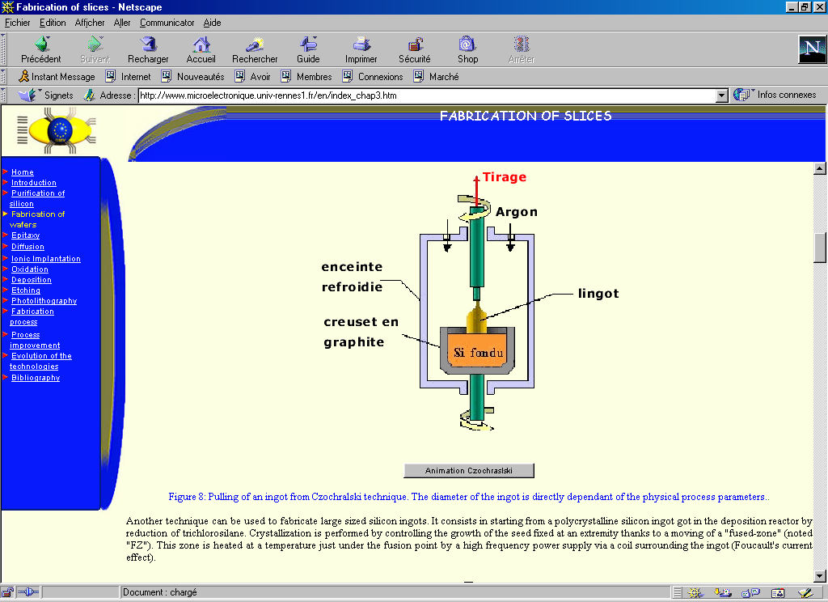
Fig. 3: Example of an html page of the integrated microelectronic technology course. This page corresponds to the English version of the document, which is in construction. The French, Finish and Romanian ones are almost achieved. Only, comments on figures are not yet translated in these last cases.

As shown on the figure 4, animations are included in the document that gives much more indications, especially in the field of technology for which a short animation describes much better an experimental technological step than a long text.
In this document, also simple simulations are available. Figure 4 gives an example of simulation that can be achieved to evaluate the growth rate of a thermal oxide. The user can change the data, and the simulation is performed through a Java applet, loaded in the personal computer or workstation of the user. In this case, the user saves some precious time of loading. Of course, the modeling is basic in this case to avoid too much long loading and calculation durations. The results are approximate but give a good idea of the basic phenomenon. As an example, the Grove’s model is used to simulate thermal oxidation in Figure 4.
Note that a lot of other examples can be given. Several colleagues have already set on the website of the Médiathèque e-EEA™ links to tools such as VHDL training, basic logic course, digital electronics, introduction to power electronics, electrical engine modeling, digital signal treatment, etc…[11]. In addition, the database can link to distance training developed by some colleagues. A good example is the Redwin long distance training developed in the frame of European collaboration [12] or a distance learning experience for IC test [13] set-up thanks to the French national committee for education in microelectronics (CNFM) [14].

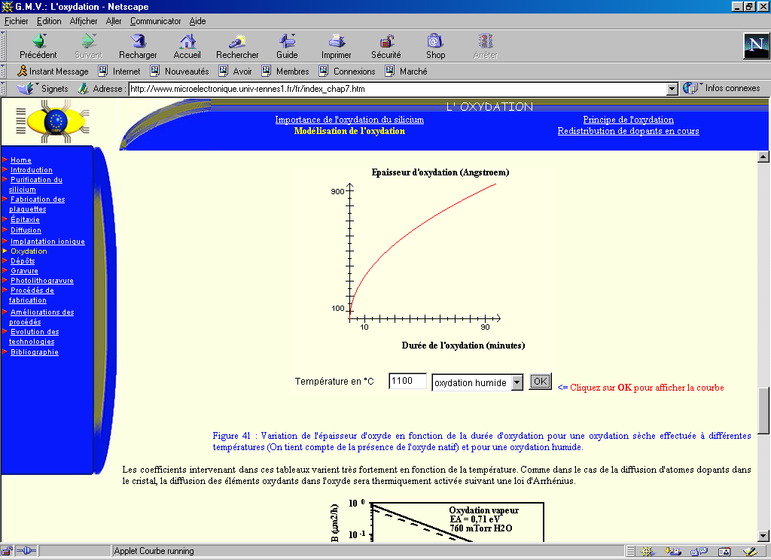
Fig. 4: Example of technological simulation included in the microelectronics module. The oxidation modeling is performed thanks to a Java applet loaded in the personal computer of the user. This procedure saves a lot of transfer time. The user has just to enter the data and activate the simulation. In this case, the modeling is simple to minimize the loading and transfer duration on the computer.

6 Conclusion

The Médiathèque e-EEA™ is potentially a huge tool able to spend knowledge as well to teachers as to students in the field of electrical and information engineering. It involves new educative technologies that allow making more attractive our fields to students and making much easier the learning of technological courses. The modern approach is in addition much more accepted by the students but also by teaching colleagues who can save a lot of time to prepare new courses in their own institutions.
This main objective is possible thanks to an active and well-organized structure built in the frame of teacher and researcher organization, the Club EEA. Diversity of approaches depending of different feelings of the scientific disciplines can enlarge the spectrum and enrich the global database. In its final form, this Médiathèque e-EEA™ should constitute a solid basement for a virtual campus.

Acknowledgments

The authors thanks all the members of the Pilot Group and all the colleagues who have contributed to set-in the database by loading their pedagogical products or establishing links to the website of Médiathèque e-EEA™.

References

- Club EEA: "Club des enseignants et des chercheurs en électronique, électrotechnique et automatique". French academic and research electrical and information engineering association. http://www.e-eea.org
- O. Bonnaud, Y. Danto, "Why a Virtual campus in technical and technological teaching", CD ROM Conference Proceedings of IEEE ITHET’2001, Kumamoto (Japan), 4-8 July, 2001.
- C. Glaize, Y. Danto, J.P. Louis, O. Bonnaud, Médiathèque EEA, 3ème Rencontre Europe – Amérique latine, Formation Technologique et Professionnelle, La Havane (Cuba), Nov. 2002
- O. Bonnaud, P. Münster, H. Lhermite, C. Diaconescu, “Interactive Microelectronics Technology Course Available on Website”, Proc. IEEE Int. Conf. on Microelectronic Systems Education, MSE’01, Las Vegas NV (USA) June 2001, pp. 14-15
- J.M.J Boutsen, G.H. Van Gerven, J. Peperstraete, "Restructuration of the engineering education", Proc. of 9th EAEEIE Conference, Lisbon, Portugal, 18-20 May 1998, pp. 1-5
- O. Bonnaud and Y. Danto, “Towards a European harmonization of electrical engineering background curricula”, Proceeding of IEEE ITHET 2000, Istanbul (Turkey), July 2000, Conf. Proc. pp : 1-6.
- O. Bonnaud, “Microelectronics Technology Course for a Virtual Campus?”, CD ROM Conference Proceedings of IEEE ITHET’2001, Kumamoto (Japan), July 2001
- O. Bonnaud, http://www.microelectronique.univ-rennes1.fr
- O. Bonnaud, A. Luukko, J. Luukko, J. Salo, M. Peipponen, J. Roihuvuo, and P. Silventoinen : http://www.microelectronique.univ-rennes1.fr/fi. Finish version of the course
- C. Diaconescu and O. Bonnaud,
http://www.microelectronique.univ-rennes1.fr/ro Romanian version of the course.
- Médiathèque e-EEA™ website : http://www.clubeea.org/enseign/mediatheque_sommaire.htm.
- T. Zimmer, P. Kadionik, Y. Danto; “A World-Wide-Web based instrumentation pool real testing in a virtual world, Proceedings of IEEE Int. Conf. on Microelectronic Systems Education, (MSE'97), Arlington-VA (USA), July 1997, pp. 114-115.
- Y. Bertrand, F. Azaïs, M.L. Flottes and R. Lorival, “A successful distance learning experience for IC test education”, Proceedings of IEEE Int. Conf. on Microelectronic Systems Education, (MSE'99), Arlington-VA (USA), July 1999, pp. 20-21.
- O. Bonnaud, G. Rey, “The French microelectronics training network supported by industry and education ministries”, Proceedings IEEE Int. Conf. on Microelectronic Systems Education, (MSE'97), Arlington-VA (USA), July 1997, pp. 121-122.

