DEVELOPMENT OF A SOFTWARE TO BIDIMENSIONAL STRESS ANALYSIS USING PHOTOELASTIC FRINGES

Prof.Dr.Perrin Smith Neto and Guilherme Cremasco Coelho
Pontifícia Universidade Católica de Minas Gerais- Brazil

Abstract- The work has as objective the development of a software of bidimensional stress analysis, capable to process and to analyze images of patterns of photoelastic fringes, obtained of plane polariscops in an automatic way, using a minimum amount of information supplied by the operator. The processing includes the obtaining of the difference between the maximum and minimun normal stress, maximum shear stress ;directions of the maximum normal stresses,isocromatics fringes and isoclinics.This software will allow studies of stress distribution in bodies of complex geometries submitted to several loading and to verify for instance, areas of high stress gradient. The method presented satisfactory results in photoelastic images generated by simulation, however it was not shown satisfactory in treatment of real experimental images. That is probably due to the fact that the methods of phase shifting, thoroughly published in the literature, are based on source of monochrome light, while the equipments used in the measurements used white light, in other words several wavelengths. In the development of phase shifting methods for white light - same that the camera is monochrome - the spectrum of the luminous source, and the answer should be known from the camera ccd to the luminous excitements of different spectra. . Concerning the analysis of monochrome images (that were generated by simulation), the processing presented satisfactory results, as described in the literature.

Introduction
Photoelasticity is a whole field technique that allows one to obtain principal stress directions and principal stress differences in the model. Photoelastic fringe interpretation, in the classical approach is made manually in a punctual form. Modern techniques that uses digital image processing for automatic fringe counting are based in some phase shifting methods.
Many authors proposed the use of more than one wavelength to produce a phase shift in photoelastic patterns. The RGB photoelasticity uses this principle, acquiring the image using a RGB video camera and then separating the red, green and blue images.
Others suggested the half fringe photoelasticity, where only one fringe in permitted in isochromatic pattern. Using this approach, one can obtain isochromatic parameters easily, but with less resolution.
Recent approaches are based in load stepping, where one increases (or decreases) the system of loads acting in the model, making the phase shifting. This approach is not so generic, because in tree-dimensional photoelasticity, one cannot change the loads acting on the slices.
Finally, one can change the photoelastic phase modifying some polariscope arrangements, such as quarter wave plate positions or analyzer positions. This approach seems to be the most simple, because has not restrictions in static applications and does not require RGB cameras or different light filters, although the phase-processing may not be the most simple.
In this work one uses the four image phase shifting method proposed by N. Plouzennec and others, because of the fact that the experimental arrangement is simple, using only a plane polariscope and image recording devices.

Phase shifting
The light emerging from a plane polariscope has the intensity given by

$I=\frac{I_{0}}{2}\left[1+\text{cos}\left(2β−2α\right)\text{cos}\left(2α\right)−\text{sin}\left(2α\right)\text{sin}\left(2β−2α\right)\text{cos}\left(2πN\right)\right]$ (1)
where $α$ is the direction of principal stresses, $β$is angle between analyzer and polarizer, $N$is the fringe order and $I_{0}$ is the image contrast.
To obtain photoelastic parameters $α$ and $N$ from a plane polariscope, one must introduce a phase shifting. Using four phase shifts, one obtain four different expressions from equation 1, so that this system can be solved for the wrapped (discontinuous) parameters.
The first image is collected when $β$is taken equal to zero and the polarizer axis is placed at +45º from the reference axis. The equation 1 then turns:
$I_{1}=\frac{I_{0}}{2}\left[1−{\text{cos}}^{2}\left(2α\right){\text{sin}}^{2}\left(πN\right)\right]$ (2)
Now placing the polarizer axis parallel to the reference axis and making the angle $β$ equal to +45º, 0º and 90º, equation 1 turns, respectively:

$I_{2}=I_{0}\left[0\text{.}5+\text{sin}\left(2α\right)\text{cos}\left(2α\right){\text{sin}}^{2}\left(πN\right)\right]$ (3)
$I_{3}=I_{0}\left[1−{\text{sin}}^{2}\left(2α\right){\text{sin}}^{2}\left(πN\right)\right]$ (4)
$I_{4}=I_{0}{\text{sin}}^{2}\left(2α\right){\text{sin}}^{2}\left(πN\right)$ (5)

Parameters determination

The solution of the system of equations 2 trough 5 is:

$\text{tan}\left(2α\right)=\frac{2I_{4}}{2I_{2}−I_{3}−I_{4}}$ (6)
$\text{cos}\left(2πN\right)=\frac{2I_{1}+2I_{3}−3I_{0}}{I_{3}+I_{4}}$ (7)

If one take the atan of expression 6, will obtain a discontinuous (wrapped) phase. This happens because atan function has image between -π/2 and + π/2. So, one must do the phase unwrapping. Many researchers have been working in phase unwrapping algorithms, mainly in radar SAR processing. The most simple method is based in the detection of discontinuities and add + π/2 or -π/2 in these points.
Another widely used method in noisy data is the unweighted least squares method, based in the minimization of the total phase discontinuities. Treating this problem through variational analysis, one reaches a partial differential equation problem, the solution of the poisson equation. In rectangular regions the homogeneous poisson problem has a fast explicit solution based in discrete cosine transforms.
Another method, more simple then the least squares approach, is based in the detection of discontinuities of the phase derivatives. When these discontinuous points are detected, in these points one make an interpolation from it’s neighborhood. Then these phase derivatives are integrated again. This algorithm was used for this work.
It is important to note that equation 6 is not defined when $2I_{2}−I_{3}−I_{4}$is equal to zero. In some cases, there are regions where it happens, for example, when the isochromatic fringes are too thick, and the term sin²(πN) is equal to zero not just in the center of the fringe, but in a region around the its center. So, it is important to use image processing routines to make interpolation or to blurr these regions.
To obtain the correct fringe number, one must unwrap from the acos of equation 7. This task is more complicated, since the discontinuous points in this case are not so apparent, the kind of discontinuity is different from those of atan function. To illustrate this problem, in figure 1 one can see an example of a continuous phase ϕ, and the wrapped from atan(tan(ϕ)) and from acos(cos(ϕ)). The algorithm to treat the acos discontinuous phase is based in the detection of places where the derivatives change the sign suddenly.

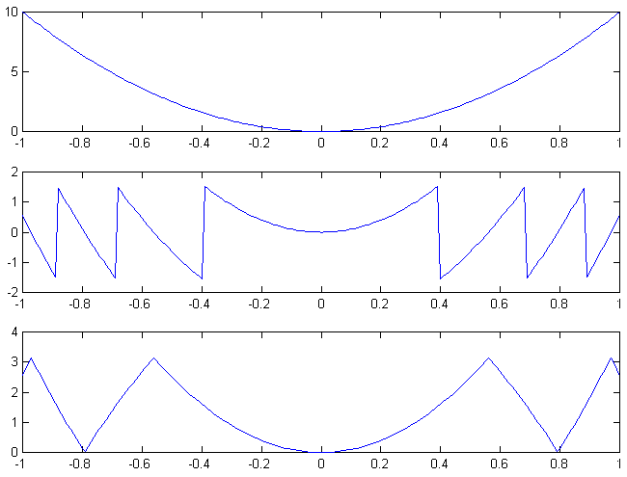

Figure 1. Different kinds of discontinuity. a) An example of continuous phase ϕ. b) The wrapped phase from atan(tan(ϕ)). c) The wrapped phase from acos(cos(ϕ)).

Application

A software were developed for photoelastic analysis using the methods described in this work. Some image processing routines were implemented, such as filters and region of interest processing. Also were implemented phase filters, specially designed for discontinuous data, and a masking routine, to eliminate regions of where the phase is not defined, based in harmonic methods.
The model is a disc under compression. The disc thickness is 5mm, the radius is 60mm, the applied load is 355 N, and the photoelastic constant is 13 KN/m. The images used in this application are shown in figure 2. The rectangular area marked in the images is defining the region used for the processing. The filtered wrapped isoclinic angle is shown in figure 3, and the unwrapped can be viewed in figure 4. In figure 5 one can see the wrapped fringe order, and in figure 6 the unwrapped fringe order.

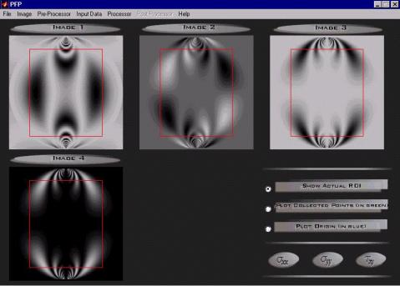

Figure 2. Four images used

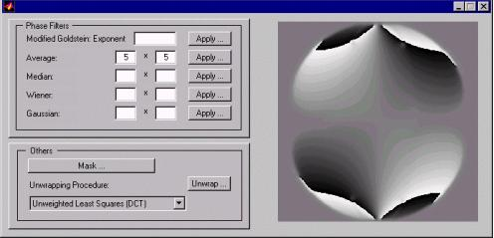

Figure 3. Filtered wrapped α

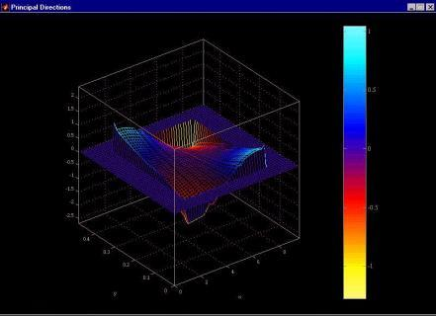

Figure 4. Unwrapped α

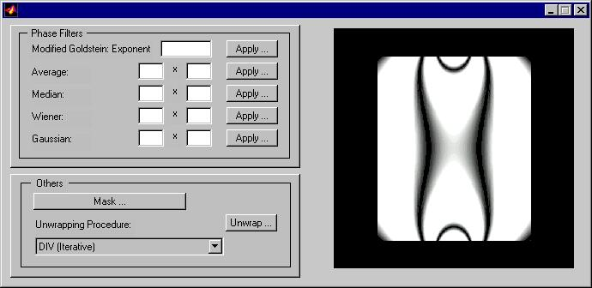

Figure 5. Fringe order wrapped phase

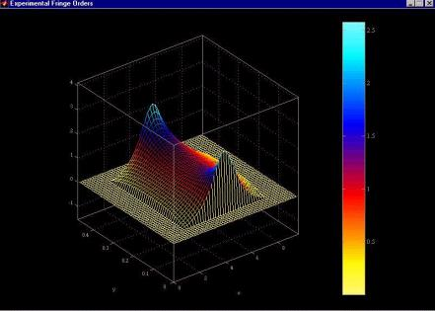

Figure 6. Fringe order unwrapped

Conclusion

Phase shifting in photoelasticity is an important tool in whole field analysis. Different ways to shift a photoelastic phase were proposed by many authors. The change in polariscope parameters has been shown to be the simplest form to do it. In this work were used a four images method, applied with image processing routines, such as blurr functions, region of interest processing, and filtering routines. Different phase unwraping algorithms were used to obtain the continuous photoelastic parameters, the direction of principal stresses and the fringe order for the whole field. An application to a disc under compression were made.

References
- Dally, James W., Riley, William F.,1991, “Experimental Stress Analysis”, Ed.McGraw-Hill, New York, USA, pp. 429-432.
- Plouzennec, N., Dupré, J.-C, Lagarde, A., 1999, ”Whole Field Determination of Isoclinic and Isochromatic Parameters Parameters”, Experimental Techniques, pp. 30-32.
- Müller, R. K. and Saackel, L. R., 1979, “Complete Automatic Analysis of Photoelastic Fringes”, Experimental Mechanics, pp. 245-251.
- Asundi, A., 1993, “Phase Shifting in Photoelasticity”, Experimental Techniques, pp. 19-23.
- Voloshin, A. S. and Burger, C. P., 1983, “Halph Fringe Photoelasticity – A New Approach to Whole Field Stress Analysis”, Experimental Mechanics, pp. 304-414.

