MODERN INFORMATION TECHNOLOGIES AND A DREAM ABOUT INDIVIDUAL EDUCATION

Zoia Sazonova, Nina Chechetkina and Tatiana Tkacheva

Abstract ⎯ The Internet conducted the informational integration of all the countries in the world. Introducing modern information technologies to the sphere of education accelerates the process of the unification of national educational systems. A united international educational environment is being formed. The accessibility of qualitative study information and the existence of an effective system of the educational process management can make our dream of the individualization of education come true.

Index Terms ⎯ Information technology, individual education, pedagogy, management of education, testing.

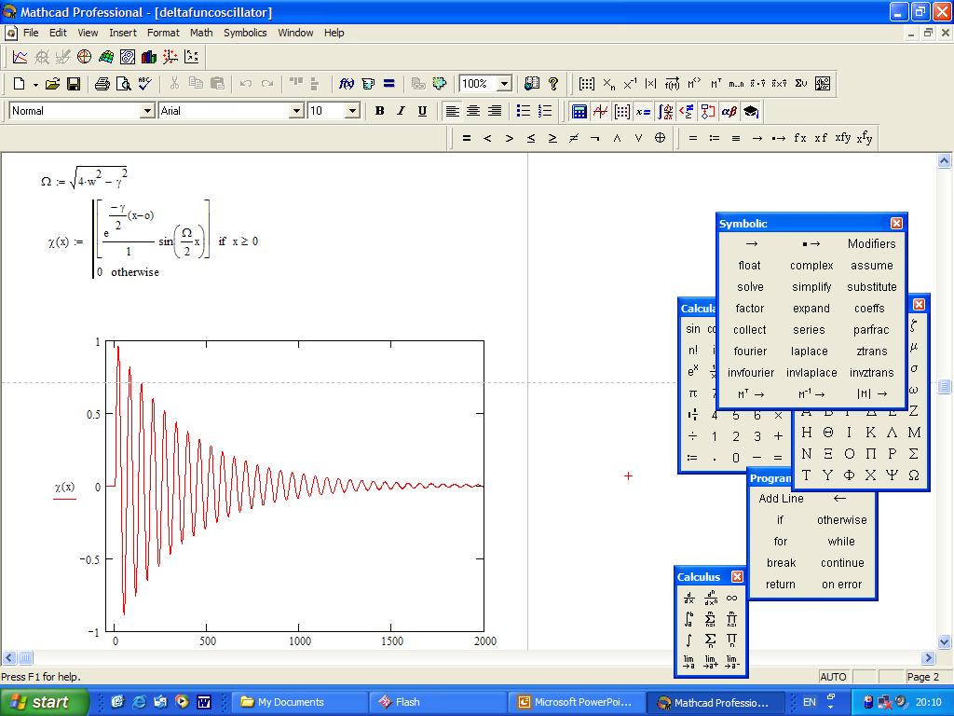
Body
The computerization era came to Russia much later than to Europe and the USA.
Just 10 years ago in the Moscow Automobile & Road Construction Institute there were just a few computers. By nowadays the amount of computers has increased by hundreds. Nowadays computers are used in the Russian system of education very intensely.
Lecturers and students of MADI actively use personal computers for various scientific and educational purposes: for instance, to model different processes, to make the control over experiments automatic, to create electronic text-books and so on.
Figure 2.
In MADI there is a local computer network (Fig.1). We use it to coordinate scientific work, to get information about the work of institute’s departments, to learn about seminars and conferences, to carry out educational & control testing, to give students their tasks and to exchange scientific information.
MADI’s local network is plugged into the Internet. Students & lecturers can get to MADI’s local network from their home computers via the Internet.
Students use various mathematical packages while performing different calculations. For example, during the exploration of the dependence of oscillations on different parameters MathCAD is especially intensely used (Fig.2).
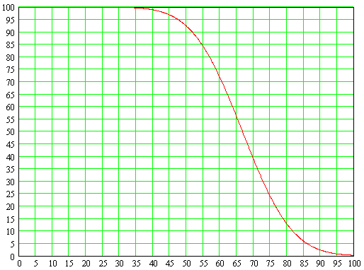

In our university different local systems of testing of the quality of knowledge in different subjects have been created and successfully used. At this photo you can see students of the 3-rd course, who have just completed one of their tests – they’re waiting for the results. The results and their analysis are presented below. The students were to complete 15 tasks. The vertical axis on the graph represents the percent of students, who have successfully coped with some task. We can see that some of the tasks turned out to be difficult for the students. This information is then analyzed and the corresponding parts of the material are then revised in a more detailed way.
% of correctly solved problems
% of students
Figure. 3
Local network
Scientific
Information
exchange
Coordination
of scientific work
Educational
tasks
Control and
Educational Testing
Information about seminars
and conferences
Information about the work
of institute departments
Global network
(WWW)
Students’
home computers
Figure 1.
Figure 3.
Testing is not just a method for controlling the quality of the students’ comprehension of the material, but it’s also a way of controlling lecture material.
Testing provides us with an opportunity to set a feedback between students and lecturers. The staff of the engineering pedagogy department uses testing as an important instrument in the process of introducing new pedagogical technologies [1,2].
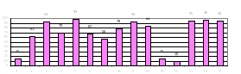
The Internet and a personal visit to England’s universities helped us to collect some information about the organization of educational process in Great Britain and the USA. We then conducted a technical analysis of the educational programs of foreign and Russian technical universities. The work carried out by us let us make the following conclusions:
- Universities of the USA and England have very well developed structures of management of the independent work of the students. Decrease of the number of auditorial classes in these conditions gives positive results.
- In Russian universities a lot of variants of perspective innovational pedagogical technologies, which take advantage of modern information technologies, have been developed. However, unfortunately, the integrity of the combination of all the conditions, which in all universities can ensure the students’ independent work, leaves much to be desired, and the timeliness of the decrease of the number of auditorial classes gives rise to doubts.
- Study plans of Russian and foreign technical universities have a lot in common, but there are some significant distinctions as well. As an example, we’ll consider study programs for the civil engineering specialization in two different universities: in the Imperial College, which is a part of the University of London, and in the Moscow State Automobile & Road Construction Institute.
Foreign programs even on the first two courses already have greater practical orientation than Russian programs do. For instance, in the programs of British universities there’s no united course of general physics. Nevertheless, different parts of physics, vitally important for a concrete specialization, are taught in a very detailed way.
For Russian universities very deep fundamental basis is characteristic. Those parts of physics, which are especially important for some concrete specializations, are taught at the so-called “elective” courses. Serious fundamental education provides students with a broad scope and the opportunity to work on the border between different types of scientific or engineering directions.
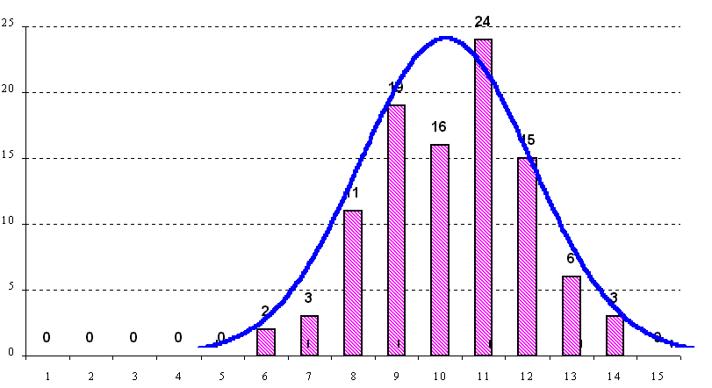
In the universities of the USA, England and Europe students start working in a team of 5-6 people on their projects already during the first year of study. During subsequent courses this work is continued. It is great when the study process tries to incalculate in the students the ability to work in a team. In Russia the work in this direction is only beginning.
Modern information technologies have created a great deal of new opportunities. The use of modern information technologies in the system of education let us modernize the organization of the study process and give a lot of study time to the students for their independent work in the framework of a well-organized educational structure. Independent work must be manageable.
Figure 4.

- X-axis: the number of the task
Y-axis: Percent of students, who solved the task

- x-axis: the number of solved tasks
y-axis: percent of students, who solved exactly this number of tasks

In order to realize this idea it is important to have an effective structure of management of the process of students’ professional development. If such a structure existed, a student could decide himself if he needed to attend lecture classes regularly or if he could work on his own, using those educational materials, which are presented on the web-site of his university.
In this case, when independent work results in good testing score, the student can continue working on his own for most of the time. Otherwise, a student will definitely go to the auditorium. He can sensibly evaluate his abilities and choose his own method of study. Such an approach is respectful towards the personality of a student and can help to solve the problem of education humanization. The creation of an effective management structure of the process of students’ independent work is a very important problem. This problem is discussed in the following paper.
Conclusion
Modern information technologies let us realize an individual approach towards the education of every concrete student [3]. Every student can optimize his own study timetable himself in order to study in a convenient routine.
Structure of the management of the independent work of the students:
- A full complex of educational materials required for successful study (in classic and electronic forms)
- Effective system of constant feedback between students and teachers (Fig.5)
tests
test accomplishment
consultations
INSTRUCTOR
STUDENTS
- System of registration of testing results supposed to support the lecturer marking students’ work for the whole course.
Figure 5.

Acknowledgment
The authors are grateful to prof. V.M.Prikhodko and prof. V.M.Zhurakovskiy for their interest towards the article and their useful comments.

References
- Zhurakovskiy, V., M., Sazonova, Z., S., Chechetkina, N., V., Tkacheva, T., M., "Modern information technologies in engineering education", Referate des 31. Internationalen Sumposiums “Ingenieur des 21. Jahrhunderts” Band 1., 2002
- Zhurakovskiy, V., M., Sazonova, Z., S., Chechetkina, N., V., Tkacheva, T., M., "Development of creative thinking as a basis for engineering pedagogy", Referate des 31. Internationalen Sumposiums “Ingenieur des 21. Jahrhunderts” Band 2., 2002
- "National Doctrine of Education in the Russian Federation", Higher education today, #2, 2001

Zoia Sergeevna Sazonova, professor, Engineering Pedagogy Dept., Moscow Automobile & Road Construction Institute (MARCI), Leningradski prospect, 64, room 345, Moscow, Russia, sazonova@dataforce.net
Nina Vladimirovna Chechetkina, assistant professor, Engineering Pedagogy Dept., Moscow Automobile & Road Construction Institute (MARCI), Leningradski prospect, 64, room 345, Moscow, Russia, kip@igip.madi.ru
Tatiana Mikhailovna Tkacheva, associate professor, Engineering Pedagogy Dept., Moscow Automobile & Road Construction Institute (MARCI), Leningradski prospect, 64, room 345, Moscow, Russia, kip@igip.madi.ru

