ANALYSES OF CURRENT METER DATA IN THE COASTAL AREA OF
SAO PAULO STATE (BRAZIL)

Joseph Harari and Alexandra F. P. Sampaio

Abstract ⎯ Oceanographic measurements in the coastal area of Sao Paulo State (Brazil) were obtained by using an Acoustic Doppler Current Profiler (ADCP). Nine records of approximately one month each (in 1998 / 1999) are relative to 7 positions, with local depths ranging from 13 to 33 meters; the sampling rate was 15 minutes, from 5 meters below the surface up to 5 m above the bottom (typically), at 1 m intervals. The current meter data were submitted to analyses, in order to obtain information about the circulation characteristics in the coastal region. For every point and at every depth, time series of east-west and north-south current components were analyzed, giving basic statistical parameters (mean, median and extreme values, standard deviations, histograms, polar histograms, progressive vectors) and spectra (of amplitude, energy and rotatory). The analyses will provide an important support to several environmental issues in the region, such as water quality and pollution.

Index Terms ⎯ Current meter data, ocean circulation, time series analysis, Sao Paulo State coastal area (Brazil).

INTRODUCTION
The ADCP (Acoustic Doppler Current Profiler) is formed by three or four acoustic transductors fixed under the ship (or deployed at the sea bottom); they are oriented in different directions and behave like transmitter-receiver.

Signals are emitted towards the bottom (or the sea surface), with a 30° angle to the vertical, being reflected by micro-organisms and particles suspended in the water; the acoustic transductors receive the reflected signals with a change in their frequency, proportional to the particles radial speed (Doppler effect). A sampling of time enables to calculate the Doppler changes in layers of water evenly matched in depth.

Then, the grouping of the signals enables to obtain a representation of the speed of the ship against each layer of water (or the speed of the layers relative to the sea bottom). Emission frequencies are between 38 to 150 KHZ with respective ranges between 1000 to 4000 m. The delivered data are speed and direction of the layers of water (with typically 1% accuracy).

Present study is relative to ADCP´s moored in the ocean floor, at 7 positions in the coastal area of Sao Paulo State (Figure 1), giving 9 records of approximately one month each, in the period of 1998 / 1999. These positions have depths that range from 13 m (point 6) to 33 m (point 5) and the observations were from 5 m below the surface up to 5 m above the bottom, at 1 m intervals, with sampling rate of 15 minutes.

The analyses of the time series generated by the oceanographic observations will provide an important support to several environmental issues in the coastal region of Sao Paulo State, especially pollution and water quality control.

METHODOLOGY
The time series of current meter data were obtained for each point and depth by decomposing the intensity and direction values into east and north components.

The time evolution of the current components was initially represented graphically and then submitted to statistical and spectral analysis, using software developed for the mathematical package Matlab (1999).

The basic statistical parameters computed for each series were: mean, median and extreme values, standard deviations, histograms, polar histograms and progressive vectors. In the frequency domain, spectra of amplitude, energy and rotatory were obtained (Jenkins & Watts, 1968).

RESULTS
A selection of results will be presented, relative to point 5 (24° 15.056’ S 046° 17.076’ W)
, at the depths of 5 and 28 meters, with observations in the period from 29 January 1999 18:00 to 19 February 1999 14:15 (local time)
.

Figures 2a and 2b present the stick plots of the daily mean currents near to the surface and the bottom, respectively, considering 20.5833 days of measurements: the currents are quite homogeneous along the vertical, being mostly to Northeast but with some observations to the Southwest. This feature is confirmed by the correspondent polar histograms, shown on Figures 3a and 3b, which give the number of observations in each direction.

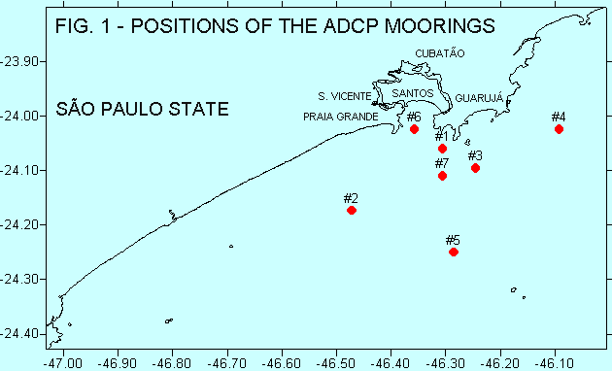

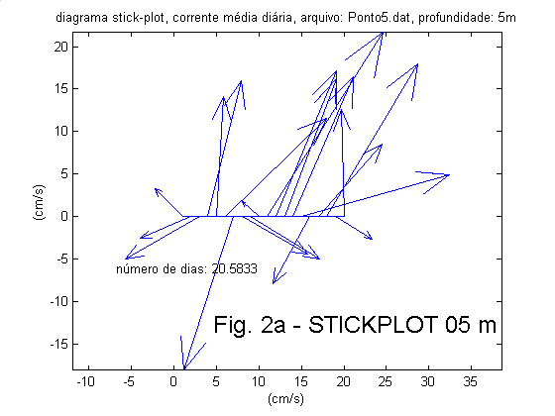 | 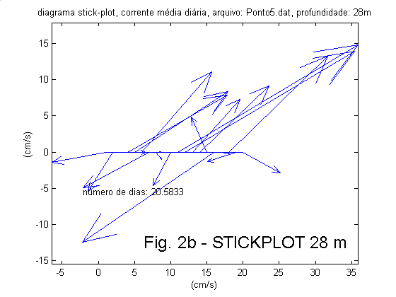
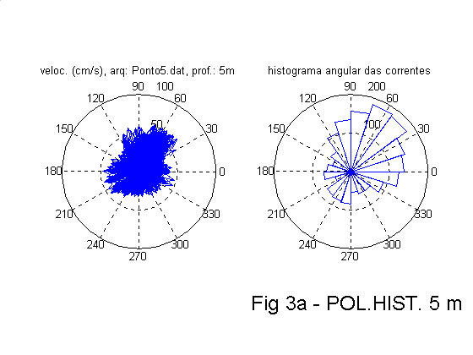 | 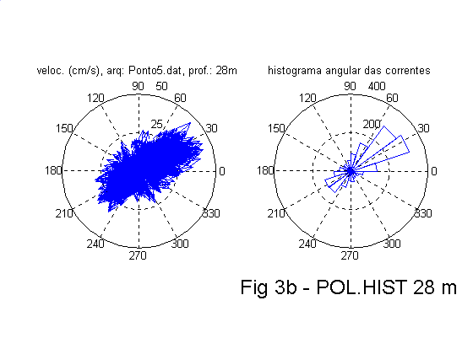
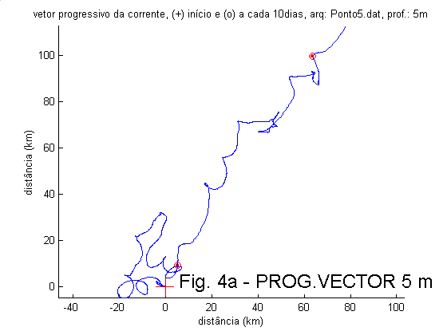 | 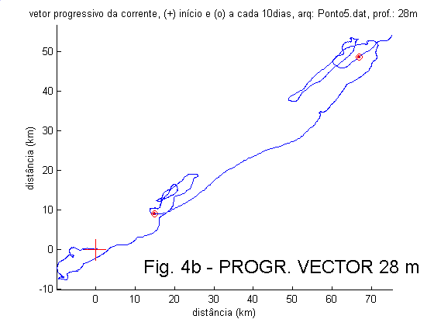
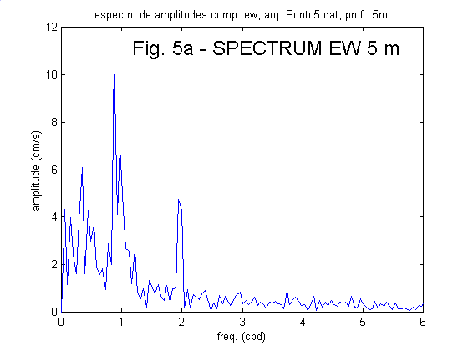 | 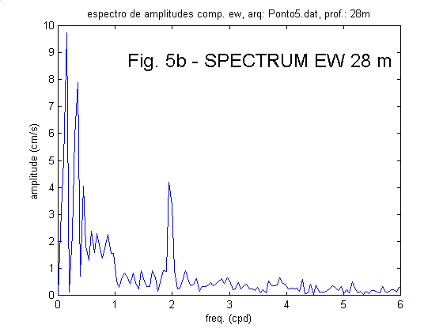
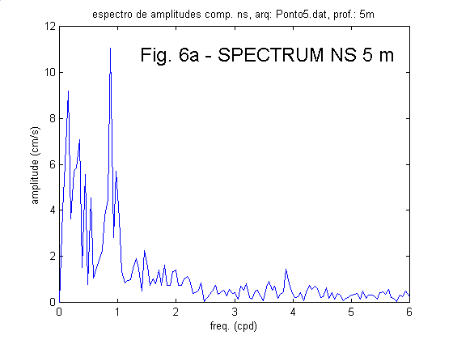 | 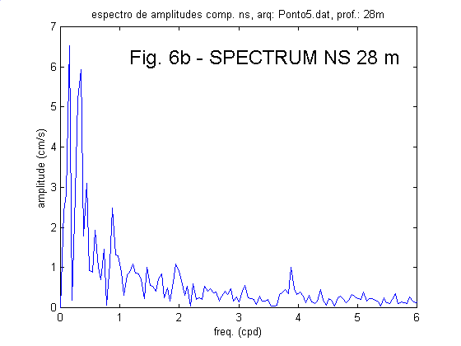

Figures 4a and 4b show the progressive vectors near to the surface and the bottom, considering samples at every 15 minutes, both with resulting values to the Northeast

The spectra of the current components are given in Figures 5 and 6, again considering the observations at 5 and 28 m depth. These figures show important differences between the surface and the bottom circulation. In the EW direction, long period components (with frequencies below 1 cpd) are energetic at the bottom and much weaker at the surface; on the other hand diurnal components (around 1 cpd), are stronger at the surface and nearly disappear at the bottom; finally, semi-diurnal current components (2 cpd) are nearly constant from the surface until the bottom. In the NS direction, long period components are significant both at the surface and bottom, the diurnal components are damped at the bottom and the semi-diurnal ones have small amplitudes.

The basic statistical parameters relative to 5 and 28 m depth, for the velocity intensities and EW, NS components are given on Table 1, which indicates that both mean and extreme values are stronger at the surface.

These circulation features agree with other publications; particularly the expressive decay of the diurnal components and much smaller one of the semi-diurnals were also observed in other current time series of this continental shelf, such as the ones of Mesquita & Harari (2000, 2001).

CONCLUSIONS
Present study shows recent developments in coastal Oceanography and Engineering, both in observations and analyses, with the use of automatic sensors for high quality field measurements and quick analyzing procedures.

The ocean circulation characteristics inferred by these analyses may be used in several applications, such as numerical predictions, navigation security, coastal protection, sedimentation, erosion and water quality control.

TABLE 1
BASIC STATISTICS OF OCEAN CURRENT DATA
(POSITION 5)

5 m depth | Values in cm/s
 | Velocity | EW comp | NS comp
Minimum | 1.0 | -47.0 | –32.7
Maximum | 65.0 | 49.6 | 61.4
Mean | 22.5 | 4.4 | 6.3
Median | 21.0 | 4.8 | 5.3
Standard deviation | 11.8 | 16.0 | 18.1

28 m depth | Values in cm/s
 | Velocity | EW comp | NS comp
Minimum | 1.0 | –28.4 | -26.5
Maximum | 46.0 | 41.7 | 31.4
Mean | 15.4 | 4.2 | 3.0
Median | 14.0 | 4.1 | 3.9
Standard deviation | 8.2 | 13.3 | 10.2

Acknowledgment
The authors are grateful to Companhia Docas do Estado de São Paulo - CODESP (Docks of Sao Paulo State Company), Universidade Santa Cecília - UNISANTA (University of Santa Cecilia), Santos – SP, and Fundação de Estudos e Pesquisas Aquáticas - FUNDESPA (Foundation for Aquatic Studies and Researches), Sao Paulo - SP. These institutions provided the equipments and data used in present publication.

references
JENKINS, G. M. & D. G. Watts – 1968 – “Spectral Analysis and its Applications” . Holden-Day, San Francisco. 525p.

MATLAB - 1999 – “The Language of Technical Computing” – version 5.3.0.10183 (R11) – The MathWorks, Inc.

MESQUITA, A. R. & HARARI, J. - 2000 - “On the sea level network and circulation in the southeastern Brazilian coast” – In: “Ocean circulation science derived from the Atlantic, Indian and Arctic sea level networks” - International Oceanographic Commission (IOC) – Workshop Report n° 171, p. 34 – 51.

MESQUITA, A. R. & HARARI, J. - 2001 - “On the harmonic constants and tidal ellipses of currents of the South-eastern Brazilian shelf” - Afro-America Gloss News, vol. 4 (1), 12 p.

Joseph Harari – Institute of Oceanography of the University of Sao Paulo, Sao Paulo, Brazil, joharari@usp.br
2 Alexandra F. P. Sampaio - University of Santa Cecilia, Santos (SP), Brazil, canastra@stcecilia.br

