LABORATORY PROGRAMS ON PHYSICS WITH USAGE OF MODERN INFORMATION TECHNOLOGIES

Konstantin A Ekimov, Roman V Prichodchenko, Anatoly D. Khakhaev.

Abstract ⎯ A set of laboratory programs used in education courses of atomic and quantum physics, metrology, spectroscopy and plasma diagnostics has been presented. The training is performed with use of new information technologies and a possibility of remote access to the equipment. Students come to know a subject area (e.g. determination of fundamental atomic constants, Zeeman effect, plasma diagnostics, temperature determination, eliminating the apparatus distortions etc.) in parallel with acquiring habits in usage of modern information systems and effective methods of accumulation, processing and transformation of data. They are trained in usage of local and remote information resources and study the operation principles and possibilities of various measurement sensors. Such an approach promotes both a knowledge basis in the subject under study and formation of a specialist, who is ready to work in the modern information environment.

Index Terms ⎯ Atomic physics, information technologies laboratory program, remote access, spectroscopy, virtual instruments.

Introduction
In the Department of Information- measuring Systems and Physical Electronics of Petrozavodsk State University laboratory programs on the following courses: Quantum and Atomic physics, Metrology, Optical methods of plasma diagnostics are carried out with usage of new information technologies: virtual instruments and opportunity of the removed access to the equipment. The virtual instruments is essentially an information- measuring system, with the interface which is similar to the panel of the usual device and has been created in graphic programming environment (for example, LabView) Thus, simultaneously with studying problems of a subject area (for example, Zeeman effect, plasma diagnostics, temperature determination, eliminating the instrument distortions etc.), our students gain experience in application of modern effective data acquisition and processing methods.
They are trained in usage of local and remote information resources, get acquainted with a principle of action and opportunities of various measuring sensors.
Alongside with fastening of knowledge in an investigated subject, such laboratory programs form the expert ready to work in the modern information environment. The brief description of our typical installations and laboratory programs are given below.

Laboratory Programs carried out on Automated Spectroscopic Set up "Light"

The set up is destined for local spectroscopy of inhomogeneous and non-stationary plasma. It allows to carry out spectrum scanning by large aperture diffraction spectrometer with resolution 0.015nm in the range 300-800 nm, scanning of spatial source surface radiance distribution by special spatial scanning block and to choose for radiation measurement the certain time moments, if a source characteristics are periodically varying . Experiment control is based on Labview and instrument interfaces, compatible with this system. The system runs under the control of the IBM-compatible computer with ОS Windows-98.
The software includes the following functional modules:
а) Module of spectral device calibration on wave lengths by a source with a known spectrum ("Spectrum calibration").
b) Module of the photodetector sensitivity calibration by the registration of a certificated temperature lamp spectrum. ("Sensitivity calibration").
c) Module of spectrum scanning in the given spectral range with the given step ("Spectrum scanning").
d) Module of spatial gating at a given wave length ("Spatial scanning").
e) Module automated spatially and spectral scanning in the given spectral and spatial intervals and time phase ("Spectrum -spatial scanning").
f) Module of data loading for subsequent analysis ("Spectrum load/Analysis").
g) Module of the remote access server.
Each module is made as a "virtual instrument", on the panel of which there are windows for input of the necessary information, control buttons (start of the module, save file) and graphic field for result representation. The example of such panel is given in Figure 1.
The module "f" allows to transform automatically the digital reading array to array of a source surface radiance, if earlier calibration by the module "b" was executed, and also to derive various information from a spectrum (e.g. maximum positions and values, line widths) by Labview tools for graphic processing (scaling and cursor positioning).

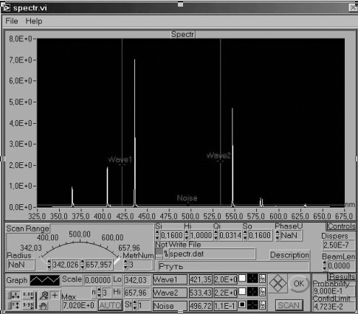

Figure. 1
Virtual Instrument " Spectrum Scanning".

The module "g" provides an opportunity for the removed experiment control.
When a user saves data file, the information file is automatically created, where date of the experiment and all experiment conditions (spatial and spectral range, gating steps, spectrometer slit aperture parameters and so on) are written together with any additional information entered by the user ( e.g. type of the source, discharge current, etc.).
On this set up the following laboratory programs are carried out:

Studying Serial Laws in the Hydrogen Spectrum and Rydberg's Constant Determination

This program is included in the course "Atomic and Quantum Physics "
In the simplified variant of work the student with the help of the module. " Spectrum scanning " registers a survey spectrum in a range 405- 660 nm. Then for more exact definition of waves lengths spectra in the interval of 5 nm from the found lines are registered with the minimal step.
For each measured wave length the wave number$\tilde{ν}$ and Rydberg's constant R is determined by the formula:

$\tilde{ν}$= R (1/4 - 1/n²), (1)
It is supposed, that all registered lines belong to the Balmer's series. Taking into account, that wave lengths and line intensities in the Balmer's series decrease with growth of the main quantum number n, for a line with greatest wave length n=3. The received R values are averaged over all lines and then it is checked, whether the theoretical value (R=109737.31 cm⁻¹) lies in 95 % confidence interval for R.
The complicated variant of work assumes preliminary spectrometer calibration on wave lengths by module "a" with use of cadmium spectral lamp.

Metrology Certification of Information Measuring System

This program is included in the course" Metrology".
The certification consists in an experimental establishment of correspondent of a system metrology characteristics to their values specified in the system documentation.
This program offers to execute operations on certification of set up "Light" as a tool for wave length measurement in the range 400-600 nm. The systematic error in a measurement of wave lengths should be no more than 0.1 nm, random - no more than 0.03 nm.
Using a source with a known spectrum (cadmium spectral lamp), in which the wave length values are known with the accuracy of 0.001 nm, and modules "Spectrum scanning" and "Spectrum load/Analysis", the student repeatedly determines the measured wave length values and calculates the random and systematic errors of the measurement.
By results of the experiment the standard " Protocol of metrology certification" has to be drawn up.

Determination of Temperature by Radiation

This program is also included in the course " Metrology". It reveals the concepts of radiance and color (spectral) temperature and methods of their measurement.
Having registered a spectrum of radiation of a filament lamp in a range 400-600 nm with help of the module "Spectrum scanning" and having transformed file of readings in file of values of spectral radiance B of a source surface by the module "Spectrum load/Analysis", the students determine source radiance temperature T for several wave lengths λ by the Planck's formula:

B(λ,T)=2hc²λ ⁻⁵{exp[hc/(λkT)]-1} ⁻¹ (2)

Here h- Planck's constant, c - light velocity, k- Boltzmann's constant .
Spectral temperature of a source is determined from the slope of the graphic Y=f(1/λ), received from (2) with the assumption, that it is possible to neglect 1 in comparison with exponent for the visible spectrum part and also that absorption coefficient Q of a light source material in some spectrum area does not depend upon the wave length. Then:
Y=а+ b*(1/λ),
where
Y=lnB+5lnλ, a=ln(2hc²)+lnQ, b=-hc/kT (3)

The least square method is used for calculation a and b; from b the spectral temperature is determined.

Emission Spectroscopy of Inhomogeneous Plasma

This program is included in the course " Optical methods of plasma diagnostics ".
The experiment consists in registration of visible intensity spatial distribution of the arc discharge in several spectral lines along the directions, perpendicular to discharge axis. After appropriate data processing the radial distribution of excited level densities in discharge should be received. For this purpose the following modules are used:
-"Spectrum scanning"- for the registration of a survey spectrum and choice lines for discharge diagnostics.
-"Spatial scanning"- for spatial gating of chosen lines radiation along a direction х, perpendicular to the axis of a source and optical axis of system. Previously spectrometer is precisely adjusted to a maximum line intensity by the module "Tuning", which is called from the module "Spatial scanning". The input and output spectrometer slits are extended enough to receive integrated over line profile intensity.
-"Spectrum load/Analysis" for transformation the file of readouts to the file of values of spectral radiance B.
For each line from a file of radiance B (х) one can find the line intensity J for a distance r from the source axis by radial transformation:[1]
J(r)=$−\frac{1}{π}\int_{r}^{r_{o}}{\frac{\frac{\text{dB}}{\text{dx}}\text{rdr}}{\sqrt{x^{2}−r^{2}}}}$ (4)

( r₀- radius of a source border).
The students are offered independently to choose and to realize in program the decision of the integral equation (4) and on found J to determine of appropriate excited level densities N, since
J=ANhc/λ (5)

A - the transition probability may be found in a reference book. Having determined densities N_{k} of levels with various excitation energy Е_{к,} the students should check up the validity of local thermodynamic equilibrium model [1] in the given plasma point. The model is correct , if the next condition is fulfilled for all levels:

N_{i}/N_{k}=g_{i}/g_{k}⋅exp[-(E_{i}-E_{k})/k] (6)

(g_{i}, g_{k}-the statistical weights of the appropriate levels).
Laboratory Programs carried out on Automated High Resolution Spectroscopic Set up "Spectrum "

The installation is intended for research of spectral line structures and shapes. The single line is picked out by the prism spectrometer or the interference filter, high resolution is achieved by the Fabry-Perot interferometer. The spectra registration is carried out with the help of virtual instruments based on LabView.
Two variants of installation might be possible:
The first one uses the Fabry-Perot in a scanning mode.
The interference rings are drawn on spectrometer input slit, which with a cross slit, established in front of it, forms a scanning diaphragm, allocating in the center of the interference picture. Behind the spectrometer output slit the photo-electric recording system is established. Spectrum scanning is carried out by pressure change in compression chamber , in which Fabry-Perot interferometer is placed. Photo-electric system signals are converted into digital form and remembered by the managing module through determined time intervals, given by the user. The module of data viewing and processing one can see in Figure 2 .

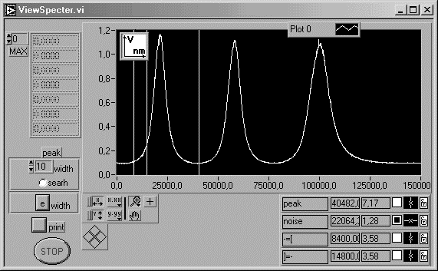

Figure. 2
The Result of Spectrum Scanning by Fabry-Perot .

This module allows to save the results in a file, and also to analyse line shape and structure (e.g. maximum positions and values, line widths ) by Labview tools for graphic processing
The second installation variant based on usage of a videocamera. Selection of spectral line is carried out by interference filter. The CD camera focused on infinity draws interference patterns on photodetector matrix . The panel of the virtual instruments for this experiment is shown in Figure 3. The module of data processing finds the center of rings and builds the dependence of interference pattern intensity on the distance from the center of a picture averaged over various directions. (Figure 4). The result can be printed out, saved in a file or processed directly by Labview graphic tools.

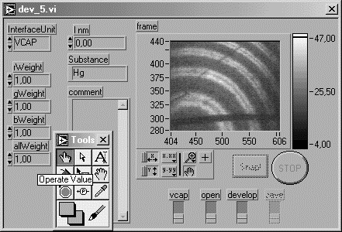

Figure. 3
Virtual Instrument for CD camera Control.

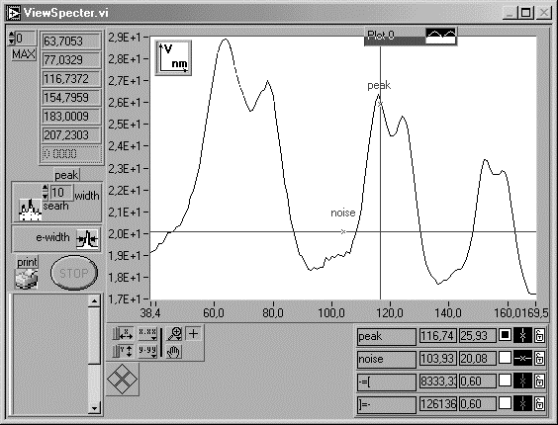

Figure. 4
Virtual Instrument for Analisis CD camera Data .

On this set up the following laboratory programs are carried out:

Zeeman Effect

This program is included in the course " Atomic and Quantum Physics" .Spectral line splitting in permanent magnetic field is studied
The effect is observed on mercury lines of 579 and 546 nm, which are excited in a mercury discharge lamp placed between poles of permanent magnet. The analyzer of light polarization is placed between the light source and the Fabry-Perot interferometer.
By rotation of the analyzer one can see spectral line splitting components polarized along and perpendicular to magnetic field. Observation of the splitting and measurement of its value are possible in any of the described above variants of set up.
By the distance between the components, polarized perpendicularly to a field, of a line 579 nm, on which the simple Zeeman effect is observed, the magnetic field induction B₀ is estimated.

$B_{0}=\frac{\text{hcx}}{2μ_{B}\text{dX}}$ (7)

Here Х-distance between nearby interference maximum in any units, х- the distance between components inside one maximum in the same units, d - interferometer thickness, μ_{В}- Bohr's magneton.

Measurement of Line Width and Determination of Plasma Atomic Temperature

This program is included in the course "Optical methods of plasma diagnostics ".
The light source is any low pressure discharge lamp.
The set up is used in the first variant. Some spectral lines are picked out by spectrometer and line shapes are received and saved in files.
In the assumption of absence of instrument distortions and Doppler line broadening mechanism [1] the atomic temperature T_{a} may be estimated from the line width Δλ.
.
$Δλ=\frac{2λ_{0}}{c}\sqrt{\frac{2(\text{ln}2){\text{kT}}_{a}}{M}}$, $Δλ=\frac{λ_{0}^{2}}{2d}$ (8)

Here λ₀- wave length of a profile center, М- atomic weight. This temperature will be obviously too high, since when working with Fabry-Perot interferometer, the instrument distortion, as a rule, could not be avoided. The interferometer spread function is:

$P(β)=\frac{(1−R)^{2}}{(1−R)^{2}+4R{\text{sin}}^{2}\text{πβ}}$ (9)

Here β is the fraction of the distance between the nearby interference peaks (for each point х in the interference order β =х/X.) R- mirror reflectance. It is known. Students are offered to calculate the spread function and to eliminate the instrument distortion by free accessed program [2] . (Figure 5).
Having measured the width of the corrected line shape, it is possible to estimate atomic temperature in plasma more accurate.
The averaging over several lines gives even more reliable result.

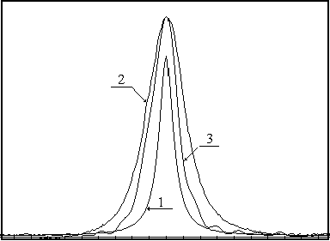

Figure. 5
The Profile of the Neon Spectral Line before (2) and after (3) Elimination of Instrument Distortion .1- the Interferometer Spread Function [2].

Having measured the width of the corrected line shape, it is possible to estimate atomic temperature in plasma more accurate. The averaging over several lines gives even more reliable result.

Verification of the Analog-digital Converter (ADC)

This program is included in the course " Metrology".
The analog-digital converter is one of the main device of automated physical experiment instrument interface
The control of correspondence its metrology characteristics to required values is the necessary condition of experiment results reliability.
In this program the ADC, which is one of the CAMAC modules, have to be calibrated. The special driver allows to operate with CAMAC from LabView environment.
The precision voltage generator is used as voltage source. The student varies the test voltage according to randomized experiment plan and registers the ADC output by virtual instrument presented in Figure 6
The results are saved in a file for subsequent processing, which consists in estimation of the systematic and random errors of the device in all working range. As a result the conclusion should be made, whether this ADC metrology characteristics correspond to limits specified in the passport of the device.

Remote Access Opportunities.

All above described laboratory programs may be carried out with the remote access to apparatus. It is organized by LabVIEW tools on the basis of information interchange protocol TCP/IP.
Simultaneously with the experiment (e.g. spectrum scanning) the observation is possible with the help of the video-equipment with program support of videoconferences.
Due to this technology, it is possible to observe visually and control the experimental process from another room (even from another country) if a computer is connected to a network and LabView "Remote access Client" is loaded.
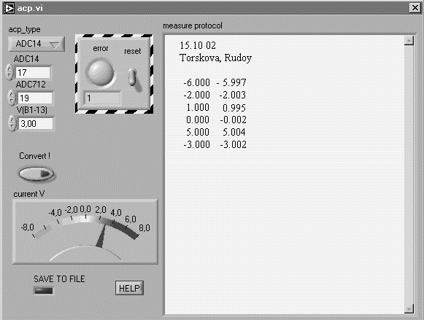.

Figure. 6
Virtual Instrument for ADC Calibration Testing .

This software is free accessed at http://194.85.172.228/index.html. Following the instruction the user can receive the list of laboratory programs. Having chosen the necessary program, the user will see the panel of the virtual instrument appropriate to the chosen experiment.

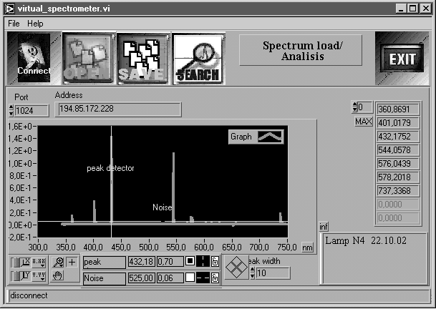

Figure. 7
Virtual Instrument for Remote Access to the Equipment.
One of the set up "Light" module is loaded .

It is also possible to start the module of a videocamera control separately.

Acknowledgment
Authors wish to thank Professors L.A. Luisova, S.D. Wagner and E.I. Socolova for help and useful discussions.

References
- Griem H. R, "Plasma Spectroscopy", Moscow, 1969, p.151
[2] Luizova L.A., Soloviev A. V. "Computer training program for elimination of instrument distortions", Proc. SPIE. Vol. 4588, 2002, pp.440-447.

Konstantin Ekimov, Petrozavodsk State University, Department of IMS&PhE, 33 Lenin str., Petrozavodsk, Russia, 185640, ekostq@dfe3300.karelia.ru
Roman Prichodchenko, Petrozavodsk State University, Department of IMS&PhE, rvprihod@st.karelia.ru
Anatoly Khakhaev, Prof, Dr, Petrozavodsk State University, Department of IMS&PhE, alim@karelia.ru The research described in this publication was made possible in part by Award No. PZ-013-02 of the U.S. Civilian Research & Development Foundation for the Independent States of the Former Soviet Union (CRDF) and of Ministry of Education of Russian Federation.

