AN EXPERIMENTAL CREATIVITY RESEARCH IN DESIGN EDUCATION BY HIERARCHICAL APPROACH

Elmira Sener, Secil Satir

Abstract ⎯ Design education is an area which has a broad point of view in its context. It consists of the feelings, thoughts and conception of both the designers and the users. Design students are confronted with some design problems in order to gain general continuity of creativity and ability. In some cases, these problems are based on some theoretical thought but they can also be formed with various materials, geometric shapes and objects exemplified in environment.
The main subject of this paper is the experimental studies conducted by grouping student according to their classrooms in design education. Consequently, only creative structures based on figure is received from the least-educated students. At the same time, knowledge-base structures were increased as the education level increased. Maintaining original compositional structures was a result based on knowledge and experience. According to the conclusions, the study states that design education should be a motivator, not a demander even in a knowledge-providing phase of the education process.

Index Terms ⎯ Design, design education, design students, design process, creativity.
Introduction
Designing is an area and a notion which has creativity in its essence which is combined with the concept of creation. To design means to create in the mind and to find solutions. Basically, almost all the problems of architecture, industrial design, engineering or the daily life, reach the first step of the solution process by the formation of the creative ideas in mind.
Designing is a process in which creativity constantly appears. This process is formed in the mind while being reflected outside as a behavior or an act. The designing or the creation process of designing which happens in mind, is generated as a new knowledge by combining the knowledge base formed from the necessary past experiences and the information sets of a given problem. According to this, creativity is not a notion which was present before (a priori) but an ability that is developed through time. Because, the formation of a synthesis is impossible without the presence of similar perceptions in mind [1].
In our time, it is understood that creativity that is known as the flexible feature of the mind about sensibility can be improved. If the course of the improvement of the creativity is initiated from the early ages and appropriate setting is defined, successful results can be obtained. Feldman (1999) has studied the dimensions, which affect the development of the creativity during individual development. In this context, the subjects that affect the creativity during individual’s growth are the family structure, formal and informal education, social and environmental specifications, social-sensitive proceedings, cultural and historical effects, variables dependent to situations, inclinations [2].
The process of the improvement of the level of creativity of the design students in the level of higher education is initiated with the “Basic design” course in almost all of the design schools. All the design problems both in the scope of the basic design course and the projects, which are done in other science and art courses, are specifically designed to prepare the students for their professional lives.
Creativity in the Design Education
Design education is a kind of process, which makes a synthesis of science, technology and art fields, which generally have a wide point of view, according to their importance. Design education in which both theory and application are delivered together, includes the human thinking, sensitivity and perceptions about creativity all together.
According to Cooper and Press, design education should aim to be involved in creativity process as an inseparable part of creative thinking. The ability, knowledge and perceptions of the students differentiate from each other. Throughout the education, the evaluation of these components in order to improve the creativity is very important [3].
The basis of the design education is constructed specifically to improve the creativity of the first year students. Experimental and introductory design and design project courses in which students communicate directly with materials, get familiar with the potential of the material and combine with their creativity; teaches the student to make their thinking systems more flexible and helps them to form solutions for the problems.
An important problem about the professional practices of all the students is their difficulties in putting creative ideas together and their ignorance about what kind of a strategy they can follow.
An “Experimental Creativity” Study in Design Education By Hierarchical Approach
An experiment has been conducted for seven hours in a rectangular area of 900 m² in order to emphasize the creativity in design education and to test the necessity of giving a quality of basic course in each class. This experiment is conducted with 70 architecture and industrial design students.
Although this creativity experiment has been planned to be conducted with 25 volunteer students, because of the reduction of the number of students in the list, it is directed with 20 first year, 17 second year, 13 third year and 20 fourth year students. Some materials and questions were given to students and they were differentiated according to the levels of experiment groups.
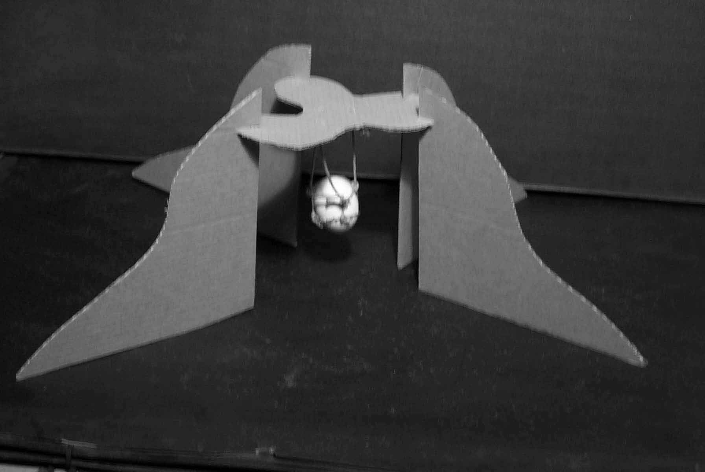
Students were divided into four groups according to their classes. The materials given to the groups were simple ones like, wood sticks, wood pieces in geometric forms, matches, plasterin, string, textured aluminum pieces, cardboard, colored pieces of paper, pasta, egg, craft paper, synthetic wires, synthetic fiber board, synthetic pipe covered with folio.
An explanation was made to experiment groups about the experiment subject before the distribution of the materials. A pre-explanation were performed with a slide show about creativity, how it is formed in thinking process, how does knowledge and perceptions can effect the creative thinking and how does it feed the allusions of the thinking system .
After such an explanation, in the study in which everyone was asked to work individually, 2 hours were given for each question and at the end, three creative design applications were maintained. In addition to this, they have been asked to determine ten concepts about each application. The materials and design subjects given to first and the third year students were the same and similarly they were the same for the second and fourth year students.
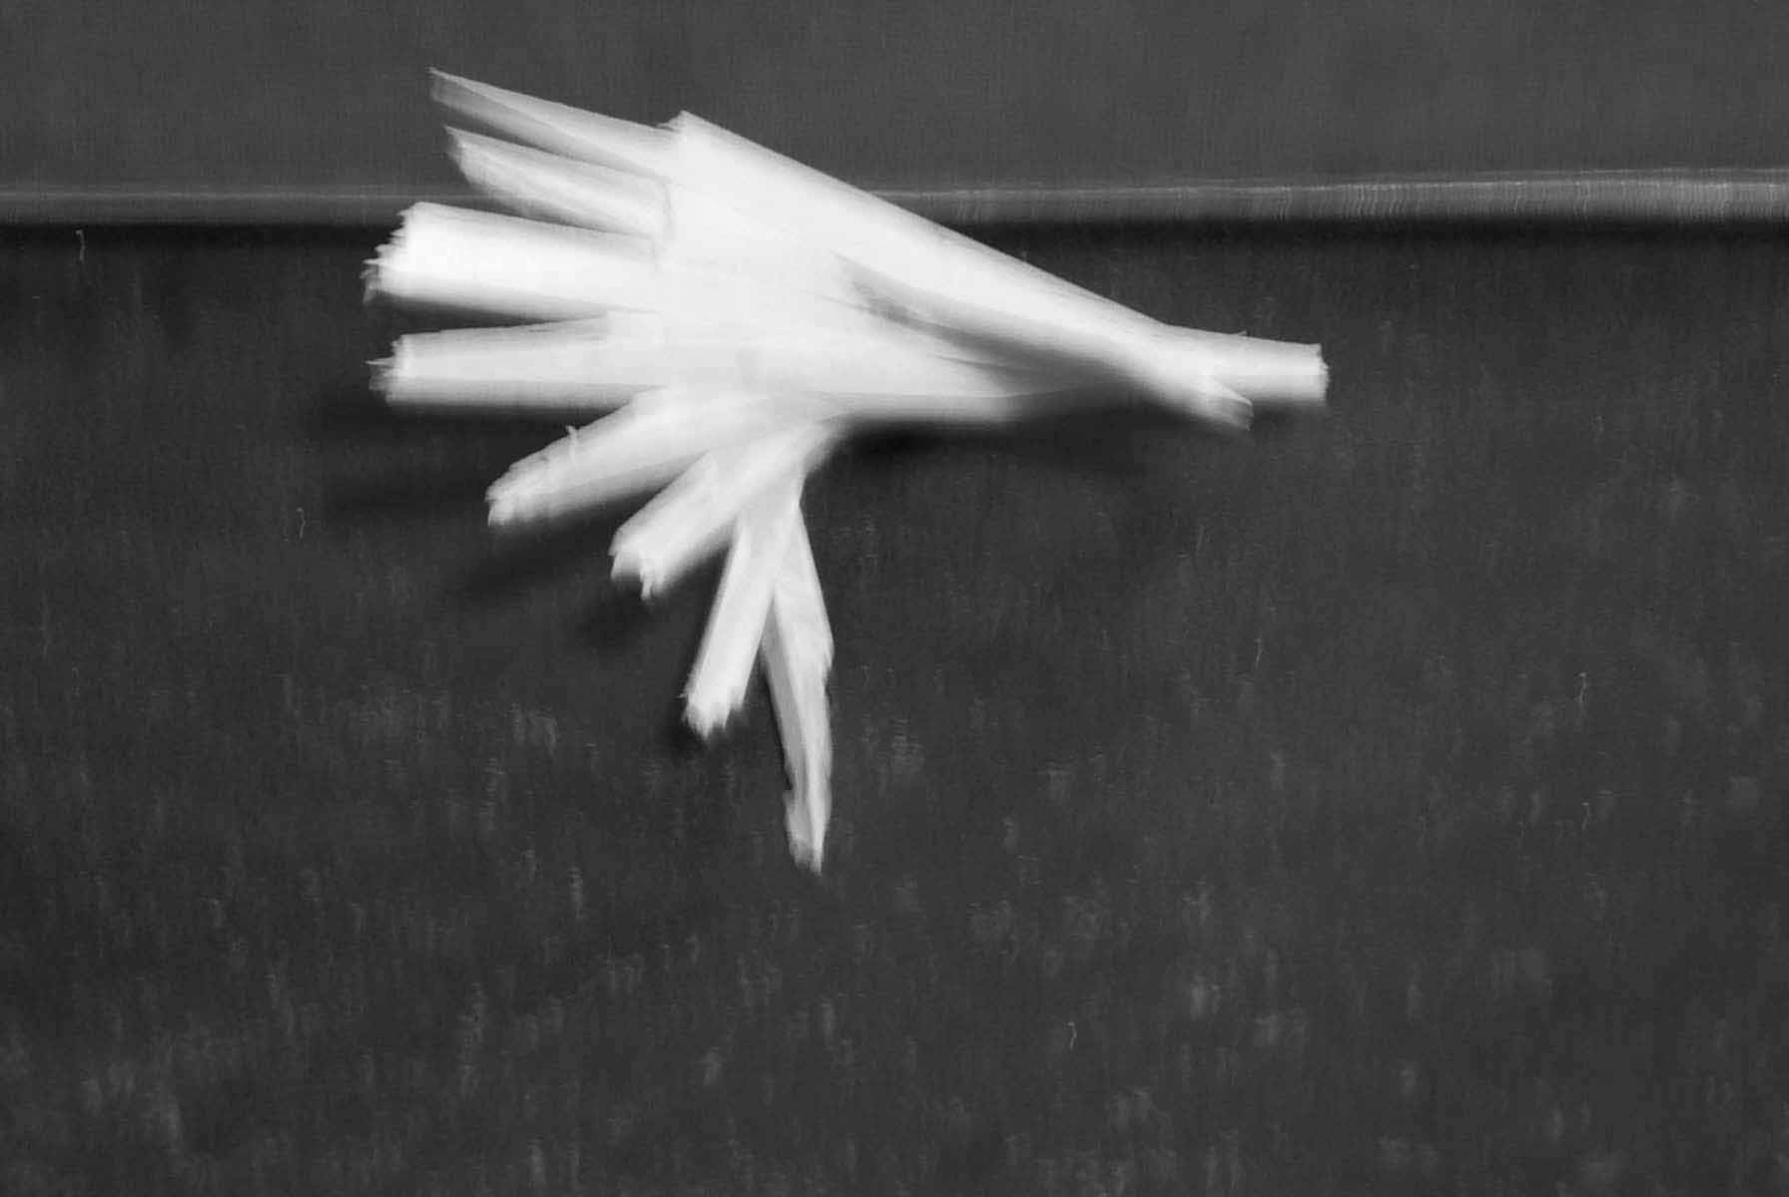
It was not possible for students to watch or to look at each other because the experiment took place in different parts of a long studio, and in a short amount of time.
Evaluation of the Experimental Creativity Study
Criterias on the evaluation of the studies were,
- Students’ general level,
- The concepts they chose,
- The structural appropriateness in terms of basic structure concepts such as weight, force and balance,
- Harmony with the material,
- Appropriateness to the structure of esthetical rules: balance, rhythm, proportion,
- Structural construction
- Reflection of creativity on the design,
- Its ability to combine knowledge and creativity.
Evaluation of the First Year Students
First year students had worked on three different design questions with the designs made of given materials such as wood sticks, wood pieces, matches, plasterin, cardboard, an egg, strings and wires, craft paper, synthetic wires, synthetic fiber board and pieces of aluminum. In addition to that, 10% students had interpreted the part ”a” of the first question, which was asked also to others, as the preparation phase of the “b” part. %90 of them had done according to the concepts.
Hundreds of concepts were emerged like, “difference, ordinariness, contrast, elevation, excitement, chaos, unity, life, balance, sharpness, emptiness, solidarity, helplessness, summit, permeable, crater, danger, etc. Like all the other students, the first year students determined in 10 concepts for each of three questions and produced designs evaluating these designs. 90% of the student designs were in harmony with the concepts.
Figure-1 A Sample of First Year Students’ Design
When the structural construction of the material was in question, the proportion of encouragement of the light structured buildings was low. When it was asked to carry the egg 15 cm above the ground, cardboards were usually folded in various sides in order to produce structural constructions. Because of the lack of knowledge of structure, determination of maintaining security was stressed.
Figure-2 A Sample of First Year Students’ Design
Apart from this, conclusions of the study which were produced with little knowledge and which could be attained only through the textures of the material were in lack of creative, flexible sensitivity.
Evaluation of the Second Year Students
The common materials that the second and fourth grade students used were pasta, strings, cardboard, wires, colorful pieces of paper, synthetic strings, wood sticks and a synthetic pipe covered with folio. In the second year, %85 of all the three questions were done. The 15% was in excess because some of the students combined the “a” and “b” part of the question.
Again, designs were prepared in accordance with the ten concepts chosen for each question such as, “expectation, privacy, curiosity, symmetry, rhythm, eternity, courage, solidarity, dialectics, balance, focusing, explosion, beginning-end, firmness, energy, multiplication, emptiness, trustworthiness, horizontal-vertical, music, motion, protection, shield, fullness, unity, contrast, space, transformation, asymmetry, axe, fluidity, pass through”.
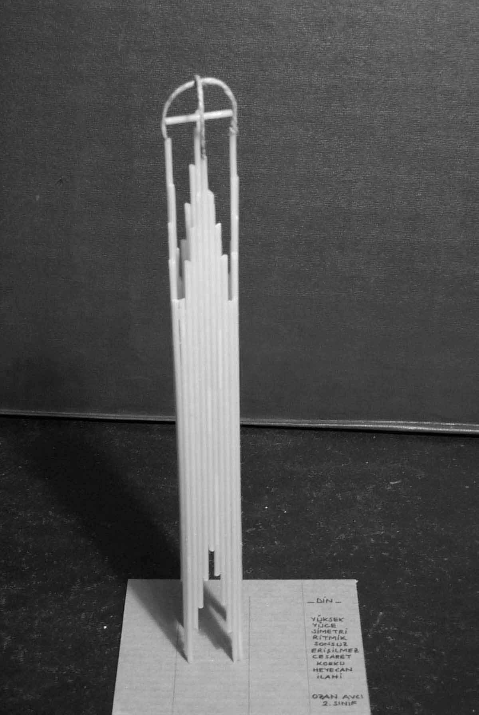
Figure-3 A Sample of Second Year Students’ Design
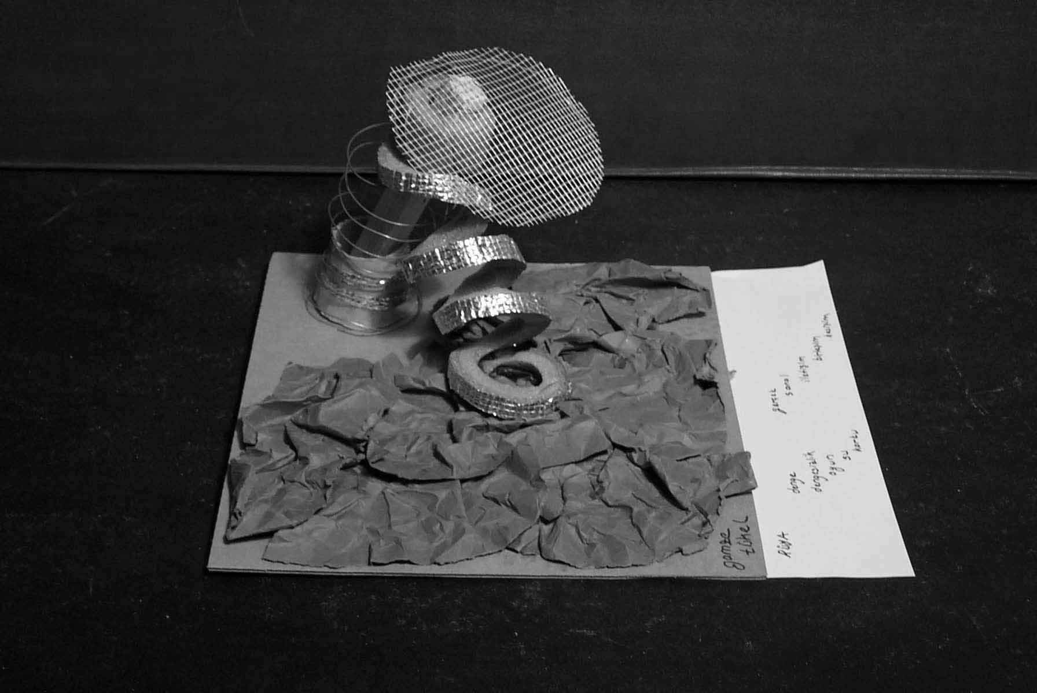
Although their concepts of solutions were in harmony with their designs, it was realized that second year students were able to evaluate their creativity in terms of establishing links between the problems by 50 %.
Figure-4 A Sample of Second Year Students’ Design
88% of them preferred to use color. In the concepts they chose, a kind of order was realized which was emerged from the their own knowledge of rhythm, symmetry, balance, energy, fullness, contrast, etc. In 87% of the designs, the consciousness about space, order and geometrical knowledge was observed. 13% of the students designed really complex designs.
Evaluation of the Third Year Students
The participation of this group was very low. Only 13 of the invited students had participated to the workshop. Yet, designs produced were sufficient to demonstrate the improvement of creativity between the classes.
The questions and the materials given were the same with the first year students. In those designs the concepts were different than the previous ones. They were cooler and more “frozen” such as “elevation, sign, direction, bayonet, fewness, grief, shadow, motion, nothingness, umbrella, system, logo, linkage, guitar, chaos, frontier, tying, inner, hardness, continuity, division, differentiation, individual life, section-whole, geometry, messy, complex, ugly, ordinary, artificial, permeable, bird nest, labyrinth, hard work, craziness, shadow, lost, time, speed, illogical, cry”.
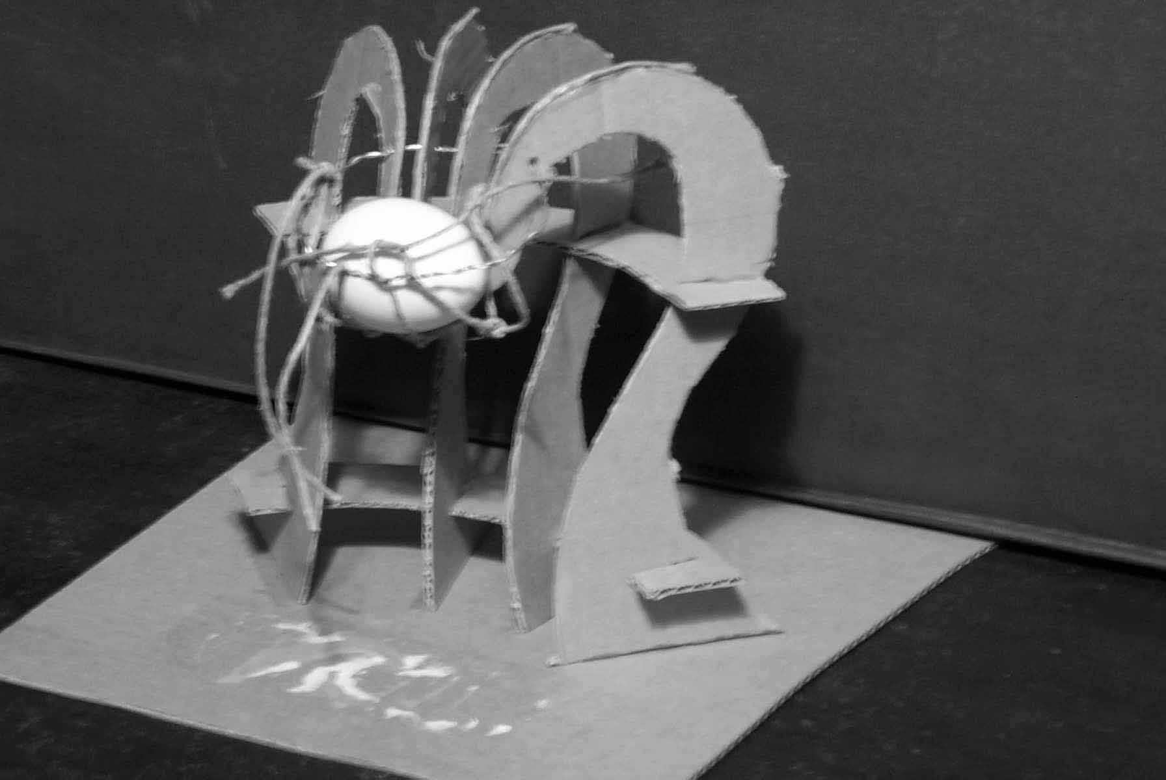
Figure-5 A Sample of Third Year Students’ Design
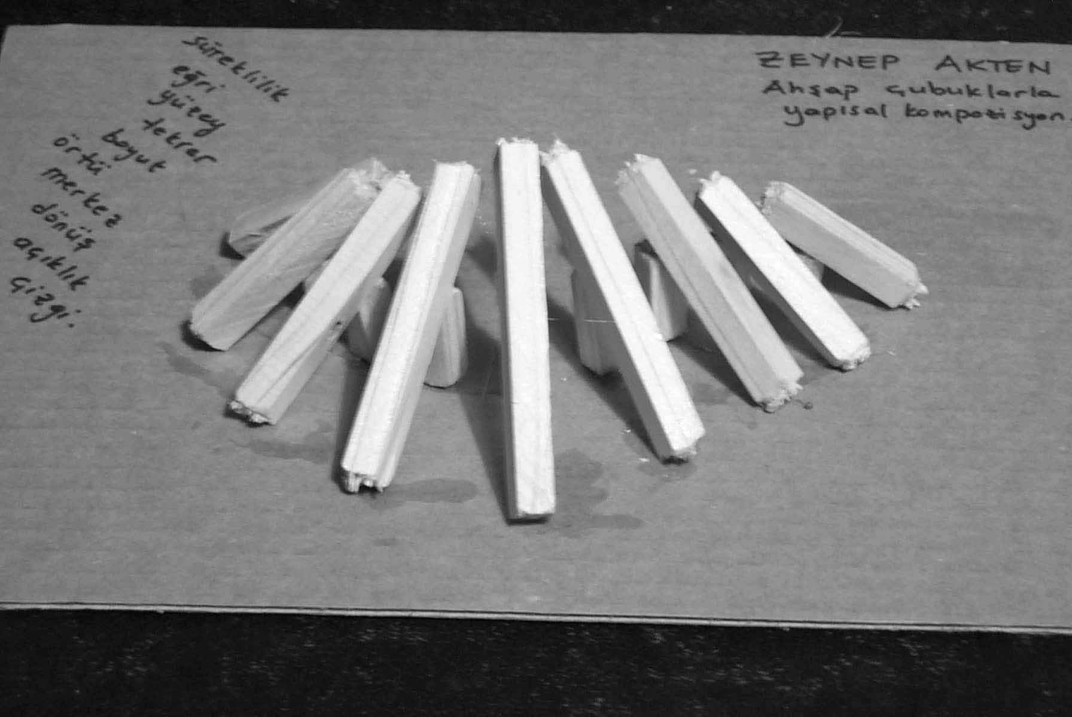
Figure-6 A Sample of Third Year Students’ Design
Designs were, again in harmony with the concepts. Throughout the concepts of the third year students, it was realized that the positive concepts were quite a few. Designs were observed to be created directly by analogies by using meaningless and negative concepts by 50%.
In the second question, 18% of the students hadn’t completed their tasks and in the last questions, they changed their materials and started to use other groups’ materials.
Evaluation of the Forth Year Students
Participation rate of the fourth grade students was high like the first year students. The materials given were the same as the second year students. 50% of them had not differentiated between the “a” and “b” part of the question and answered both of them with the same design.
The concepts they used were extremely structural and esthetical concepts like “emptiness-fullness, tearing, rhythm, balance, order, wave, knot, holding, valve, to approach, to go away, support, emptiness, folding, stretched, to direct, to stretch, horizontal, vertical, underground, above the ground, open-closed, spatialization, back bone, trust, arcade, bump, direct, triangle, energy, sails, roads, to hold, dreaming about thinking, willing to think, orthogonal, superposition, coordinate”. The high participation rate showed that the students were aware of their design consciousness and they were willing to learn more. They preferred to use these materials to organize concepts like rhythm, balance, and proportion.
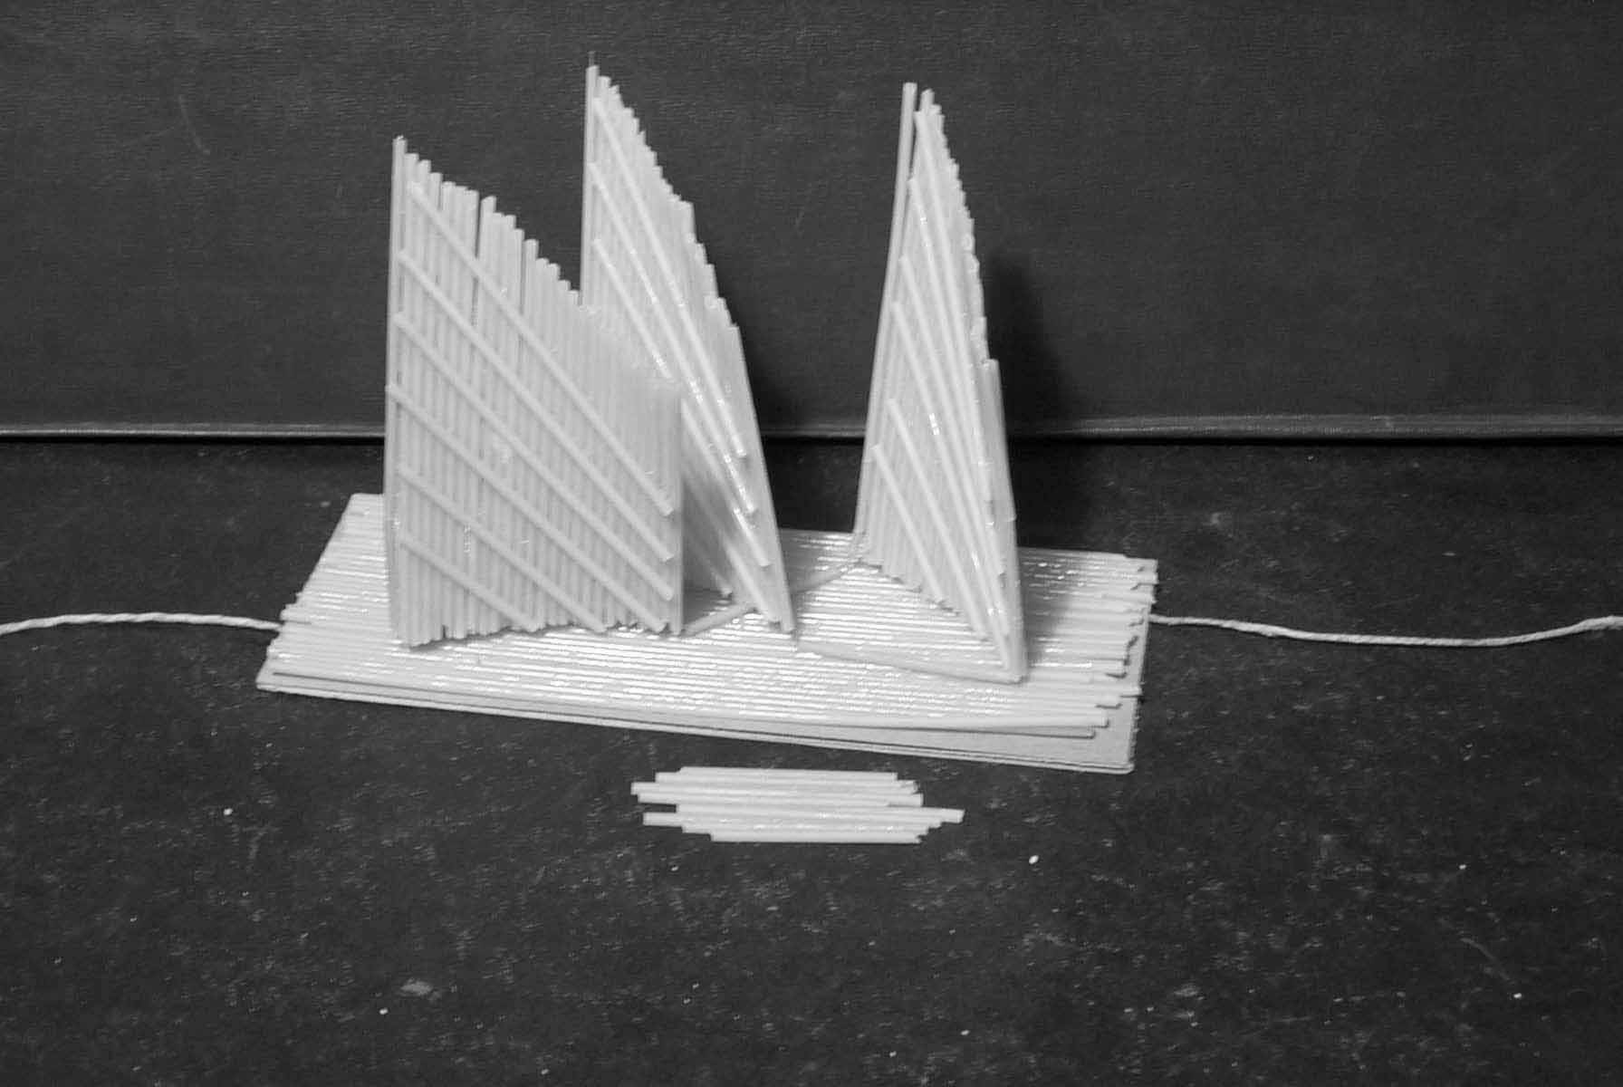
Figure-7 A Sample of First Year Students’ Design
55% of this group worked neatly and completed their designs. Apart from them, 65% of the students managed their designs mainly with knowledge-base concepts.
Figure-8 A Sample of First Year Students’ Design
Fourth year students were more inclined to use the material more freely. Shiny, cylindrical isolation material was commonly used both by the fourth and the second year students. 79% of the fourth year students specifically used this material.
General evaluation
This experimental study about the need of creativity education in the programs of all the years cannot be expected to give 100% true conclusions. To provide more accurate conclusions this experiment is needed to be repeated over and over for some years. Additionally, the backgrounds of each student, their capabilities, and way of living and growing up will also affect the research.
However, many students had participated to a weekend workshop without any obligations. Although they were not over a hundred people, the enthusiasm of the curious students who were aware of the importance and the meaning of design constituted a firm base for this evaluation.
The high participation rate of the first year students was because of curiosity whereas the fourth years’ was because of consciousness.
In all levels, the chosen concepts and the designs were in harmony. Some designs are differentiated according to different levels of construction, structural and esthetical knowledge.
Conclusion
We think that design courses should be given not only in the first years as a basic design education, but in all years in the context of design projects or creativity courses. These courses should be supported by structural concepts.
The structural knowledge which fourth year students observed to have, should not be constructed as partially learned knowledge in design studios. They should be thought in creativity courses from the first year until the fourth year where structural concepts and philosophical concepts will support the imagination. The imagination and thinking capacities of the students should be enriched with the design made from different materials and compositions.
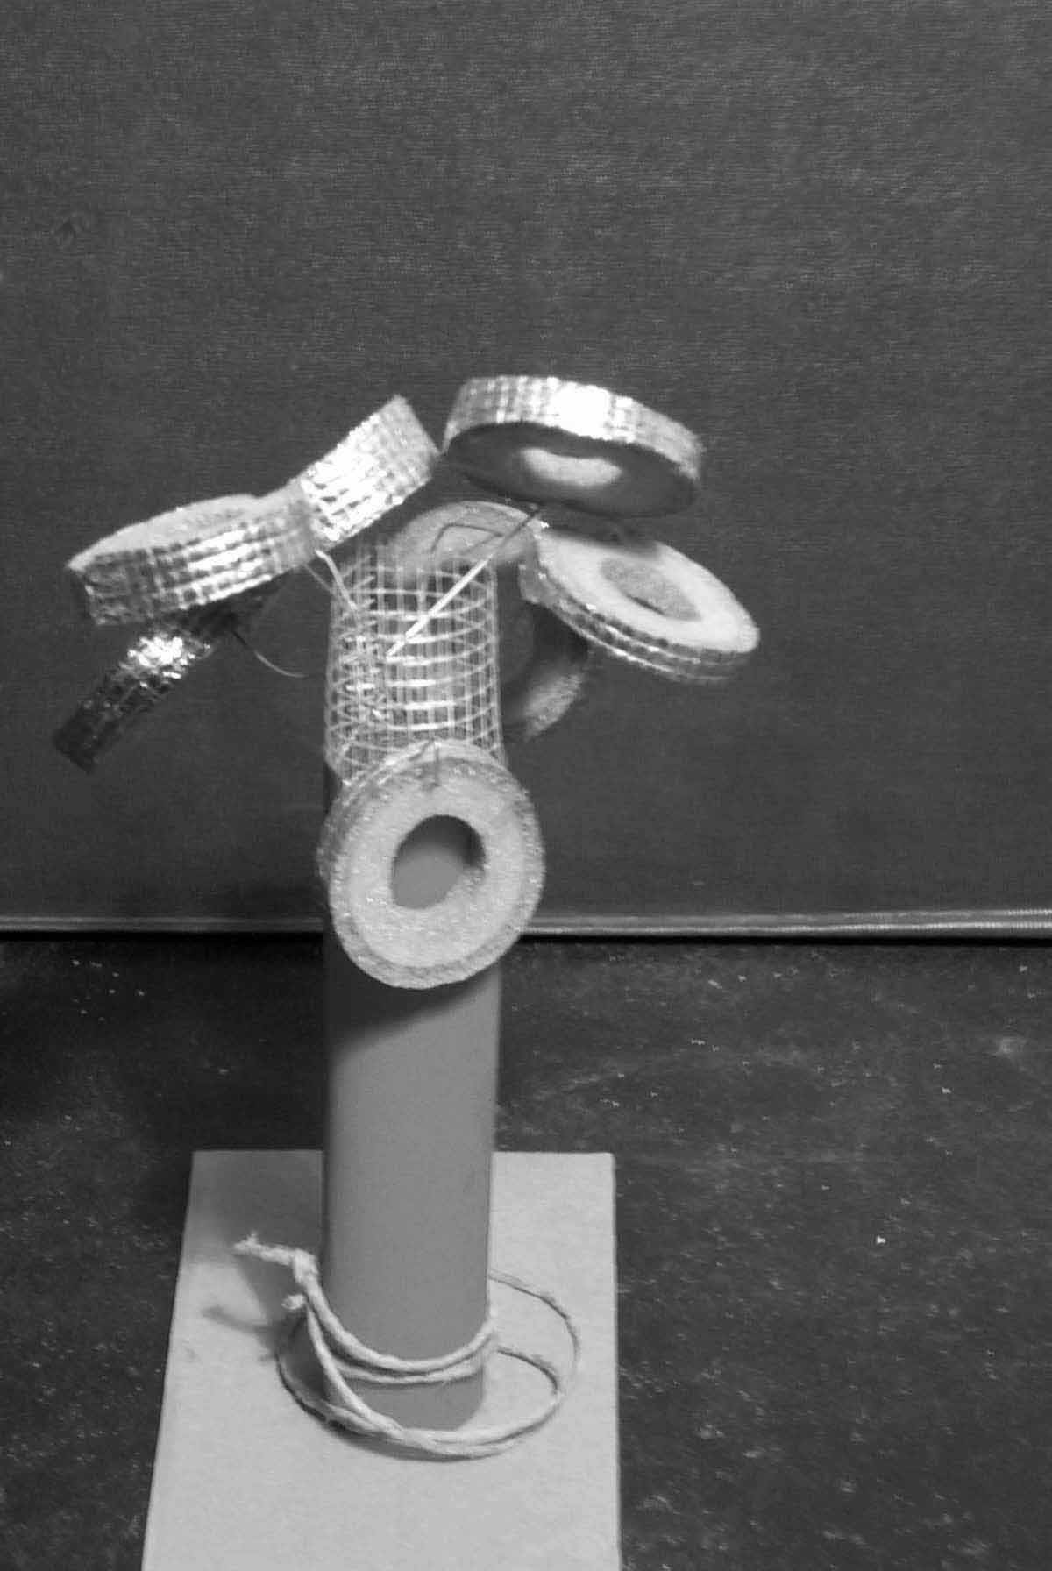
References

[1] Vries,A.D. de, Structuring Information for Design Problem Solving, Eindhaven University of Technology, Eindhoven, 1994.
[2] Feldman, D.H., “The Development of Creativity”, Handbook of Creativity, ed. Stenberg, R.J., Cambridge University Press, NY, USA, 1999, 169-186.
[3] Cooper, R., Press, M., The Design Agenda: A Guide to Successful Design Management, John Wiley & Sons Ltd., Baffins Lane Chichester, UK, 1995.

Elmira Sener, Istanbul Technical University, Faculty of Architecture, Department of Architecture, Taskisla, 80191, Istanbul, Turkey, senerel@itu.edu.tr
Secil Satir, Istanbul Technical University, Faculty of Architecture, Department of Industrial Design, Taskisla, 80191, Istanbul, Turkey, satirse@itu.edu.tr

