AN EXPERT SYSTEM OF THE ESTIMATE TECHNOLOGY FOR DISPLAY MEANS

Park, Sang-bong

Abstract ⎯ An estimate technology for standard machining time focused on the large size TV set has been studied. Generally speaking, the estimate calculating work of mould is achieved by experienced engineers. However, at most mould manufacturing enterprises, there are frequent cases that they calculate by rule of thumb because they have neither established standardization nor have determined clear estimate method. As the result, in fact, it is natural that not only much time is wasted but also absolutely draw up and submit non-consistent quotation, which leads to raise major and minor quarrels with their clients continuously. Therefore, in order to remove such a problem point, in this study, the development and application of expert system is studied for estimate calculation at the mould manufacturing process. The application of the developed system to the working site has the advantage that even beginners can create better quoting result than experts. The developed system used visual BASIC language and SQL Data Base under Windows environment.

Index Terms ⎯ Estimate technology, Expert system, Machining time, Mould base, NC data

Introduction
The mould technology has been developing pretty rapidly as well as being in good harmony with the technical renovation of the 6T. And, this trend is expected to continue at an increasing tempo, while deepening the width and depth of its application even more. The rapid economical and social transition in recent years have changed the technologies of production and cost management in manufacturing sector remarkably. In particular, the mould manufacturing sector requires innovative changes in quality, cost and delivery and, accordingly, the improvements in technical development, productivity and reliability are on the way to meet the requirements. Also, the trade volume of moulds are increasing continuously and the various restrictions on international trading are strengthening more than ever before.
The countermeasure of the mould enterprises in this circumstance, unlike what had been in the past, is to submit more rational, rapid and objective data, and only a settlement of management technology, say of one stage more advanced, will enable enterprises to survive and develop steadily in the future. However, still now most of enterprises follow neither objective nor scientific estimate method and are still facing with occurrence of frequent and indefinite claims from their clients. So they are suffering great damage in judgment of right or wrong.
In spite of an importance of the scope there has been very few relevant reported works in literature. In particular, Olsen[1] analyzed the prime cost for magnesium die casting mould in 1988, and Rosen et al.[2] studied and presented the prime tool cost for injection mould and die casting in 1992. On other hand, some large enterprises have developed their own system for mould prime cost calculation. However it usually can be applied only to some specific conditions. Clearly that the variety of real situation and need at many enterprises requires general but much more sufficient approach and development.
In order to remove such a problem, this study aims to build up an expert system in order to handle mould for display means. The built up system consists of Ini-MOULD 2002TM for initial estimate calculation.

Standard Processing Time for Mould Manufacturing

Standard Processing Time
Based on researches so far, the standard process time in mould manufacturing can be measured by the Time Study Method, Pre-determined Time Standard Method and Standard Data Method, etc. Figure 1 is showing the content of mould processing time by disintegrating its structural elements.

- Preparatory time, Setting time: It includes time for preparing clearance and spare time for preparing as necessary preparing and clearing for machine processing occurred only one time for specific manufacturing quantity (1 processing lot) of the same processed good. Much time for thinking how to work is included in the preparing work. Generally speaking, we don't separate time for clearing from the time to spare in considering the preparation time. From the mould processing stage to the stage of finishing preparation requires some time for test processing.
- Cycle time: The time necessary for mould processing for a unit of processed good includes the real repeat time (the real processing time and the real supply demand time) and the time to spare.
- Net cycle time: The repeat clearing time includes the machine time (real processing time) of automatic transfer and manual transfer, and the supply demand time (real supply demand time) accompanied to the mould processing. The necessary clearing time for cutting after the machine is operated includes the time for removing cutting chips or the time for air cut, when the cutting chips are not discharged due to approach to tools and over run. In the case of the NC machine, it is the length of time for tools to approach the processed goods from the machine origin to return the original location after finishing the necessary cutting.
- Net handling time: As doing mould processing for a unit of the processed good, it's the worker's working hour, such as installation and removal of the processed goods, maneuvering of machines and measuring of the processed goods, occurred incidentally.
- Automatic feeding time: It's the real processing time in the case that the mould processing is implemented through automatic transfer or numerical control.
- Allowance time: As a factor occurred irregularly during the repeated work, it's the length of time considered as time to spare since the insert is difficult during the real repeat time. The allowance time is calculated by multiplying the values required man hourly and materially in the type of percentage by the real time. The spare man hour means the fatigue spare to compensate the damage appeared due to the fatigue during work, and the physiological spare, such as going to the lavatory and drinking water, etc. The material margin means the so-called work margin, such as the irregular and various time to spare occurred materially from machines, tools and materials, etc.

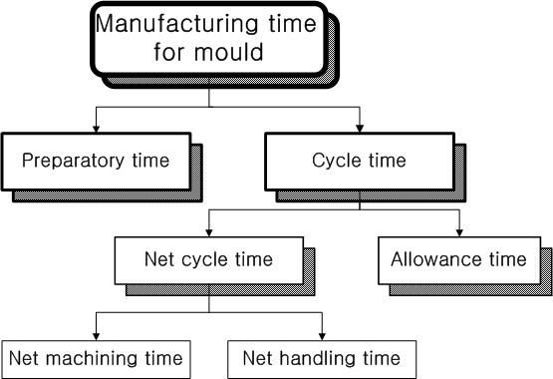

Figure. 1
Classifications of manufacturing time for mould.

There is a work place margin to compensate the time to spare occurred due to the managerial irrationality during work. It is not related with mould processing, and divided by the non-processing time.

Consideration of the Mould for Display Means
In the case of TV products, we are going to examine in this study, are moulds composed of big mould base, having 1 cavity. The mould base can not use the standard type. A TV mould part can be largely divided by two parts, front and back. We are going to research on the front and the back. 

Figure. 2
Front Part of TV Product.

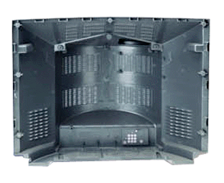

Figure. 3
Back Part of TV Product.

Figure 2 shows the front part. The front is characterized by the precise small electrical discharge machining to accommodate speaker holes in the front side and the installation of the bottom side core for installing a control knob in the bottom side.

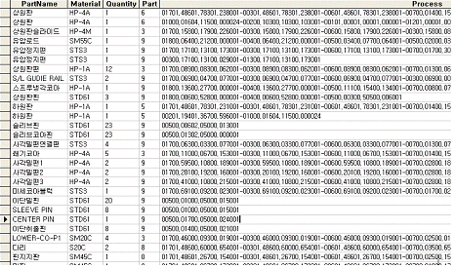
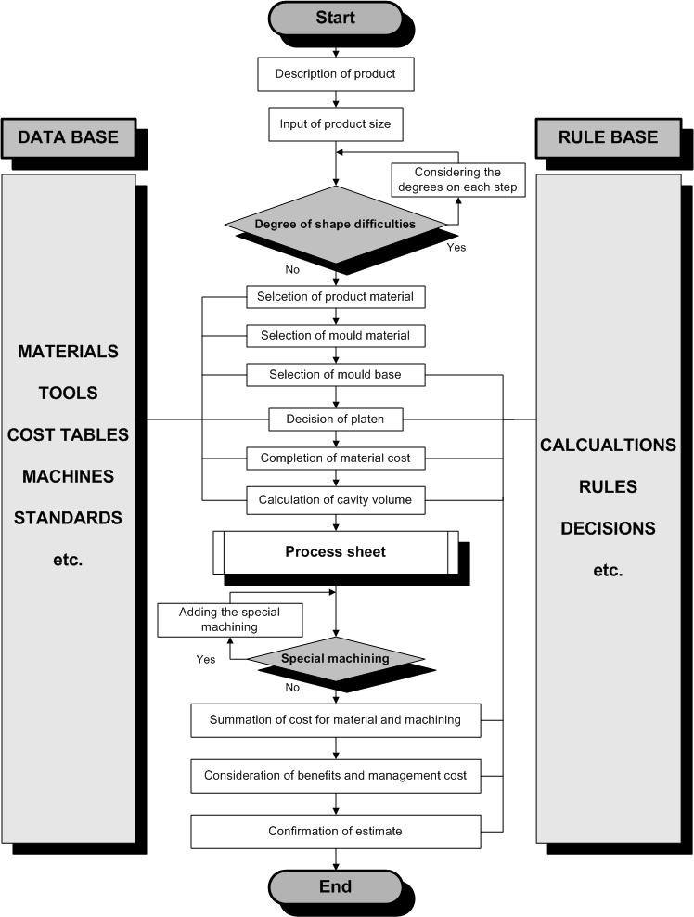

Figure. 4
Main Structure of System.

Figure 3 shows the back components. The pivotal point is to calculate the processing time for machining a lot of holes for air vent on the back side and for the milling machining to make deep cavities. Also, a lot of electrical discharge machining is required to form the bosses and the ribs. The calculating technology for the standard processing time of mould manufacturing is needed by both sides of placing and receiving orders at the same time. The order placing side can utilize it for suggesting standards and the order receiving side can utilize the system for producing quotations, considering the company's working load. The suggested amount can be modified through verification and coordination, and the final quotation can be decided objectively.

Figure. 5
Process Sheet.

Figure 4 shows the organization of the developed system. The input data for the system includes the general specification, size, materials and mould base type, etc. The material cost and processing cost are calculated based on those things. The mould base can be selected by deciding the weight of mould base and the size of the stationary and movable platen. The decision on the cost for hot runner and other mould factors is made in this stage. The processing cost is divided by the general processing cost and the special processing cost. The general processing cost means the cost for each process, from design to test, required to make a mould. We have established a system to calculate the processing time for the pertinent processing factor by inputting specific processing parts and shapes for the contents that are included in special processing cost like polishing, carving, core machining, corrosion and electrical discharge machining, etc.
The output unit calculate the mould manufacturing cost considering profits and general expenditures, and the processing cost, standard manhour rate and standard processing time for each process are printed on specific forms. The system is designed to store the results into the database for future reference in preparing quotations for the similar products and for the records management.

Process Sheet
The previous study[3] calculates all factors of moulds by repeating the degree of shape difficulty, and then the standard processing time for special processing is calculated by considering the necessity of special processing. In this case, we were able to get the adequate result if the mould is based on the standard mould base or the mould assembled by the standard mould factors.
This study is characterized by the non-standardized mould base and the non-standardized mould components, different from the previous study. We have introduced the concept of process sheet to calculate the processing time and cost. Figure 5 shows an example of the newly added process sheet. It has the information on the part’s names, materials, quantities, heat treatment status and detailed process. The processing time for each mould component is calculated, based on the systematic information.
Application and Examination

We have reviewed the system established through this study. Figure 6 shows main screen of the system. The system is designed to input the general information about the TV products to be completed at the left hand side of the screen and to input the detailed information, such as mould structure, machining range, materials and machine conditions, etc. at the center. And the right hand side shows the general output of the system.
Figure 7 shows an example of the information input for the degree of shape difficulty of the product. The degree of mould manufacturing difficulty is decided by the quantity of boss, rib, shape of the parting line, tolerance of the assembled parts and the quantity of ejecting pin, etc. and it affects the processing time a lot. In particular, we established the system to reflect the free curved surface because the degree is related with the increase and decrease of the NC machining time. Considering the 10 kind of items, total shape difficulty is decided . In this cace, it is calculated as 1.64. This value is used as a factor to confrm the machining time on each process.
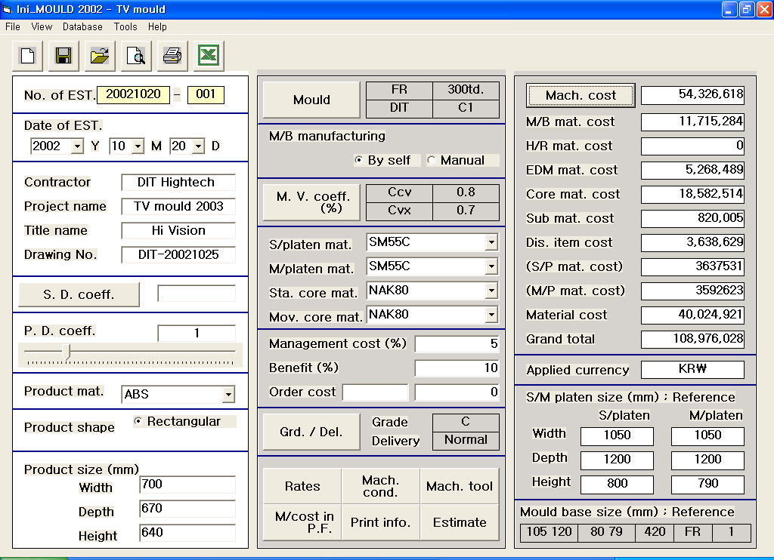
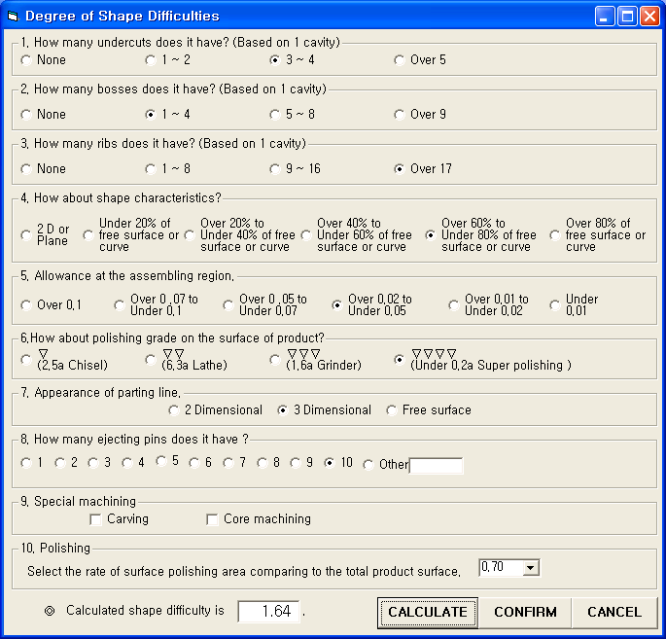

Figure. 7
Degree of Shape Difficulty.

Figure. 6
Main Screen of System.

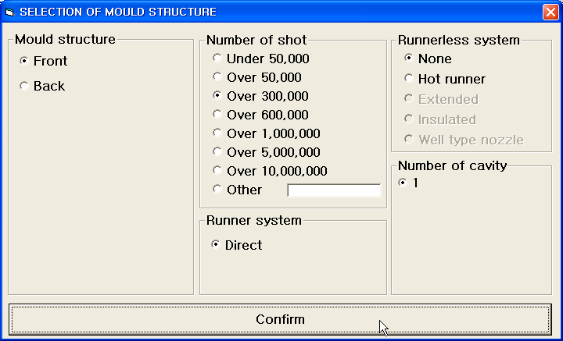

Figure. 8
Mould Structure.

Figure 8 shows the cavity quantity of mould and production quantity and the application status of hot runner. When calculating the standard processing time, we need to consider the heat treatment status, condition of the process and the status of the processing machines, as well as materials to be cut, shape and materials of tools, precisely. The cutting condition is divided by the case of four processes of Roughing, Semi-roughing, Semi-finishing and Finishing, and the case of three processes of Roughing, Semi-roughing and Finishing. When it comes to the methods of cutting, it's appropriate to consider both cases of the traditional NC machining and the high speed machining at the same time. The conditions of these processes can be selected in Figure 9.

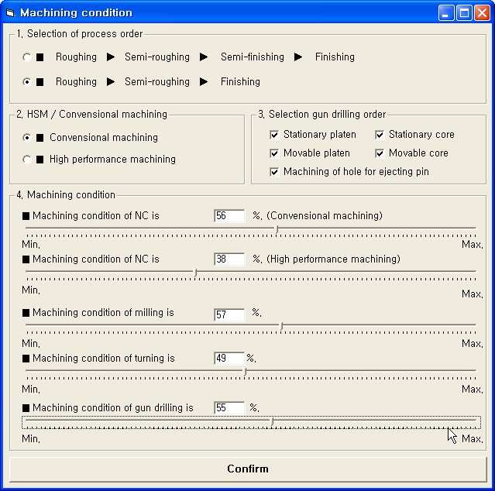

Figure. 9
Machining Condition.
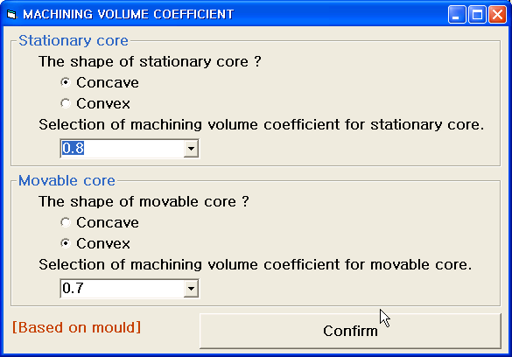

Figure. 10
Machining Volume Coefficient.

Figure 10 shows how to decide the cutting volume to make cavity and core that can be said the most important factors of moulding. The processing cost of each manufacturing process can be calculated by applying the standard manhour rate after the standard processing time is decided. The standard manhour rate here means the various costs per each time required to perform the unit processing. [4]
Figure 11 shows the function to select the standard manhour rate from the database . The system has been established to manage database by adding or deleting manhour rate in accordance with the ability of mould manufacturers and to select the pertinent manhour rate required.

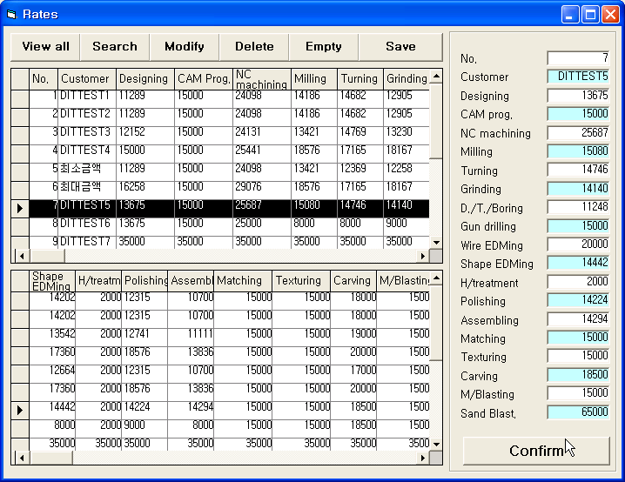

Figure. 11
Standard Manhours Rates.

Figure 12 shows the result of the standard processing time required to make the mould for TV components, implemented in this study. And Figure 13 is the result of the back part. The standard processing time was calculated by unit processing for each mould manufacturing process from designing, CAM programming to texturing. As for the total processing time, the front was 3,435.8 hours and the back was 3,710 hours. The mould processing time of back part took 7.4 percent time than that of the front part.

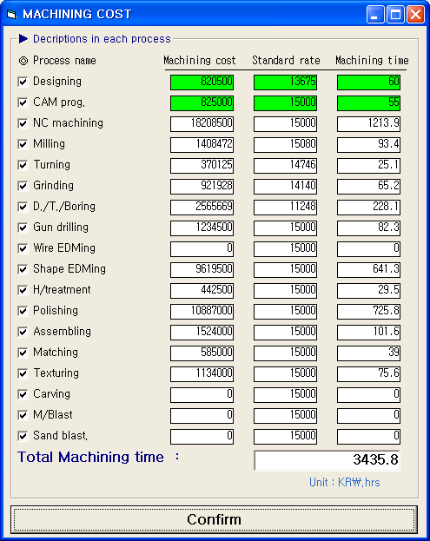

Figure. 12
Result of Front Part.

We were able to calculate the standard processing time required for each mould processing on the front and the back through this study, and compare and analyze the processing characteristics in the two types of mould manufacturing.
When it comes to the degree of difficulty in mould manufacturing, the total cavity volume of the front part is smaller than that of the back since it requires small and precise partial cores forming knob. However, the percentage of electrical discharge machining of the front part is higher than that of the back part. On the other hand, the back part has deep cavity and larger cutting volume. Figure 14 shows the comparison between the two moulds. Altogether, the high percentage processes out of the total 14 unit processes are NC machining, polishing, electrical discharge machining and drill/tap/boring process. The NC machining of back part requires 20.6 percent more time; 1,530 hours vs. 1,213.9 hours. It's probably because the back part has bigger cutting volume than that of the front.

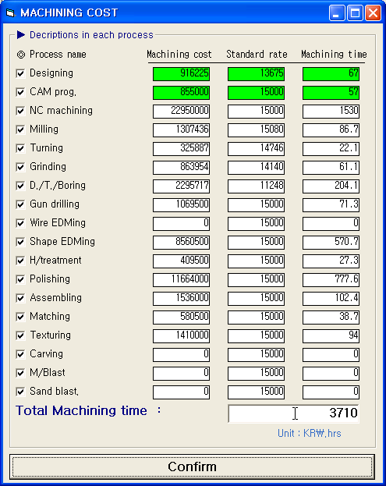

Figure. 13
Results of Back Part.

The polishing is very important process, determining the final quality of a mould[5]. It requires the process time in proportion to the size of the polishing area. The back part has wider external polishing surface than that of the front. Though the polishing area of the pront external surface has small portion comparing to the back part, it has a lot of partial cores which requires to polish. There are 6.6 percent machining time difference between the front (725.8 hours) and the back (777.6 hours).
In the case of the back part with electrical discharge machining, it will take a lot of time to make holes for air vent. On the other hand, the front part requires elecro-discharge machining to make small grooves or holes of partial cores or side cores. There are 11 percent machining time difference between the front (641.3 hours) and the back (570.7 hours).
So far, we have confirmed that the developed system through application and examination can be applied to the actual work. The continuous study on the standard manhour rate and the accumulation of data regarding the process time can be a good way to enhance the reliability[6]. Also, it can be a good means to strengthen competitiveness following the profits increase, as well as improving productivity through the rationalization of quoting at the industrial site if we supplement database through various process experiments on materials and tools, and through the verification with theoretical calculation.

Conclusion
We have researched on the standard process time calculation of manufacturing moulds for TV products. The developed system through this study can be a good method to enhance the domestic and international competitiveness with cost reduction and productivity improvement at mould factories. The following is a summary;

1) We have developed standard process hour calculation technologies on each work process at the stage prior to mould design on various TV moulds with different shapes and sizes.
2) A scientific and logic based reliable standard process hour expert system has been completed, and it turned out that the result of the system had the similar trend with the on-site actual data.
3) Even a beginner can reduce cost by calculating the high level standard process hour, and cope with any manpower shift.
4) A quick action can be taken in calculating mould quotation by utilizing the database when calculating similar mould standard hour.
5) The result calculated by the system can perform rational process management if it is used as a planned man-hour, man-day for mould manufacturing.
6) We were able to reflect major factors in the work process as much as possible by introducing the concept of process sheet. Accordingly, we have established the foundation to apply it to the standard process hour for other injection products.

This study requires continuous comparison between the planned standard hours and the actual standard hours by applying it to the mould manufacturing process and the establishment of database while reflecting the characteristics of actual mould manufacturing process, as well.

Acknowledgment

This work is fully supported by the Ministry of Commerce, Industry and Energy in Korea (Nov. 1997 - Oct. 2002). Their supports are greatly acknowledged.

Figure. 14
Comparison between Front and Back.

References

- L. Olsen, "Cost Analysis of Magnesium Die Castings", Society of Automotive Engineers, Report 880513, 1988, p.1∼6.
- D. W. Rosen, J. R. Dixon, C. Poli and X. Dong, "Features and Algorithms for Tooling Cost Evaluation in Injection Moulding and Die Casting", Computer in Engineering, Vol. 1, ASME, 1992, p.45∼52.
- Park Sang-bong” Application of Initial Estimate Expert System Focused on Special Type Mould Structure", Proceedings of the 12th Intl. Conference on Flexible Automation and Intelligent Manufacturing, Dresden, Germany, 2002, pp. 64∼74.
- Sirotani Junichi: “The calculating method of machining time”, Nikankokyosinbunsha, p.245, 1989.
- S. F. Krar, M. Rapisarda, A. F. Check, "Machine Tool Manufacturing Technology", Delmar Publishers, 1996, p.691.
- M. McKelvy, "VISUAL BASIC 5", SYSBEX Inc., 1998, p.715.

Park, Sang-bong, Dongeui Institute of Technology, San 72 Yangjung-dong, Busanjin-gu, Busan, 614-715, Korea, psb@dit.ac.kr

