LEARNING STYLE IN THE CLASSROOM:
A RESEARCH-GUIDED APPROACH

Teresa L. Larkin

Abstract — This paper will explore relevant research which documents that a learning style approach in the classroom can lead to enhanced learning gains. Particular emphasis will be placed on the Dunn and Dunn Learning Style Model. The basic tenets of this learning style model will be highlighted. The Dunn and Dunn model forms the basis of the Productivity Environmental Survey (PEPS) which is a valid and reliable learning style instrument. The PEPS is currently being used as a research tool within the introductory physics course for non-majors at American University. Two teaching approaches which have been developed based on a learning style approach will be shared. These approaches include the use of writing as well as interactive on-line discussions using Blackboard technologies. Ideas for effective adaptation of these approaches by educators in other branches of science, as well as mathematics, engineering, and technology (SMET) education will be discussed.

Index terms — Learning style, writing, assessment, student learning, on-line discussions.

Introduction

The rapid changes that are continuing to occur in modern society, and in academia in particular, suggest that learning must be a continuous process. A growing body of research on adult learners suggests that increased learning gains can be achieved when instruction is designed with students’ learning styles in mind [1]-[6]. In addition, several practitioners within the domain of physics as well as engineering education have noted the importance of teaching with learning styles in mind [7]-[14]. Attention to learning styles and learner diversity in the classroom has also been shown to increase student interest and motivation to learn. Increasing student interest and motivation to learn may lead to enhanced learning.
The particular population of students that encompasses the focus of this paper is non-science majors taking introductory physics at American University. Most students take this introductory physics course to satisfy the university’s General Education Natural Sciences requirements for graduation. Because the backgrounds and ability levels of the group of students that elect to enroll in this course is quite broad-based and diverse, it is anticipated that the teaching and learning strategies to be described in this paper can be adapted for use with other populations of students as well. The underlying message is quite simple - a learning style approach CAN be successfully applied with ANY population of students.
This paper addresses the critical role that a learning style approach can play in terms of teaching introductory physics. A detailed overview of the learning style model used by the author will be provided. In addition, two specific teaching and learning strategies developed, in part, from current research on learning styles will be highlighted. These strategies involve extensive use of writing as a teaching and learning tool as well as the use of live, online chats using Blackboard technologies. Student perceptions regarding these strategies will also be shared. It is anticipated that these teaching and learning strategies can be adapted for use within the international community of science and engineering educators.

Description of Student Population

The introductory course for non-science majors at American University in Washington, D.C. is entitled Physics for the Modern World (PMW). PMW is a large enrollment, one-semester, algebra-based course. Topics covered in PMW typically include kinematics, Newton’s Laws, conservation of momentum and energy, rotational motion, fluid mechanics, waves, and sound. Although traditional in its content, the course is not taught in a traditional lecture format. Many traditional teaching methodologies have clearly been shown to put students in the role of passive rather than active learning [15]. Numerous teaching strategies are used which correspond to the accommodation of students’ needs and diverse learning styles [16]. The use of a variety of teaching strategies is very desirable, especially in a large enrollment course. In addition, the course includes strong conceptual and problem solving components.
PMW is a 3-credit course and consists of a lecture and a laboratory component. Students meet twice a week for class sessions that are 75 minutes long. On alternate weeks students meet for a two hour laboratory. Approximately 120 students, with 60 students in each of two sections, enroll in the course each semester. Of this enrollment, roughly 20% of the class is made up of international students.
Attention to learning style and learner diversity begins on the first day of class and continues throughout the semester. Students are given a learning style assessment on the first day of class. The assessment is completed by the students and returned for analysis during the next class period. The analysis process takes approximately one week at which time students are given an individualized learning style profile for their use. Students are also asked to write about their individual learning style preferences for their first writing assignment. Before a more detailed discussion of the specific teaching and learning strategies that utilize a learning style approach can be outlined, a description of learning style and the learning style model that is used in PMW will be presented.

Learning Style Described and Defined

What exactly is a learning style? Several definitions of learning style currently exist. Keefe [17] defined learning style as being characteristic of the cognitive, affective, and physiological behaviors that serve as relatively stable indicators of how learners perceive, interact with, and respond to the learning environment. Learning style is a gestalt of combining internal and external operations derived from the individual’s neurobiology, personality, and development which are reflected in learner behavior. Learning style also represents both inherited characteristics and environmental influences.
Dunn [18] described learning style as “... the way each learner begins to concentrate, process, and retain new and difficult information” (p. 224). She noted that this interaction occurs differently for everyone. Dunn also highlighted that “To identify and assess a person’s learning style it is important to examine each individual’s multidimensional characteristics in order to determine what will most likely trigger each student’s concentration, maintain it, respond to his or her natural processing style, and cause long-term memory” (p. 224). The assessment of individual student learning styles provides both the student and the instructor with valuable information regarding factors that influence learning.
Dunn [19] has suggested that the uniqueness of individual learning styles could be thought of as a fingerprint. She said “Everyone has a learning style, but each person’s is different - like our fingerprints which come from each person’s five fingers and look similar in many ways” (p. 27). Interestingly, Sternburg [20] indicated that an individual’s learning style can be compared to her/his ability and is therefore not etched in stone at birth. In fact, a person’s learning style can change over time as a result of maturation [21]. Kolb [22] has suggested that “As a result of our hereditary equipment, most people develop learning styles that emphasize some learning abilities over others.” (pp. 76 – 77).
Dunn contended that strong preferences can change only over a period of many years and that preferences tend to be overcome only by high levels of personal motivation. She further asserted that teachers cannot identify students’ styles without the use of appropriate instruments. Assessing an individual’s unique style is vital to the teaching/learning process. A significant number of research studies have shown that students instructed in a classroom environment where individual learning differences are acknowledged and accepted are more receptive and eager to learn new and difficult information [23 – 28]. Dunn also suggested that a match between a student’s style and a teacher’s style will lead to improved student attitudes and higher academic achievement. A description of the Dunn and Dunn learning style model employed with students enrolled in PMW is given in the next section.

Description of the Dunn and Dunn
Learning Style Model

Many different learning style assessment models and instruments are available. De Bello [29] indicated some models are multidimensional, encompassing cognitive, affective, and psychological characteristics, and others are limited to a single variable, most frequently from the cognitive or psychological domain. This section will focus on the learning style model developed by Dunn and Dunn [30] as shown in Figure 1 and the associated learning style assessment instrument developed by Price, Dunn, and Dunn [31].

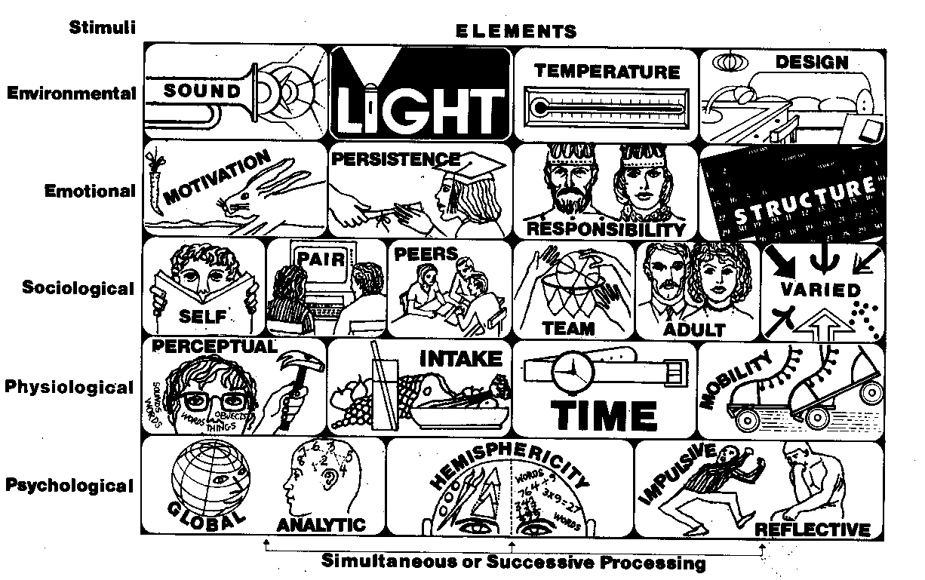

FIGURE 1.
The Dunn and Dunn Learning Style Model

Price, Dunn, and Dunn suggested that productivity style theorizes that each individual has a biological and developmental set of learning characteristics that are unique. They further suggested that improvements in productivity and learning will come when instruction is provided in a manner that capitalizes on an individual’s learning strengths. Attention to learning styles does not mean that a student should only be taught through their strengths, however. The utilization of a variety of teaching strategies helps to ensure that students have an opportunity, at least a portion of the time, to learn new and difficult information through their strongest preferences while simultaneously allowing them an opportunity to build up and enhance their weaker preferences.
As a model, Price, et al. indicated that productivity style embraces several general principles that they state in the form of philosophical assumptions:
1) Most individuals are capable of learning.
2) The learning conditions in which different individuals learn best vary extensively.
3) Individual learning preferences exist and can be measured reliably.
4) Most students are self-motivated to learn when they have the option of using their learning style preferences and experience success.
5) Most teachers can learn to use individual learning styles as a basis for instruction.
6) When selected teachers are not capable of learning to use individuals’ learning styles as a basis for instruction, students can be taught to teach themselves and, thus, bypass their teachers’ styles.
7) Use of individual learning style strengths as the basis for instruction increases learning and productivity. (pp. 21 -22)
As De Bello noted, the basic tenet of the Dunns’ model is that individual styles must be assessed, and, if a student is to have the best opportunity to learn, instructional techniques must be used that are congruent with each student’s style. Not all theorists agree with this tenet because they feel it is extreme. Other theorists wrestle with the question of whether we should teach to an individual’s strengths or try to help them develop their weaknesses. The best answer is actually both. One of the best ways, especially in large classes, to teach to individual students’ strengths is to use a variety of instructional styles and modes of delivery.
The learning style assessment instrument chosen for this study is the Productivity Environmental Preference Survey (PEPS) by Dunn, Dunn, and Price. This instrument was chosen because of its comprehensive nature, and, because of the relative ease of assessing students and interpreting the results. The PEPS was developed from the Dunn and Dunn Learning Style Model and is described in the following section. As Figure 1 shows, the Dunn and Dunn Learning Style Model is based on five different stimuli: (1) Environmental, (2) Emotional, (3) Sociological, (4) Physiological, and (5) Psychological. These categories provide the basis for the elements displayed in the feedback profile obtained after student responses to the PEPS have been scored.
The Dunn and Dunn Learning Style Model has had widespread use with adult learners, however its use in physics as well as other branches of science and engineering education has been quite limited. As a result, the use of this model in physics, as well as in other branches of science and engineering education becomes even more interesting to study.

The Productivity Environmental

Preference Survey (PEPS)

The PEPS consists of 100 questions on a Likert scale. This instrument uses a standardized scoring system that includes scores that range from 20 to 80. The scale is further broken down into three categories. These categories are referred to here as Low, Middle and High and are represented in Figure 2. The Low category represents standard scores in the 20 - 39 range; the Middle category scores in the 40 - 59 range; and the High category scores in the 60 - 80 range. Individuals who have scores lower than or equal to 40 or higher than or equal to 60 for a particular element find that variable important when they are working. Individuals who have scores in the Middle category find that their preferences may depend on many factors such as motivation and interest in the particular topic area being studied.

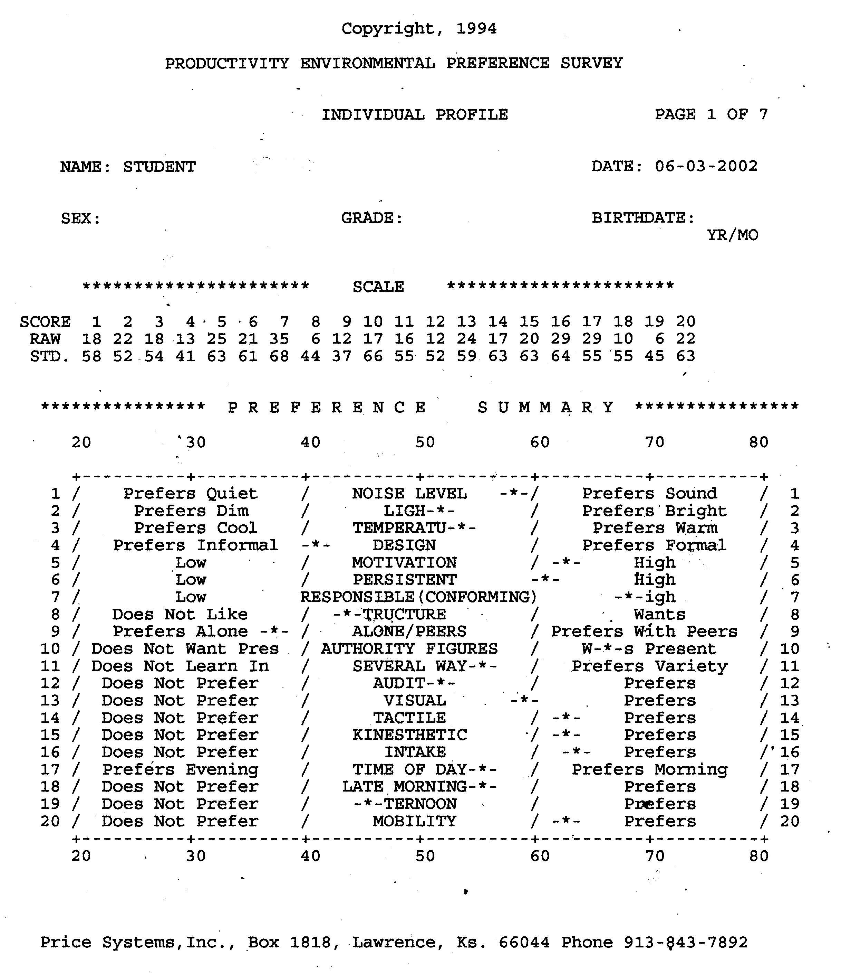

FIGURE 2.
Results of the PEPS (reprinted with permission)

Looking at one specific example, within the category of environmental stimuli are the elements of sound, light, temperature and design (formal versus informal). The elements within this category are self-explanatory. This category is one that is difficult to accommodate in the classroom. However, learners can easily satisfy their preferences when working outside of class. For example, a score ≥ 60 for the element of sound would mean that an individual has a preference for sound when learning new and difficult information. An individual could accommodate their preference for sound by listening to soft music. A score ≤ 40 on the sound element would imply that an individual does not show a preference for sound and thus should work in a quiet environment (using earplugs if necessary). A score in the middle category means an individual might prefer sound at one time, and not at another. In this case, an individual’s preference would depend on other factors.
Once the PEPS has been administered, students receive an individual feedback profile as quickly as possible. Students must immediately be made aware that no high or low exists on this scale in terms of superiority of scores. Furthermore, no scores are bad scores - all are simply unique. No scientific evidence shows that one type of learning style is academically superior over others.
Numerous research studies [32] have documented the reliability and validity of the PEPS. Dunn and Dunn [33] posited that research on their model is more extensive and more thorough than research on many educational topics. As of 1998 research utilizing their model had been conducted at more than 112 institutions of higher education, at all levels K - college, and with students at most levels of academic proficiency, including gifted, average, underachieving, at-risk, dropout, special education, vocational, and industrial art populations.
Dunn, et al. [34] performed a meta-analysis of the Dunn and Dunn model of learning style preferences. They reviewed forty-two different experimental studies conducted with the model from 1989 to 1990. Their results indicated that overall academic achievement of students whose learning styles have been matched can be expected to be about three-fourths of a standard deviation higher than those of students whose learning styles have not been accommodated. Further, when instruction is compatible with students’ learning style preferences, the overall learning process is enhanced.
The need to identify individual learning styles through formal assessment has never been more important than it is at present. Instruction responsive to individual learning styles is especially critical as the pool of students who enroll in introductory physics classes becomes more and more diverse. The following section highlights two instructional approaches developed for use with introductory physics students. The underpinnings of each approach are grounded, in part, in the results of current research on learning styles.

Teaching and Learning Approaches: Strategies to Enhance Student Motivation and Interest

All students enrolled in Physics for the Modern World at American University are given the PEPS at the beginning of the semester. Students receive a computerized individual feedback profile approximately one week after that. This profile is similar to a prescription in that it identifies categories (based on the Dunn and Dunn Model) in which students have strong preferences and gives them information as to how to best utilize these strengths. Students are also extended an invitation to visit with the instructor individually regarding their learning style profiles. The instructor also maintains a copy of each student’s profile and makes use of that when working with them individually during office hours.
Teaching approaches utilized in the introductory physics course have been designed, in part, using the Dunn and Dunn Learning Style Model. Two unique teaching approaches will now be described. One approach involves a writing activity developed by the author called a folder activity. A second approach involves the use of a live, interactive, online chats that make use of Blackboard technologies. These approaches are described in the following sub-sections.

Approach (1): Writing Activities

The first teaching approach to be described involves the use of writing and is called a folder activity. Writing has long been established to be an effective means of expressing one’s ideas, thoughts, and understanding about nature and the world. The folder activity was developed by the author more than 10 years ago to help students elicit and confront their misconceptions in physics in a non-threatening way [35]. This is particularly important as science classes are often viewed by many students as threatening and intimidating places to be. The folder activity also allows students to be creative and use their unique learning style preferences when they prepare their written responses. Writing can also be a very effective vehicle for allowing students to develop and enhance their critical thinking and problem solving skills.
As part of their homework assignments, students are required to keep a two-pocket folder. Students receive 5 - 10 writing assignments each semester. Upon collection of the folders, a block of time is set aside (approximately 6 - 8 hours) to read them and provide each student with written feedback. This direct written feedback is absolutely essential. When students take time to reflect on their writing and on the instructor’s comments, the folder becomes a highly effective tool in helping them uncover and then wrestle with their misconceptions while the learning is actually taking place. Typical folder activities range in length from 1 - 4 pages. To eliminate some of the burden on the instructor of reading 120 papers at a time, assignments are sometime alternated between sections. For example, a folder assignment might be given to the first section prior to the introduction of a new topic, and the same assignment given to the second section after discussion of the topic has take place. This strategy allows the instructor to gauge where students are at in terms of their understanding of a topic before and after it has been covered in class. If the students’ writing shows that they have not made the desired progress on a particular topic, additional class time can be devoted to reinforcing it.
The specific emphasis of the writing activities depends on the goals and objectives for a particular topic or content area. For example, for some activities students are asked to explain a problem or a concept that was highlighted or discussed during a class session. Thus, students essentially have the “answer” to the problem in their hands when they write up this folder assignment. The rationale for this type of activity is that learning can be enhanced when students take on the role of teacher through their detailed written responses and explanations.
An additional example of a typical folder activity involves the creation of sample exam questions. In addition to writing a question, students must explain their choice of responses (i.e. for multiple choice questions) including the reasoning behind both the correct response as well as the incorrect options. In some cases, exemplary student exam questions are organized and distributed to the entire class as a means of a review. The student sample exam questions are never actually used on a classroom quiz or exam. The questions are simply used to help enhance student understanding.
Students are always encouraged to share their understanding of a particular topic or concept in their own words. Thus, students are not pressured to bog their writing down with a lot of scientific jargon. This provides a much clearer window into the students’ thoughts and to their level of understanding and often offers deeper insight than can be ascertained from traditional paper and pencil assessments. Interestingly, as the semester progresses, the students begin to naturally make correct use of more sophisticated scientific terminology in their writing.
An important aspect of the folder activities is that students are permitted to be as creative as they would like to be. They are encouraged to write their responses in a fashion that allows them to make use of their individual learning styles. For example, some students like to enhance their writing through the use of manipulatives and artistic drawings. Other students choose to write their responses in the form of a story, a poem, or a short play. Students know that they have complete control of this activity and are free to put their learning styles to good use. Students also know that they don’t receive any type of “bonus” for being creative. However, allowing a good of flexibility with the format of the writing offers more students an opportunity to demonstrate their understanding of a topic or concept in a manner best suited to their particular styles of learning.
The assessment of the folder activities is somewhat unique in that students are not penalized for incorrect use of physics. Not penalizing students helps make the folder activities non-threatening. The written feedback provided by the instructor indicates to the students that their writing is taken very seriously, and that it should be used as a vehicle to promote understanding. In addition, numerical scores are not put on students’ papers until the end of the semester. The intent here is to get the students to pay attention to the written feedback from the instructor and not the grade they received. For example, if a student received a score of 17/20 on an assignment they might be tempted to say to themselves “Well, 17/20 is a pretty good score, I’m happy with that” and then never look at the assignment again. Then later on, the 3 points they missed come back to haunt them on an exam, only the 3 points have now magnified into many more points.
The bottom line is that students need to be encouraged to take the time to understand the flaws in their thinking and if they simply file a graded assignment into their notebooks without taking the time to seriously look at it, then no real learning is taking place. Students are provided a grading rubric in the course syllabus and they understand that as long as they complete the assignment according to the prescribed directions, they will receive full credit. The purpose of this grading scheme is to encourage students to think deeply about the comments they have received and then do whatever they need to do to correct any problems with their thinking and understanding of a particular topic or concept. Thus, the folder activities give students an opportunity to learn from their mistakes without risk of penalty. Students are very comfortable with this grading scheme, and genuinely enjoy receiving the written feedback provided on their folder assignments. In fact, students often times bring their folder assignments in during office hours once they have received the written feedback in order to address the flaws that might have existed in their thinking.

Approach (2): Interactive Online Chats

Using Blackboard Technologies

The second teaching approach used with introductory physics students involves the use of live, interactive online chats using Blackboard technologies. This approach was piloted during the fall 2002 semester. The Blackboard Learning System™ [36] is a technology platform aimed at achieving several objectives including:
- Measuring and improving student performance.
- Increasing instructor productivity.
- Enabling “Web-enhanced” classroom-based teaching and learning.
- Delivering distance learning.
- Supporting lifelong continuing education.
- Blending the benefits of face-to-face and online learning through the use of hybrid courses.
- Leveraging technology to enhance institutional competitiveness, applicant selectivity and retention.
- Providing a platform framework that integrates course and learning management capabilities with an organization’s student information, security, and authentication protocols.
- Providing a framework for managing an institution’s digital assets and content. (p. 3)

The Blackboard Learning System™ also features an online environment that has been designed to supplement either traditional learning or distance learning. Through an intuitive interface, instructors are able to manage online environments for teaching and learning by using the following utilities:
- Content Management and Content Sharing.
- Assessment Management.
- Gradebook.
- Collaboration and Communication.
- Assignment and Portfolio Management. (p. 4)

Blackboard Inc. recently announced the charter release of the Blackboard Learning System ML™ in Brazilian Portuguese [37] in October 2002. The Blackboard Learning System ML™ is a multi-language edition of the company’s market-leading course management system. Other languages available through this system include Chinese, French, German, Japanese, Spanish, and English. In addition, others including Dutch, Italian, and Korean are currently being developed. Thus, the global nature of this learning environment has broad ranging potential for use at the international level.
The particular feature to be explored in this paper involves the collaboration and communication utility of Blackboard. During the fall 2002 semester all students in PMW were enrolled in a course-specific Blackboard site. Students had immediate access to course documents such as syllabi and assignments. The instructor was able to communicate with all students by email through the Blackboard site to send reminders, announcements, etc. In addition, the Blackboard site provided a forum for interactive online chats. The chats are similar in nature to AOL Instant Messenger™ (AIM) [38] that is so commonly used by students to chat with their friends on the web. With AIM the chats with friends appear on separate screens. Thus, if a student is chatting with several friends simultaneously, the desktop contains a screen for each person they are chatting with. The unique feature of Blackboard is that the instructor and students can chat on a single screen. This feature allows for a continuous discussion to take place between everyone logged into the chat.
The online chats provide a useful way of allowing for peer-, rather than instructor-given feedback. In addition, online chats allow students to use a different form of writing to communicate with their peers. The online chats have also proven to help students elicit and confront their misconceptions [39]. The most common use of the chats has been for the discussion of homework questions. During the semester, chats were routinely scheduled for days that coincided with when homework assignments were due. The chats were set up on different days and at different times each week so as to allow more students an opportunity to participate. The chats were not required, but rather they were advertised as an additional way for students to get assistance on their homework when they needed it. One feature of Blackboard allows the instructor to prohibit anonymous postings. Thus, each chat participant was recognized by name. During the chats students would often refer to each other by first name. This recognition created a very professional working environment for the online chats.
The format of the chats consisted of a student(s) posting a specific question to the group. Other members of the class were then free to jump in and offer the student help and advice. If the students fell off course with their discussion, the instructor would offer some guidance and attempt to steer the discussion back on track. Oftentimes the instructor would make use of Socratic dialogue techniques during the chats. Hake [40] developed the Socratic Dialogue Inducing (SDI) lab method which combines interactive engagement teaching and learning strategies with various forms of hands-on experiences. The SDI method was the outgrowth of the work of Arons [41]. Much of Arons work stemmed from the work of cognitive science and often blended ideas from scholars such as Socrates, Plato, Dewey, and Piaget. SDI labs have proven to be an effective way to guide students to a more solid conceptual understanding of Newtonian Mechanics [42]. Hake has suggested that the SDI method might be characterized as “guided construction” rather than “guided discovery” or “inquiry”. Through the online chats the instructor encouraged guided construction by posing frequent, probing questions to the students. The instructor also used the chats to facilitate a “think out loud” protocol in which both the students and the instructor could offer assistance and guidance to a particular student’s question or comment. This strategy appears to be a very effective way to assist students in confronting their personal misconceptions about a particular topic or concept.
Typically about 20 students would log into the online chats. This represents approximately 15 – 20 % of the total number of students enrolled in the PMW class. However, this number is potentially misleading as many more students took advantage of the discussions generated during the chats. A unique feature of the Blackboard chats is that they are automatically archived online. This means that a student who is unable or chooses not to log in and participate in the live chat, can access the archives at any time. Through informal discussions with students the instructor determined that a much larger percentage of students were actually taking the time to look at the archives prior to completing their homework assignments. As a result, the quality of the homework papers submitted by many students during the semester was very high in comparison with previous semesters.
The use of online chats offers a relatively new avenue through which the learner can take an active role in the learning process. Furthermore, the online chats can be viewed as one form of computer-assisted communication that promotes interactive engagement of the learner with the content being studied. In addition, the online chats may offer some students a more “comfortable” environment in which to interact than the traditional large lecture class. Although students are identified by name during the chats, the instructor works to be sure that each student is treated with respect. Students were very comfortable with the fact that their comments could be identified by name and never expressed any discomfort with this concept.
Certainly there are advantages as well as disadvantages associated with any form of computer-mediated instruction. This mode of communication has the potential to offer greater consistency and to enable students to improve their communication skills while engaging in problem-solving activities [43]. In addition, key differences between computer-mediated conversations and face-to-face discussions include: place dependence, time dependence, and structure and richness of communication [44]. However, if used as an additional learning tool, the online chats can offer students an alternative to traditional instruction and simultaneously appeal to a wider diversity of learning styles [45]. In the section that follows, a brief synopsis of student perceptions regarding the two instructional approaches described is presented.

Student Perceptions of the

Learning Approaches

Student perceptions regarding the two learning approaches highlighted in this paper were elicited through classroom surveys as well as through informal communication between instructor and students. A summary of the results of several surveys regarding the folder activities given in recent semesters will be presented. These results will be shared in the form of typical student responses. Given that the Blackboard chats were first used in the fall 2002 semester a survey was not conducted. Thus, a summary of student feedback elicited through informal discussions will be shared. In future semesters, additional forms of assessment of student perceptions as well as of student learning will be employed.
Regarding the folder activity, students were asked whether or not they found that the written feedback they received had encouraged them to think more deeply about the physics concepts discussed in class. Some common student responses were:

- “It made me think more about the common sense behind the physics.”
- “With the amount of writing on the paper and the fact that I knew you took the time to look at my work I knew that I needed to spend more time on my physics, but not necessarily a specific concept.”
- “The feedback makes me think more deeply about what I have written. The feedback on the learning style made me think more than the second one [folder assignment].”

In terms of the online chats, many students acknowledged that even if they could not log into the live chats, they did make use of the archives when they were completing a homework assignment. Several students indicated that the live chats as well as the archived discussions were so useful that participating was a “no-brainer!” In some cases, students would request a chat, which indicates that they genuinely found them valuable to the learning process.
Overall, the results of these surveys and informal discussions suggest that students found the writing and online chats beneficial and useful to them in some way. A fundamental difference between each of these learning approaches involves the nature of the feedback students receive. With the writing activities, students receive feedback directly from the instructor. However, with the online chats feedback is predominantly from students’ peers. These approaches, albeit quite different, provide students with diverse learning styles some additional learning tools and strategies.

Conclusions

Acknowledgement of students’ individual learning styles can play a critical role in the learning process. Furthermore, the use of formal learning style assessments can provide useful information that benefits the student as well as the instructor. Important to note is the fact that the learning style assessment tool used is not as critical as the actual assessment of learning styles. Through the specific teaching and learning strategies that have been described in this paper, the value and importance of adopting a learning style approach in the classroom has been illustrated. It is the contention of the author that the adoption of a learning style approach in the classroom can increase student interest and motivation to learn, in part, through the development of alternative learning strategies designed to accommodate an increasingly diverse population of learners.

References

- Dunn, R., Bruno, J., Sklar, R. I., & Beaudry, J. 1990. Effects of matching and mismatching minority developmental college students’ hemispheric preferences on mathematics scores. Journal of Educational Research, 83(5), 283 – 288.
- Gordon, R. B. 1993. The effects of computerized instruction on the improvement and transfer of writing skills for low-skilled and below average-skilled sophomore students, considering student gender, ethnicity, and learning style preferences. (Doctoral dissertation, University of LaVerne). Dissertation Abstracts International, 55(1), 23.
- Lenehan, M. C., Dunn, R., Ingham, J., Murray, W., & Signer, B. 1994. Learning style: Necessary know-how for academic success in college. Journal of College Student Development, 35, 461 – 466.
- Nelson, B., Dunn, R., Griggs, S., Primavera, L. Fitzpatrick, M. Bacilious, Z., & Miller, R. 1993. Effects of learning style intervention on college students’ retention and achievement. Journal of College Student Development, 34, 364 – 369.
- Ranne, T. M. 1996. Hawthorne uncapped: The relationship of adult learning styles to the academic achievement of nursing students. (Doctoral dissertation, State University of New York, Buffalo). Dissertation Abstracts International, 57(9), 3771.
- Williams, H. S. 1994. The differences in cumulative grade point averages among African-American freshman college learning styles: A preliminary investigation. National Forum of Applied Educational Research Journal, 8(1), 36 – 40.
- Agogino, A. M., & Hsi, S. (1995). Proceedings of the 1995 Frontiers in Education Conference.
- Felder, R. 1996. Matters of style. ASEE Prism, 18 – 23.
- Felder, R. M., & Silverman, L. K. 1988. Learning and teaching styles in engineering education. Engineering Education, 78(7), 674 – 681.
- Larkin-Hein, T. 2000. Digital video, learning styles, and student understanding of kinematics graphs. Journal of SMET Education: Innovations and Research, Vol. 1, Issue 2, 17 – 30.
- Hein, T. L., & Zollman, D. A. 1997. Investigating student understanding of kinematics graphs following instruction that utilized interactive digital video techniques and the role that learning style plays in that process. AAPT Announcer (Addendum), 26(4), 3.
- Harb, J. N., Olani Durrant, S., & Terry, R. E. 1993. Use of the Kolb learning cycle and the 4MAT system in engineering education. Journal of Engineering Education, 82(2), 70 – 77.
- Sharp, J. E., Harb, J. N., & Terry, R. E. 1997. Combining Kolb learning styles and writing to learn in engineering classes. Journal of Engineering Education, 86(2), 93 – 101.
- Herrick, B., Budny, D., & Samples, J. 1998. Teaching to your audience. Frontiers in Education Conference, Session T1H, Tempe, AZ.
- Meyers, C., & Jones, T. B. 1993. Promoting active learning: Strategies for the college classroom. San Francisco: Jossey-Bass Publishers.
- Hein, T. L. 1995. Learning style analysis in a calculus-based introductory physics course. Annual Conference of the American Society for Engineering Education, Anaheim, CA.
- Oregon School Council Study Bulletin, 30(9), 1987. Overview of theories and findings on learning styles. Eugene, OR: Oregon School Study Council.
- Dunn, R. 1990. Understanding the Dunn and Dunn learning styles model and the need for individual diagnosis and prescription. Reading, Writing and Learning Disabilities, 6, 223 – 247.
- Dunn, R. 1982. Would you like to know your learning style? – And how you can learn more and remember better than ever? Early Years, 13(2), 27 – 30.
- Sternburg, R. J. 1990. Thinking styles: Keys to understanding student performance. Phi Delta Kappan, 71(5), 366 – 371.
- Dunn, R. 1986. Learning styles: Link between individual differences and effective instruction. North Carolina Educational Leadership, 2(1), 4 – 22.
- Kolb, D. A. 1984. Experiential Learning: Experience as the Source of Learning and Development. Englewood Cliffs: Prentice Hall.
- Brandt, R. 1990. On learning styles: A conversation with Pat Guild. Educational Leadership, 48(2), 10 – 13.
- Dunn, R. & Bruno, A. 1985. What does the research on learning styles have to do with Mario? The Clearing House, 59, 9 – 12.
- Dunn, R., Dunn, K., & Freeley, M. E. 1984. Practical applications of the research: Responding to students’ learning styles – step one. Illinois School Research and Development, 21(1), 1 – 12.
- Hein, T. L. 1994. Learning style analysis in a calculus-based introductory physics course. Paper presented at the annual meeting of the National Association for Research in Science Teaching, Anaheim, CA.
- Lemmon, P. 1985. A school where learning style makes a difference. Principal, 64(4), 26 – 28.
- Perrin, J. 1990. The learning styles project for potential dropouts. Educational Leadership, 48(2), 23 – 24.
- De Bello, T. C. 1990. Comparison of eleven major learning style models: Variables, appropriate populations, validity of instrumentation, and the research behind them. Reading, Writing and Learning Disabilities, 6, 203 – 222.
- Dunn, R., & Dunn, K. 1993. Teaching secondary students through their individual learning styles. Boston, MA: Allyn and Bacon, 39. Reprinted with permission.
- Price, B., Dunn, R., & Dunn, K. 1990 Productivity Environmental Preference Survey: An Inventory for the Identification of Individual Adult Preferences in a Working or Learning Environment. Price Systems, Inc., Lawrence, KS.
- Research Based on the Dunn and Dunn Learning Style Model. (Annotated bibliography). 1990. New York: St. John’s University.
- Dunn, R. & Dunn, K. 1992. Teaching Secondary Students Through Their Individual Learning Styles. Boston: Allyn and Bacon.
- Dunn, R., Griggs, S. A., Olson, J., Beasley, M., & Gorman, B. S. 1995. A meta-analytic validation of the Dunn and Dunn model of learning-style preferences. The Journal of Educational Research, 88(6), 353 – 362.
- Hein, T. L. 1999. Using writing to confront student misconceptions in physics. European Journal of Physics, 20, 137 - 141.
- Blackboard, Inc. 2002. Blackboard Learning System: Product Overview White Paper. Washington, DC. (Release 6)
- Blackboard, Inc. 2002. Blackboard Inc. announces charter release of Blackboard Learning System™ in Brazilian Portuguese. Washington, DC: Blackboard Press Center.
- http://www.aim.com/index.adp (accessed 01/10/03)
- Hein, T. L. & Irvine, S. E. 1998. Classroom assessment using online discussion groups. AAPT Announcer, 28(2), 82.
- Hake, R. R. 1002. Socratic pedagogy in the introductory physics laboratory. The Physics Teacher, 30, 546 – 552.
- Arons, A. B. 1990. A guide to introductory physics teaching. New York: John Wiley & Sons.
- Hake, R. R. 1998. Promoting student crossover to the Newtonian world. The American Journal of Physics, 55, 878 – 884.
- Phillips, G. & Santoro, G. 1997. Teaching group discussion via computer-mediated communication. Communication Education, 38, 151 – 161. [24] Research Based on the Dunn and Dunn Learning Style Model. (Annotated bibliography). 1990. New York: St. John’s University.
- Harasim, L. 1990. Online education: An environment for collaboration and intellectual amplification. In L. Harasim (Ed.), Online education: Perspectives on a new environment (pp. 39 – 63). New York: Praeger.
- Irvine, S. E., Hein, T. L., & Laughlin, D. 1999. Different degrees of distance: The impact of the technology-based instructional environment on student learning. Proceedings of the Frontiers in Education Conference, San Juan, Puerto Rico. IEEE Catalog number 99CH37011. ISBN 0-7803-5643-8.

Teresa L. Larkin, Department of Computer Science, Audio Technology, and Physics, American University, 4400 Massachusetts Ave. NW, Washington, DC 20016-8058, tlarkin@american.edu

