CONTROL AND AUTOMATION TEACHING: AN UNIFIED APPROACH IN A GUI DIGITAL ENVIRONMENT

Breno Scopinho, Clayton G. Mata, Francisco J. Gomes, João C. Netto and Leonardo A. M. Moraes

Abstract ⎯ The work deals with a graphic environment that allows the user to plan, tune and analyze feedback control systems loops, involving he more common models of systems utilized in control daily practice. These models include PID controllers in the feedback loop and, in all cases, controllers' gains tuning are possible by changing the electronic circuit of a PID structure. The process models are of first and second order, in the s domain, but working also with their associated electronic circuits. All the parameters of the models and controllers can be changed in “real time”, allowing the user to analyze their effects on the final dynamics. Besides, the environment includes a “step-by-step” procedure for designing a control system based on the pole placement technique, in the state-space, for an inverted pendulum. The importance of this work is mainly in giving to the student a strong relationship between theoretical models and its physical implementations through electronic circuits, embedded in a friendship environment.

Index Terms ⎯ Engineering Education, Control and Automation Education, Digital Environment, PID Controllers.

Introduction
The computer is becoming an essential tool in teaching and training of projects and analysis of control systems. This fact relays on its capacity to determine the systems dynamics under analysis, in a closed or open loop, to help in the tuning of controllers and analyze its performance, prior to the construction of the physical systems. Through several situations simulated, dynamics with desirable characteristics can be obtained, taking in account parameters like dumping, settling time, stability, overshoots, and others.
In the teaching process of control and automation, however, some difficulties generally arises when trying to conciliate theoretical concepts, like the conceptual analysis of the systems, with their ordinary physical implementations. Excellent simulators, like Simulink, use basically mathematical tools, while practical aspects of implementation of these systems can be analyzed only with others environments like PSpice. The difficulties grow up when the training imposes the necessity of physical modules, that are, in general, imported and with expensive prices.
Analyzing this situation, the present work – a graphical simulation environment – was implemented based on conventional mathematical tools, basically transfer functions and state-space equations, allowing the user to define and tune the parameters of control systems (plants and controllers), verifying the associated dynamics in "real-time". The most important environment characteristic is the fact that the systems – plants and controllers – can be analyzed and worked not only as mathematical functions, but also as electronic circuits, allowing the user to operate with mathematical models and/or physical implementations.
The next section deals with the module based on Proportional-Integral-Derivative (PID) controllers. Its electronic circuit is accessible to the user, allowing its tuning through alteration of capacitors and resistors values. With this environment is possible to have, graphically, answers of, to references changes, load rejection and models rupture, in "real-time". This open the possibility of using the “PID Controller” in a very extensive range of applications, involving academical applications and even industrial operators training.
The following section illustrates the state-space project module. Elaborated as a step-by-step project manual, based on the classical inverted pendulum system, it allows the user to analyze its relative and absolute stability, trough poles placement. The final conclusion ends the work. All the sections, additionally to the conceptual contents of each module, display some environment screenshots and the possibilities they offer to the user.

PID Controller
This section deals with the PID Controller module, that simulates in closed-loop the most common models utilized in practical control configurations that embraces the majority of the common industrial area control situations. The selected systems, in their several configurations, are presented in closed-loop, with unitary or first-order dynamic feedback, and with a PID controller.

Models
The developed environment allows the simulation of six classical systems in closed-loop configurations:

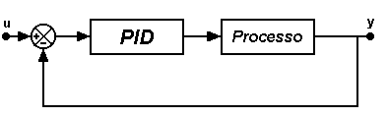

Figure. 1
Model 1.

Figure 1 shows the first simulation model, with first- or second-order dynamics, according to the user’s choice, and unitary feedback.

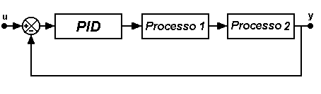

Figure. 2
Model 2.

The second model, as displayed in Figure 2, consists of two first- or second-order processes, cascade configuration and unitary feedback gain, allowing simulation of third or fourth orders dynamics.
For these two first models is possible to define reference alterations and model rupture. The third option, presented in the Figure 3, has first- or second-order dynamics, unitary feedback gain and allows reference alterations, load rejection and model rupture.

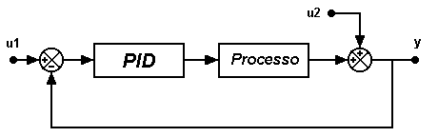

Figure. 3
Model 3.

The fourth model selected, shown in the Figure 4, simulates dynamics of first- or second-order, unitary feedback gain and allows reference alterations, load rejection and model rupture, in a different configuration.

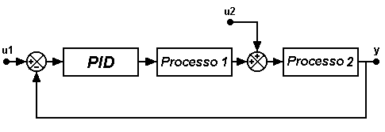

Figure. 4
Model 4.

The fifth model opens the possibility of selecting the load perturbation dynamics, according to the user's selection.

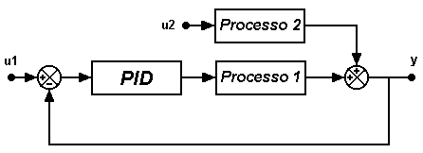

Figure. 5
Model 5.

The last model, shown in the Figure 6, offers additional characteristics to the fourth model, by including not-unitary feedback gain, selected by the user.
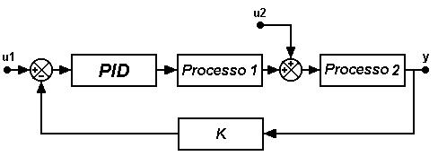

Figure. 6
Model 6.

All the presented options, like perturbations and alterations introduced in the systems, are selected through a friendly graphical environment.

The Program

The initial screen of the environment allows the user to select the models for simulation, available with its characteristics, just scrolling over the mouse on the icons. Figure 7 shows, as an example, the choice of the first model.

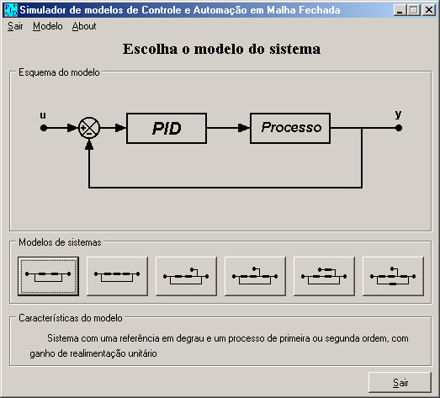

Figure. 7
Initial Screen of the PID Simulator.

Figure 8 shows the simulator screen, after selection of the model, "waiting" for the simulation start. The PID controller tuning is possible trough "clicking" on the PID block, on the closed-loop block diagram. In doing so, the window containing the schematics of the analog electronic circuit of the controller is opened, as shown in Figure 9.

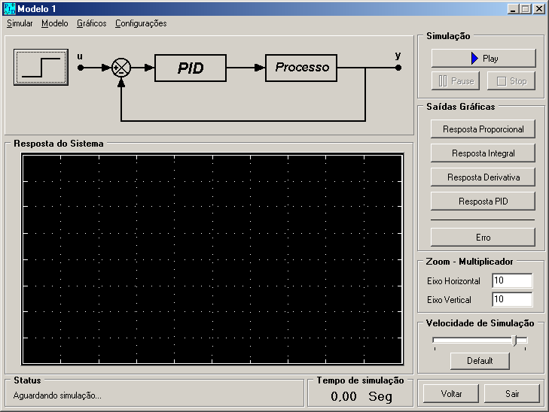

Figure. 8
"Waiting" Simulation of the Model 1.

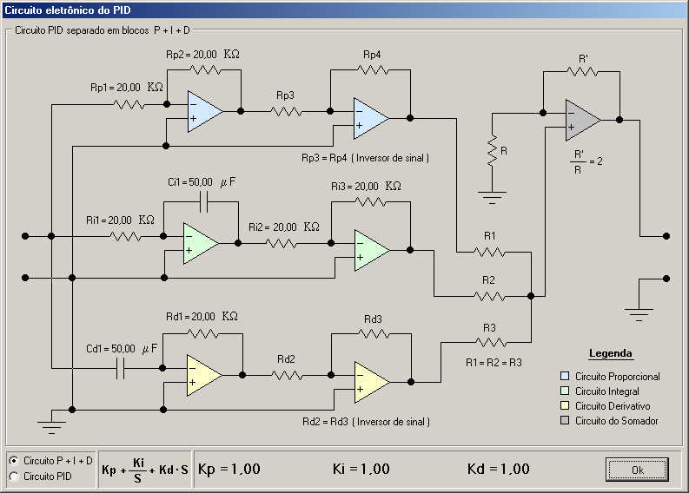

Figure. 9
Screen Of the Electronic Circuit of the PID Controller.

Figure 10 shows the input screens for reference alterations, allowing analysis of the servo behavior, and the plant parameters, which allows model rupture.

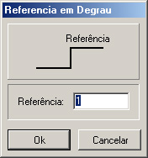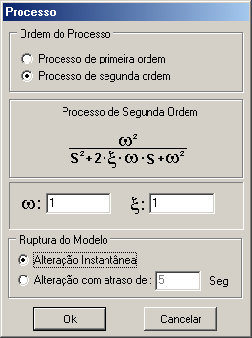

Figure. 10
Input Screen for the Reference and Process Values.

In a similar way, the models can also be analyzed through its electronic circuits, allowing selection of the parameters (gain and time constant) directly in the hardware or through numerical values.
The several systems are modeled by their differential equations and solved with the 4th order Runge-Kutta method.
While the simulations are running, all the values (controller tuning, plant and perturbation constants) can be changed in "real-time". The alterations influences on system dynamics can be analyzed by the user either graphically or numerically. As the environment was designed for teaching and training purposes in the process control area, the following screens are available to the user:
- Controlled variable: the user can follow the evolution of the perturbations on the final dynamic of the controlled variable.
- Separated PID Controller modules actions: aiming a better user understanding of the PID controller modules, the environment displays, simultaneously, separated windows for the proportional, integral and derivative modes, allowing the user to analyze each one's influence on the final control law.
- Control Law: the environment also displays, graphically and numerically, the final control law corresponding to the three PID modes sum, allowing the user to verify its final composing.
- System Error: finally, is also showed the deviation between the controlled variable and the reference allowing the user to verify, numerically, the error dynamics for the selected perturbation.

The controlled variable graphical is displayed on the simulated model window and the others ones are shown in separated windows, opened according to the user's need. Figure 11 is an example of the controlled variable graphic, with the proportional answer displayed on a separated window (right).

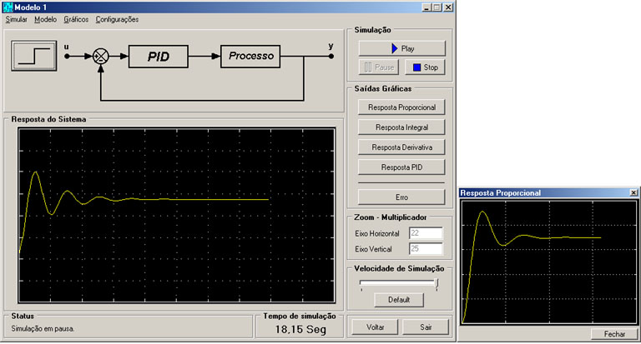

Figure. 11
Graphical of the Controlled Variable with the Proportional Answer in Another Window.

Inverted Pendulum Simulator
As mentioned, the implemented environment incorporates a case of state variables controller design, based on poles placement methodology applied to a classical control problem: the inverted pendulum. The user has the possibility of implementing, step-by-step, with the help of the simulator, the poles placement controller, checking the system behavior for alterations on its closed-loop poles.

The Inverted Pendulum
The system consists of an inverted pendulum constructed on a cart commanded by a motor, generating a unstable system, falling laterally, at any time, unless an adequate force is applied on the car, driving the pendulum to a vertical position.
The selected model, state-space equations based, can be obtained on the specific bibliography and has the form:

$\left[\begin{matrix}\overset{˙}{θ} \\ \overset{¨}{θ} \\ \overset{˙}{x} \\ \overset{¨}{x}\end{matrix}\right]=\left[\begin{matrix}0 & 1 & 0 & 0 \\ \frac{M+m}{\text{Ml}}g & 0 & 0 & 0 \\ 0 & 0 & 0 & 1 \\ −\frac{m}{M}g & 0 & 0 & 0\end{matrix}\right]⋅\left[\begin{matrix}θ \\ \overset{˙}{θ} \\ x \\ \overset{˙}{x}\end{matrix}\right]+\left[\begin{matrix}0 \\ −\frac{1}{\text{Ml}} \\ 0 \\ \frac{1}{M}\end{matrix}\right]u$ (1)
$$\left[\begin{matrix}θ \\ x\end{matrix}\right]=\begin{aligned}\left[\begin{matrix}1 & 0 & 0 & 0\end{matrix} | \right] \\ \end{aligned}$$

The model used in the majority of current applications, and also in the developed environment, is a linearized one. Supposing the angle θ (angle between the bar and the vertical axis) is small, the sin θ can be approximated to θ, cos θ = 1 and θ² = 0.

Poles Placement

Mathematically, is possible to prove that if a closed-loop system is completely controlled by the state, then its poles can be put anywhere in the complex plan, using the state feedback, through an appropriated feedback gain matrix. Specifically in this case, the system is completely controllable if its controllability matrix M has a rank equal to 4.
This matrix M for the system of the inverted pendulum is given by:

$M=\left[\begin{matrix}0 & c & 0 & a⋅c \\ c & 0 & a⋅c & 0 \\ 0 & d & 0 & b⋅c \\ d & 0 & b⋅c & 0\end{matrix}\right]$ (2)

where

$\begin{aligned}a=\frac{M+m}{\text{Ml}}g \\ b=−\frac{m}{M}g \\ c=−\frac{1}{\text{Ml}} \\ d=\frac{1}{M}\end{aligned}$ (3)

If the system is completely controllable by the state, a state feedback matrix can be calculated, just like its respective equations.

The Simulator

Considering the inverted pendulum as a system with one input (the force u acting over the cart) and two outputs (the position x and the angle θ between the bar and the vertical axis) and using its model equations, the environment displays its dynamics through graphics or animated frames. Using this option, one can see the sketch of the inverted pendulum moving according to the answer of the system.

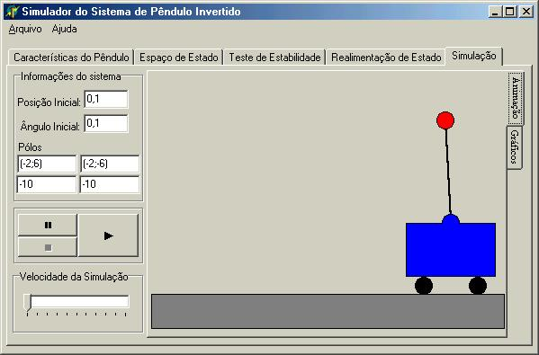

Figure. 12
Screen Of Inverted Pendulum Simulation at Its Initial Position.

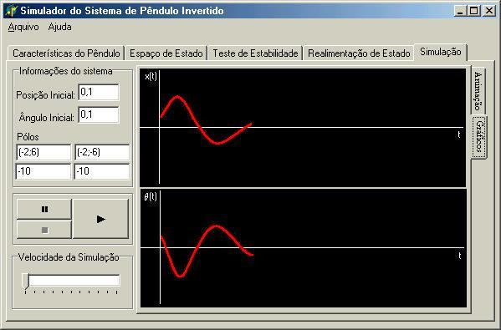

Figure. 13
Simulation of the Inverted Pendulum System Occurring.

The simulator also offers the option of varying the system parameters (pendulum mass and length and car mass), the initial position and angle and the closed-loop poles, which determine its final dynamics.

Step-by-step, the user analyses what happens during the process of designing the control system. When the simulation starts, the simulator takes on stability tests to verify the possibility of doing the poles placement, indicating to the user, step-by-step, the procedures for getting the final controller design. During this process, it is built the system feedback matrix, asking for the user to determine the closed-loop poles positions. The system then determines the answer corresponding to the variation of the position x and θ. At the end, these variables are exhibited in a graphic form, where parameters like the output of the system, as well factors like accommodation time and dumping factors can be analyzed.
Figure 13 shows the inverted pendulum simulation screen with the characteristics imposed by the user, for the pendulum and the composition of the graphical outputs.

Conclusions
This work is extremely useful in the study of control and automation procedures due to its user-friendly interface. With a differential characteristic of having mathematical models linked directly to their physical implementation, the environment allows and facilitates the understanding and operationally of the control laws and procedures by the users. Based on common models that can be utilized for representing the dynamics of most industrial processes, this work is very important for academical studies and training of industrial systems operators.

Acknowledgment
To Special Training Program – Programa Especial de Treinamento – PET/SESu – UFJF.

References
- Ästom, K. and Hägglund, T., “PID Controllers: Theory, Design and Tuning”,Ed. ISA, 2nd Edition, 1992.
- Buchanan, J. L. and Peter R. T., “Numerical Methods and Analysis”, McGraw-Hill International Editions, 1992.
- Cornell, G., “Delphi: Segredos e Soluções”, Makron Books, 1995.
- Engo, F., “Como Programar em Delphi 3”, Makron Books, 1997.
- Gayakwad, R. and Sokoloff, L., “Analog and Digital Control Systems”,Prentice-Hall International Editions, 1988.
- Harriott, P., “Process Control”, McGraw-Hill Book Company, 1964.
- Ogata, K., “Engenharia de Controle Moderno”, Prentice-Hall do Brasil, 1993.

Breno Scopinho, Faculty of Electrical Engineering, Federal University of Juiz de Fora, R. Benjamin Constant, 790, 36.016-400, Juiz de Fora, MG, Brazil, brenos@jfnet.com.br
Clayton Guimarães da Mata, Faculty of Electrical Engineering, Federal University of Juiz de Fora, R. Benjamin Constant, 790, 36.016-400, Juiz de Fora, MG, Brazil, clayton@pet.ufjf.br
Francisco José Gomes, Faculty of Electrical Engineering, Federal University of Juiz de Fora, R. Benjamin Constant, 790, 36.016-400, Juiz de Fora, MG, Brazil, chico@jfnet.com.br
João Carneiro Netto, Faculty of Electrical Engineering, Federal University of Juiz de Fora, R. Benjamin Constant, 790, 36.016-400, Juiz de Fora, MG, Brazil, netto@jfnet.com.br
Leonardo de Almeida Matos Moraes, Faculty of Electrical Engineering, Federal University of Juiz de Fora, R. Benjamin Constant, 790, 36.016-400, Juiz de Fora, MG, Brazil, leonardo.moraes@ieee.org

