THE EFFECTS OF DESIGN STUDIO’S PHYSICAL ENVIRONMENT ON ARCHITECTURAL EDUCATION

Elmira Sener, Sinan M. Sener

Abstract ⎯ The basis of the architectural education is “architectural design studio” class. In Istanbul Technical University Faculty of Architecture, architectural design studios take place in two kinds of design studios: “single room design studio” and “separated design studio groups in a large classroom”.
The aim of this paper is to investigate the physical characteristics of these two kinds of design studios in terms of learning environment, in which “design process” takes place; to question the relationship between the physical characteristics of the design studio and the interaction of student / tutor; to research about the different consequences of the different physical characteristics of the “single room design studio” and “separated design studio groups in a large classroom” on positive or negative behavior among the students.
In this structure, the study is enriched by a questionnaire, which investigates the experiences of about usage the design studios; conclusions, which can be useful for designing the architectural design studios, are recorded.

Index Terms ⎯ Architectural design education, design studio education, design studio’s physical environment, student/tutor interaction.
Introduction
The “architectural design studio course” which is fundamental for architectural education is an applied course where architectural design process is realized artificially. This environment is an educational element in terms of the importance given by the academicians, educational institutions and the time reserved for the course. The architectural design studio in the Istanbul Technical University lasts for four years, which make eight complementary semesters following each other. The “design studio” where the students may choose a different tutor every semester and the tutor educates an average number of 10-15 students is also the name of the classroom.
Scope of the research
The architectural design studio in the Faculty of Architecture of Istanbul Technical University is a period in which the architecture candidate works on a subject on a pre-defined project plot for fourteen weeks and for eight hours a week, in each semester.
The learning process can be driven by the concept of working in teams or groups. Because, creativity can be enhanced by collaboration and cooperation [1]. Thus, collaborative and cooperative works, establish the design studio education.
In I.T.U. Faculty of Architecture, the studio courses take place in two types of physical studio environment: “single room design studio”(Figure-1) and “separated design studio groups in a large classroom”(Figure-2). One or two architectural project groups continue their courses in “the single room design studios” while approximately ten project groups are in the same space in “separated design studio groups in a large classroom”.
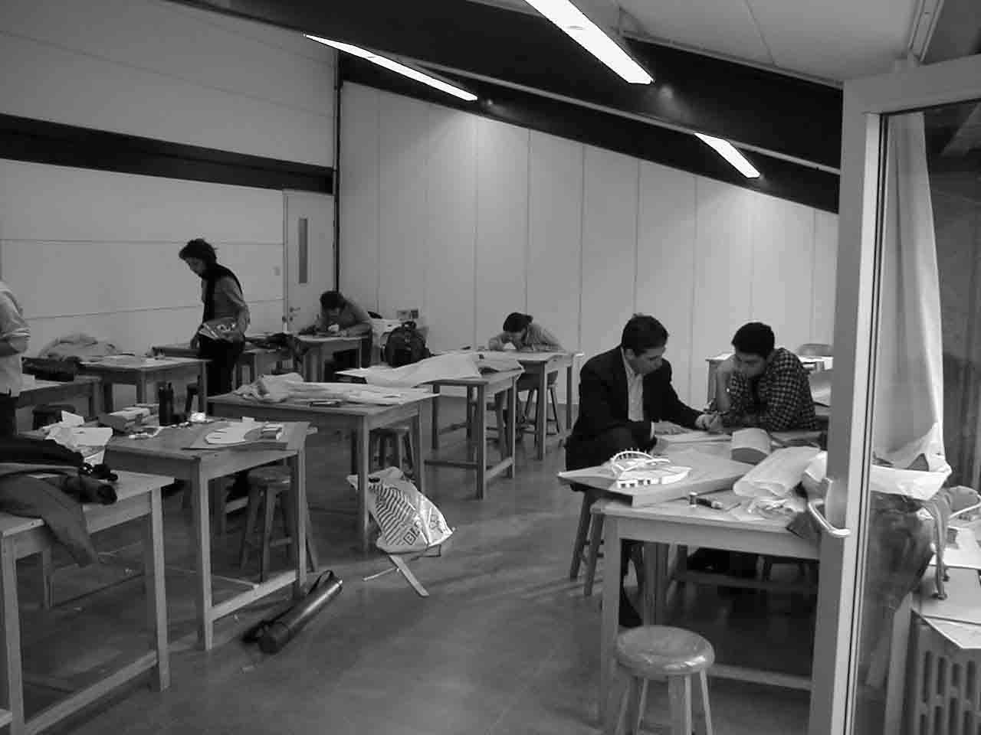
Figure-1 General view to “single room studio”
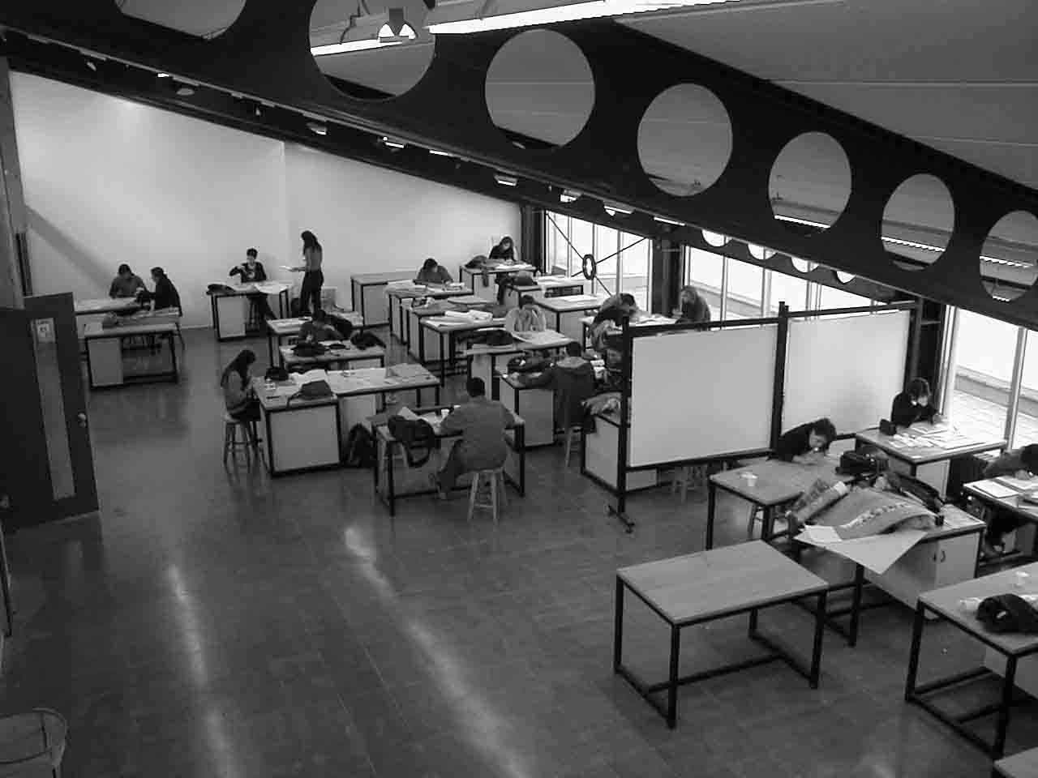
Figure-2 General view to “separated studio”
Thus, it is very important to arrange the spatial and physical capabilities of the project studio in a way to contribute to the project education period, considering that the academic semesters are limited.
Research Objectives
In the architectural design, creativity has a very important role like in all the other design educations. The indirect link between design and creativity is established in the studio environment throughout the time in which the first ideas starts to appear. As Candy and Edmonds stresses, it is important to gain experience from past examples, to produce possible methods and strategies out of collected information, to synthesize the visual perceptions and to experience various information in this studio is important [2].
Cuff, evaluates the studio education not only as a “work place” but also as a “home” and a” work place” together, similarly to the contemporary concept of a home-office. The reason of this approach is the fact that the studio education is spread through a long period of time in the education process. Students should perceive the studio as somewhere, which they can work in enthusiastically both in and out of the class hours [3].
The objective is first to observe the physical properties of the above mentioned studio types, the studio space and the sub-compounds of it where the activity of “architectural design” takes place, and second, to cross-examine the relation between the results of communication and interaction of student-tutor depending on the physical properties of the architectural studio space. In existence of a relation, it shall be searched in which way the two studios, by which properties cause which kind of behaviors, and whether they create a discontent. The reason for a trend in spatial choices and the advantages/disadvantages shall also be compared.
Research Method
Within this study, in terms of the above-mentioned educational necessities and spatial properties, a survey design has been conducted among the students who use different types of physical environments. The survey instrument used in the study was a self-designed standardized questionnaire. By analyzing the effect of studio space on the design education, it was tried to reveal their preferences about the studio environment and the physical environment of the space.
In this process, the questionnaire is tested with 174 students. 71 of them were students who use single room design studio, and 103 of them were from separated design studio groups in a large classroom. Information, which can be data for the design of architectural design studios and about the experiences and desires of the students about the studios, has been gathered.

Evaluation of the Survey Design
The survey included two groups of students. These were either from a studio where one or two tutors shared the same space, or from a single large studio where up to ten studio groups are divided by separator panels.
Same questions were asked to all the students and their responses and positions were displayed in the graphics below.
It became clear that students from 3-4th semesters mostly study in “single room studios” (35% 6-7th semesters, 65% 3-4th semesters), while in “separated studios”, the student ratio of 3-4th semesters to 6-7th semesters is equal (50% 3-4th semesters, 50% 6-7th semesters).
71% of the students who study in “separated studios” are pleased with their physical studio environment and 29% are not pleased, while only 38% of the students who study in “single room studios” are pleased and 62% are not pleased with their environment (figure-3,4).
Figure-3 PLEASED / NOT PLEASED StudentS IN“sıngle room StudioS”
Figure-4 PLEASED / NOT PLEASED StudentS IN “separated STUDIOS”
Student Preferences on Studio Environment
When the students of “single room studio” group were asked in what type of a studio they would like to attend their courses, 27% preferred “single room studio”, 30% preferred “separated studio”, 33% preferred “personalized space in separated design studio”, 7% preferred virtual (reality) studio and %3 answered the choice as “other”.
For the students of “separated studio” group, 13% preferred “single room studio”, 60% preferred “separated studio”, 14% preferred “personalized space in separated design studio”, 10% preferred virtual (reality) studio, and 3% answered the choice as “other”.
Studio Environment Effects on Tutor-Student Relation
When it is questioned what affect the studio space has on the tutor-student relationship, it drew our attention that the output of the survey was the same for two groups. 47% of the students suggested that the studio space did not have any contribution to their interaction with the tutors while %29 suggested that the space was a positive factor and 24% suggested just the opposite.
The Existence of Separators in the Studio Environment
In case the separator panels between different project groups inside the large classroom were removed, %7 of the single studio’s students thought it would be positive, 66% said it would be negative, 12% suggested it would not make any difference, 12% expressed that it would confuse them and 3% told they would feel more relieved (figure-5).
Figure-5 Impacts of separators on single room studio Students’
On the other hand when the students of separated studio were asked the same question, 4% of the students thought it would be positive, 73% said it would be negative, 9% suggested it would not make any difference, 12% expressed that it would confuse them and 2% told they would feel more relieved (figure-6).
Figure-6 Impacts of separators on separated studio students’

Single Room Design Studio’s Advantages and Disadvantages
According to the survey, when the students of a single room studio were asked about the advantages of single room studio, 29% of them chose sincerity, 23% chose individualization of the space, 23% chose quietness, 2% chose prevention of distraction, 2% chose benefits of separator panels and 1% chose “other”(figure-7).
Figure-7 Advantages of “SINGLE ROOM STUDIOS” accordıng to students of “sıngle ROOM STUDIOs “
When the students of separated studios evaluated the advantages of single room studios, 24% of them chose sincerity, 21% chose individualization of the space, 24% chose quietness, 26% chose prevention of distraction, 4.5% chose benefits of separator panels and 0.5% chose “other” (figure-8).
Figure-8 Advantages of “SINGLE ROOM STUDIOS” accordıng to students of “separated STUDIOS”
On the other hand, when the students of a single room studio were asked about the disadvantages of the single studio, 25% chose unawareness of other groups works, 2% chose quietness of the space, 20% chose lack of communication with friends in other groups, 21% chose inconvenience or distress due to small space, 19% chose negative effect of insufficient air, 12% chose feeling too much control of the tutor and %1 chose as “other”.
For the students of a separated studio, 23% chose unawareness of other groups works, 4% chose quietness of the space, 19% chose lack of communication with friends in other groups, 20% chose inconvenience or distress due to small space, 19% chose negative effect of insufficient air, 14% chose feeling too much control of the tutor and 1% chose as “other”.
Separated Design Studio’s Advantages and Disadvantages
The size of the studio space was also questioned within the survey study. Assuming that their studio type was separated studio, first the students of single room studios chose the advantages of largeness in an order. According to the results, 34% chose awareness of other groups works, 30% chose visual communication with other groups, 27% chose flexibility of space reserved for any group, 7% chose less control of the tutor and 2% chose as “other”(figure-9).
Figure-9 Advantages of “separated STUDIOS” accordıng to students of “sıngle room STUDIOS”
When the students of separated studios were asked to choose the advantages, 31% chose awareness of other groups works, 32% chose visual communication with other groups, %26 chose flexibility of space reserved for any group, 9% chose less control of the tutor and 2% chose as “other”(figure-10).
Figure-8 Advantages of “separated STUDIOS” accordıng to students of “separated STUDIOS”
When it came to thinking the disadvantages of a separated studio, 32% of the students of single room studios chose distraction of attention while 38% chose noise, 4% chose low temperature in studio, 6% chose interior breeze or wind, 19% chose distraction of tutor and %1 chose as “other”(figure-11).
For the disadvantages of separated studios, 27% of the students of separated studios chose distraction of attention, 40% chose noise, 7% chose low temperature in studio, 7% chose interior breeze or wind, 17% chose distraction of tutor and 2% chose as “other”(figeure-12).
Figure-11 dısAdvantages of “separated STUDIOS” accordıng to students of “sıngle ROOM STUDIOS”
Figure-12 dısAdvantages of “separated STUDIOS” accordıng to students of “separated STUDIOS”
General Evaluation
While the students of separated studios are pleased with their spaces on a high percentage, this percentage is lower for the students of single room studios.
Another general result is that, the students of separated studios mostly prefer studying in the same type of studio, but the students of single room studios desire individualized space inside a separate studio at the first place. Their second and third choices were a separated studio and their own –single room studio-, respectively.
All test subjects thought that the physical environment in their studio did not contribute to the interaction between the students and the tutors.
All test subjects agree that the separator panels are important and positive elements.
The common view of both student groups is that “a separated design studio group in a large classroom with individualized spaces” is the best for them. But it was also seen that a flexible arrangement of space inside single room design studios would enhance their satisfaction with the studio.
While the most important aspect of a design studio for the students of separated studios is “visual communication with other groups”, this choice leaves its place to “awareness of other groups” in a single room studio group. As a matter of fact, the students of single room studios have grown to ignore the importance of visual communication, which they already lack. In order to increase creativity inside the studio, the students prefer a freedom of perception at their own will and timing, instead of visual and cognitive isolation.
Although the separated design studio groups in a large classroom is mostly preferred by students, this model is also blamed for poor acoustics and distraction of attention of both students and the tutors.
The preferred aspects of the single room studios are spatial sincerity, individualization, quietness and prevention of distraction. On the contrary, both group of students state that distressing or boring size of space and unawareness and lack of communication with other groups is important disadvantages.
Conclusion
The contribution of design studio, which is a touchstone for architectural education, is obvious. This survey, which searches effect of “single room design studio” and “separated design studio groups in a large classroom” type of studios and their spatial organization, on the student-tutor behaviors, depicts the positive and negative aspects of these spaces. The likes and dislikes of the students about a studio appears more clearly. Consequently, as the results have shown the dilemma or duality on this matter with both advantages and disadvantages, it was evaluated that both types of studios should exist in terms of variety in architectural education. As a general comment, it is natural that students who have not used the possibilities of a flexible type of studio may require other spaces, which belong to themselves or small groups.
It would not be wrong to say that the students’ choice agrees with the “separated large design studio groups in a large classroom” type of studio provided that; acoustical comfort is maintained, individualization and belonging is easily created via mobile panels, it is always possible to interact with other groups depending on their choice and flexible use is supported.

REFERENCES

[1] Salama, A., New Trends in Architectural Education, Designing the Design Studio, Tailored Text & Unlimited Potential Publishing, NC, 1995
[2] Candy, L., Edmonds, E., “Creative Design of the Lotus Bicyle: Implications for Knowledge Support Systems Research, Design Studies, 17, No.1, 1996, pp.71-91.
[3] Cuff, D., Architecture: The Story of Practice, The MIT Press, Cambridge, Massachusetts, USA, 1991.

Elmira Sener, Istanbul Technical University, Faculty of Architecture, Department of Architecture, Taskisla, 80191, Istanbul, Turkey, senerel@itu.edu.tr
Sinan Mert Sener, Istanbul Technical University, Faculty of Architecture, Department of Architecture, Taskisla, 80191, Istanbul, Turkey, mert@itu.edu.tr

