BASIC AND TECHNICAL SCIENCES INTEGRATION IN TERMS OF THE LECTURES COURSE "ENGINEERING CREATIVENESS BASE"

Tatiana M. Tkacheva, Zoya S. Sazonova and Nina V. Chechetkina

Abstract — Lectures course "Engineering Creativeness Base" is one of very important fundamental disciplines for engineer's training in the State Technical University MADI. This course appears to be syntheses of basic (Physics, Chemistry, Mathematics) and technical disciplines (Material Science, Strength of Materials, Engineering Graphics) and makes students to learn them more and allows students to grasp deeper the significance of their future job and it allows them to feel creative work satisfaction. Learning the course "Engineering Creativeness Base" After learning of this discipline students can better perceive other disciplines necessary to become a real ENGINEER.

Index Terms — Philosophy, history, Natural Science, classic Physics, quantum Physics, Chemistry, Biology, Synergy, Ecology, Evolution

- INTRODUCTION
In the 20th Century the basic feature of our own period were formed and they can be determined as following: snowballing increase of information, vigorous growth of computer science and using it everywhere, a competition increase of intellectual labor, formation and development of new branches of science, technics and technology. That is why the engineer's background changes and new requirements are necessary. The main aim of engineer's background now is innovative thinking cultivation and creative work ability formation instead of traditional skill development which is not enough for successful engineering activities. An engineer of 21st Century must be a creative personality, who can reveal and propound himself a creative problem in all situations and surely solve this problem.
New ways of engineering education all over the world depends on the development of the human society in a whole and on the development of science, technics, technology and culture in particularly. Contemporary intensive processes of new pedagogical technologies formation and development can be considered as a part of new informational technologies speedy elaboration. High level of Russian engineers qualification is supported by innovative pedagogical technologies and by special programs of the engineering education.
Russia was famous earlier and is famous now for its theoretical developments in different branches of science. ________________________
T. M. Tkacheva, Moscow State Automobile and Roads Institute (Technical University), 64, Leningradskoe shosse, Moscow, 125829, Russia; tel.+7(095)155-0390, fax +7(095)151-6278; e-mail:tmtkach@orc.ru
Manuscript received on November 30, 2002
Engineering education is not an exclusion. You know well the name of P.K. Engelmeier who was not only engineer but one of the philosophy of technics founders [1]. It is necessary to mention the name of G. Altschuler [2] and M. Zinovkina [3] who search and contrive creative methods for children and adults, for students in particular. Now Russia need to use all its theoretical experience and try to implement it in the tutorial process.
Departments of the engineering education are organized now in several Russian technical universities. They are charged not only to use but to search, to find and to implement new pedagogical ideas in the background of engineers. Their activities can be carried out within the framework of fundamental disciplines complex i.e. disciplines of natural science, humanitarian disciplines and technical disciplines. The Department of the Engineering Education of the State Technical University MADI correlates its tutorial programs with programs of the general education departments such as departments of Physics, Mathematics, Chemistry.
The best way to get students to understand the importance of basic sciences learning is a real example. The most demonstrative example of basic sciences and technics integration is PC production process and its history. The first step was done in the 19th Century by M. Faraday and H. Becquerel who began to study properties of semiconductors. Then in 20-40 years of the 20th Century the fundamental theoretical items were proposed together with some prognoses of future practical semiconductor application. In 1923 Schottky was published the theory of solid state amplifier. In this theory the necessity of quantum-mechanical methods was highlighted. In 1940 during the Second World war the first crystal detectors for waves of centimeters in length was built. In 1947 Shockly, Bruttein and Bardin proposed and done the first semiconductor bipolar transistor. This year became a new era birthyear.
It is well known that more that 90% of electronic devices and systems are made using silicon as a basic material. On the Earth silicon can exist only as silicon dioxide or silica and as a part of different compounds. The transformation of the raw material into pure silicon single crystal can be considered as the purification from the case when silicon content is equal to 98-99 % (raw material) to the case when siliocn content is equal to 99.9999999 % ( silicon single crystal or wafer). This kind of the transformation is possible only by using fundamental scientific knowledge and Hi-Tech tecnologies.
The way of silicon raw material into electronic devices demand knowledge and skills of different sciences and engineering:
raw material search and mining – Geology, Chemistry, Physics, engineering; silicon dioxide rectification – Physics, Chemistry, Material Science, Metallurgy, engineering; matrix and then devices production – again and again Physics, Chemistry, Material Science and engineering. The last step of some electronic devices, i.e. PC, demands to use mathematics and information science. During all steps of semiconductor devices production it is necessary to keep in mind the ecological problems which can follow these manufactures. Before manufacturing of devices and during this process it necessary to follow the market demands. Now it is well known that the every dollar invested in silicon wafer production will return multiplied by 18-20 after matrix manufacturing and multiplied by 100 at least when electronic system was produced.
It is necessary to note that sequences of engineering activities can play double-natured role: from one side we have some material objects i.e. machines, new materials, buildings, bridges, roads, etc. and from other side we notice a change in a human way of thinking and its social behavior. So, we can underline that social sequences of engineering activities to increase the engineer responsibility.
From our point of view the base of engineering creative work consist of high fundamental education, comprehensive imagination and patriotism. The latter can be strengthen if a student knows the ways of engineering development in Russia, if he knows the biographies of the great Russian engineers and scientists. One of the practical task for students is writing of reports on great people biographies. In its practical work the professors of the Department of Engineering Education use to visit Moscow Museums devoted to the great Russian Scientists and Engineers as well as Museums of Art and History. State Technical University MADI has its own museum where students can acquaint themselves with MADI formation and development and with biography of its graduates.
Fundamental education appears to be a result of mutual efforts of departments of general education such as Departments of Physics, of Chemistry, of Mathematics and by Departments of humanitarian sciences. Scientific cognition's methods used by different branches of natural science enrich a future engineer, give him an opportunity to make himself master of successful application of these methods. Learning humanitarian disciplines a future student receive a possibility to reach figurative selfrealization. One of the founder of quantum mechanics E.Heisenberg wrote that his breakthrough in Physics were based on his speculation arose during Platon's "Dialogues" reading.
One of courses developed by professors of the Department of the Engineering Education of the State Technical University MADI is the course "Engineering Creativeness Base". This discipline includes several world outlook sections but in a whole this discipline is directed to practical training. A future engineer must understand that the Universe can be cognized. Every engineer's project must be realized according the Nature laws which are under research infinitely. That is why the engineering education must not stay but it are developing too.
There are several stages of engineering activity that we can select. They are:
- problem searching and propounding
- invention creating
- project designing
- engineering research fulfilling
- project developing
- technology and industrial engineering
- an exploitation and evaluation of mechanisms and means of production
- a liquidation of dated or disused construction and machines.
An engineer of the 21st Century must also know the rules of marketing, advertisement and he can evaluate his commitment (including evaluation of production cost) and future profit.
An engineer of the 21st Century can work in an individual manner and as a member or a leader of a team. So, he must know how to organize his own work when he is alone and when his work is a part of cooperative work. That means that he must know some Psychology information.
All of these stages can be successfully carried out on the base of knowledge received during learning the course "Engineering Creativeness Base". Students of the second year learn it during two semesters. This discipline includes:
- a natural-science Universe pattern and a historical view on science formation and development from ancient civilization till nowadays;
- a historical view on technics creation and development;
- dynamics of science and technics interaction, a historical view on technical science formation and technical education origination;
- a consideration and using interdiscipline synthesis for development of a creative work skill
- an integration of knowledge in the area of natural science and using of natural science methods and techniques in an engineering activities
- characteristics of engineering activities and a structure of an engineering project;
- methods of different technical problems propounding and methods of scientific and technical creative work;
- ways of modern information technologies using in everyday engineering activities;
- an initial information from Psychology and using its imagination in an engineer activities;
- an engineer's responsibility, interaction of engineering activities and ecology problems;
- specific features of engineering thinking and innovation thinking cultivation;
- an element's, function's and structure's analysis as a part of a system analysis;
- an initial information about value analysis and value engineering;
- an initial information about marketing and advertisement;
- presentations of successful scientific and technical careers
By learning the course "Engineering Creativeness Base" students will adopted the ways of fundamental sciences using in their future creative work, will understand their own creative potential, will study the principles of a creative work in a team. A student obtains an opportunity to become a creative personality who possesses knowledge in rather wide frame from different sciences. After learning the course "Engineering Creativeness Base" students can generate new creative idea, or even create new technical objects.
During Centuries science and technics were as twins: i.e. Archimedes was one of the first engineer-scientist or vice versa scientist-engineer. The same words we can say about Leonardo da Vinchi, Galileo, Huygens, Gilbert or others. It is well known that every great scientist or engineer is a creative personality. This conclusion push us again to great importance of a creative work in engineering activities too.
The main goal of creative engineering activities is "a technical object". Every time the preliminary idea of any technical object promises a perfect product. During speculations and then during producing of this new item there are two types of work (this division is rather rough, of course): creative work which sometimes is very close to irrational thinking, and routine work the other name of which can be "rational thinking". More irrational in your work means the fact that you are closer to creative thinking and work. Father you from irrational thinking means the fact that you fulfilled now only rational work and your thinking now is rational thinking (Fig.1). You can see that "technical object" contains basic sides of a human activity – material, scientific, artistic – which can not birth and exist without creative work. It should be noted that every new creative idea based on the previous knowledge. You can follow the changing of any technical object i.e. ships, and you can

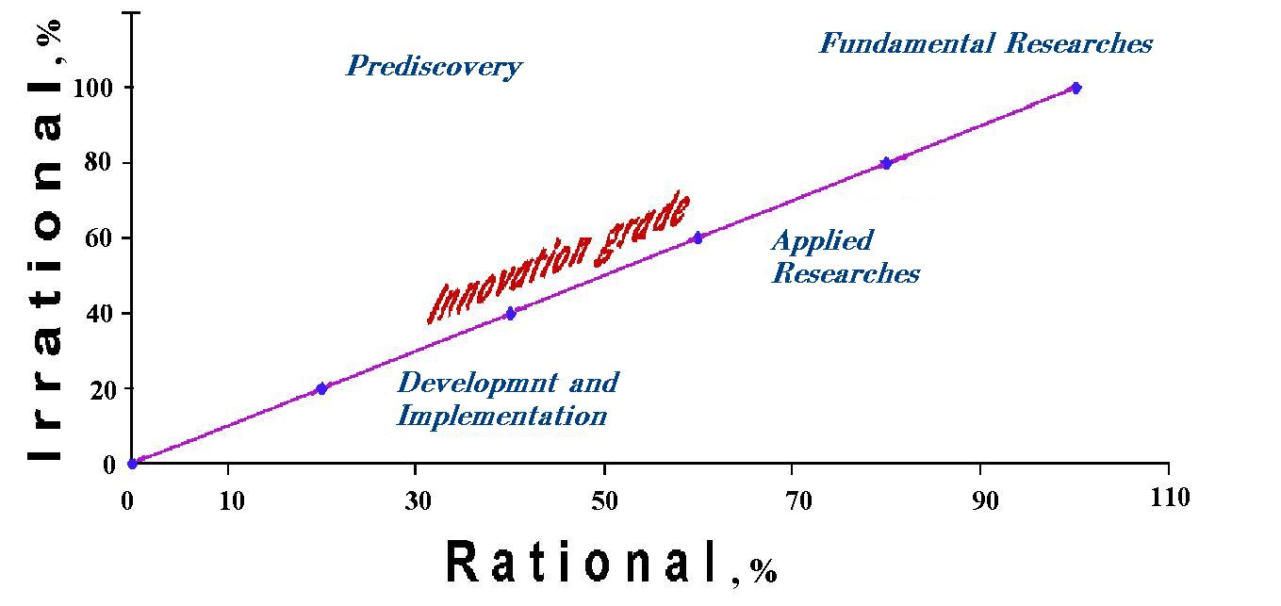

Fig. 1. The relationship of irrational and rational thinking and an innovative grade dependence for different types of engineering activitis.

see that every following exemplar has some feature of a previous one (Fig.2). This figure shows us one of a rule of an application for patent creation: every following step consists of the previous one.

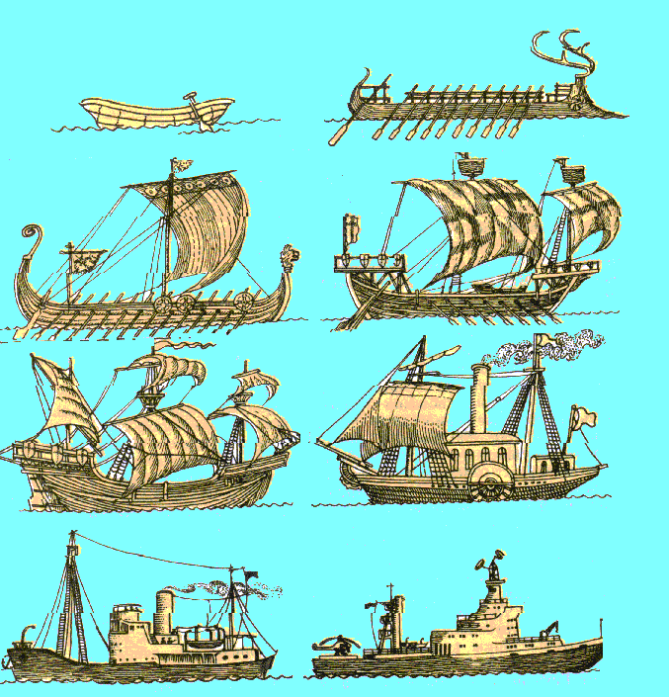

Fig.2 An example of more and more sophisticated models of ships as a result of a human creative work.

Looking at these ships we can follow the process of well-known idea transformation: oars plus clothing – quicker sailing… vapor plus clothing – quicker and more margin of safe… nuclear energy instead of electricity – more power, more time for sailing, more interval for velocity etc.
At present a man lives in the artificial environment. The logic of this environment development and evaluation depends only on intellect, knowledge and high moral principles of the human society.
To receive new perfect technical decision or to create new technical product is possible only if you know some methods. In application to engineering activities such method or methods are the methods of a creative work.
As a rule every stage of engineering activities consist of three creative acts. They are:
- "a guessing act" (an idea) which results in clear propose or intention;
- "a knowledge act" (a plan) which results in clear scheme;
- "a skill act" (an implementation) which results in final technical project creation or pilot construction formation.
So, at first it is necessary to understand what methods can be considered as methods of a creative work. The second step is learning of this methods through using them as an individual person, then as a member of a team , and it is necessary to try to reach the leader place in a team. During learning of methods of a creative work all modern technical devices and tools must be used. For example, database of physical, chemical effects, database of some constructional elements, database of known technologies etc.
The method of learning can be transformed by using interactive self-instruction technology. From our point of view this technology is generalized one. Then cognitive, instructional and training activities are the main and leading activities for a student. A professor will play role of a consultant. One way of dialogues between a student and a professor is a formation of interactive web-site (www.ipmadi.narod.ru). The Department of the Engineering Education of the State Technical University MADI has its own interactive web-site, where an information which is necessary for students is situated and where its professors can find students questions and demands. So, professors and students can better get to know each other.
It is necessary to note that the most active students after learning several courses of the Department of the Engineering Education use their new knowledge in practice. For example, during methods of a creative work learning namely "brain storm" or "value analysis" ("Engineering Creativeness Base") several students used rules of work in a team ("Psychology of Business Interaction"). The best student value analysis carried out when they received as a task "automobile system of gas waste getting off" bellowed to that students who learnt the both above mentioned disciplines. These student found necessary information about several systems, analyzed them, they found necessary constructional-technological documentation and made a creative analytical work to propose their own modernization steps to increase ecology safeness of this system. Naturally because of their small practical experience and knowledge these proposition are not real for implementation in the production But the main thing is that they begin their creative work, enjoy it and want to know more and do better.
It should note that every time when it was necessary to use some information from any fundamental discipline (i.e. room heater modernization require using of physical effects: Ohm's law, Joule-Lenz' law, Stefan-Boltzman law etc.) the best propose and the most literate propose came from students who had good knowledge in this concrete discipline. Contrarily after learning of "Engineering Creativeness Base" we can notice the motivation increasing to learn basic fundamental discipline and we can note some increase of marks level that students receive later (Fig.3).
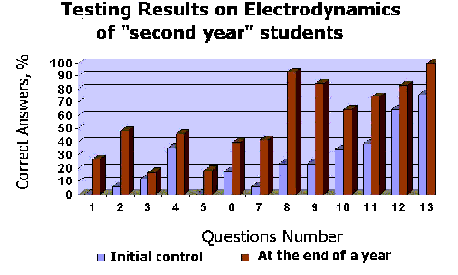

Fig. 3 The comparison of " the second year" students testing results on "Electrodynamics" fulfilled before and after "Engineering Creativeness Base" learning.

It is necessary to mention very interesting students projects carried out during learning methods of "brain storm" (increasing of walker safe in the street), of "focal objects" (it was several unexpected application of TV in the northern parts of the Earth) and "morphological analysis" (room heater modernization). Propounding of a technical problem was a task for students when the leakage of oil in 70th years of 20 Century was done as an example of global difficulty. Some students proposed their original decisions.
The analysis of correct answers shows that we receive approximately the expected Gaussian distribution. The initial questions (1-5) represents new material that students learned just before testing (brown raws). n the middle of diagram there are that questions which our students studied in school and then repeated them during their student life (blue raws)y see that after "Engineering Creativeness Base" learning the pattern of correct answers distribution is approximately the same one but correct answers percent increase (Fig.4)
Fig. 4. The comparison of correct answers patterns before and after "Engineering Creativeness Base" learning for "the second year" students.

Practical tasks for students, their questions and demands, testing results allow the o professors of the Department of the Engineering Education correlates tutorial programs to teach talented and creative engineers.
It should be note that humanities in engineering education, the role of natural sciences in engineering education appear to attract a dramatic attention of the professors worked in engineering education all over the world. It is enough to read the papers presented on the 31st International Symposium "Engineer of the 21st Century"[ ]. The most of papers highlight the importance of basic sciences as well as humanities and creative work for teaching the real engineers of the Future.

References
- Egelmeier P.K. Creative work theory, - Sankt-Petersburg, 1910
- Altschuller G.S. Creative work as an exact science. Moscow, ed. "Sovetskoie radio", 1979
- Zinovkina M.M. Engineering thinking (Theory and innovation pedagogical technologies), - Moscow, MGIU, 1996
- Sazonova Z.s., Chechetkina N.V., Tkacheva T.M. Interdiscipline course "Engineering Creativeness Base" as innovative pedagogical method in engineering education, in book "Innovation in Russian High School",-Moscow, 2002, p.p.188-196
- "Ingenieur des 21. Jahrhunderts", B.1, B.2, - Sank-Petersburg, 2002

