ON THE USE OF NUMERICAL MODELS AS SUPPORT FOR SOLVING ENVIRONMENTAL PROBLEMS IN COASTAL AREAS

Joseph Harari and Ricardo de Camargo

Abstract ⎯ Numerical models have been largely used for studying environmental systems – atmosphere, oceans, continents, polar areas, etc. These models solve the differential equations that describe the spatial and temporal variabilities of these systems, allowing simulations, hindcasts and even forecasts Coastal areas are particularly affected by environmental problems related to sea - air interactions and human activities: coastal erosion, water pollution, flooding of flat areas, etc. Numerical models may help engineering solving these problems by giving information on the behavior of the systems. The numerical models commonly used are: atmospheric models (for simulating winds and meteorological systems), wave models (wind generated sea surface waves), hydrodynamic models (ocean currents, sea surface levels and properties of sea water), and dispersion models (distributions of particles, substances or pollutants, in the atmosphere and oceans). Environmental issues and the use of related numerical models are presented, for study cases in the Southeastern Brazilian coastal region.

Index Terms ⎯ Numerical models, Atmospheric systems, surface waves, ocean currents, dispersion in the air and sea.

INTRODUCTION
Numerical modeling is the technique that makes use of mathematical and computational methods to represent and analyze physical events. In other words, numerical modeling simply takes the equations that describe a system and use them to simulate the changes in the system. With the right equations and proper mathematical techniques, scientists can use numbers and variables to create rather accurate portrayals of atmospheric and oceanic processes. The equations are solved for specific variables, which can be used in visualizations of how the atmosphere and ocean change with time.

Atmospheric and ocean dynamics are represented in the models by equations of conservation (of mass, momentum, heat, water vapor or salt, etc…), modified according to the spatial and temporal scales involved. Solutions to the equations are found through numerical methods (finite differences, finite elements, etc …).

Models may be used for hindcasts and forecasts, provided the necessary initial and boundary conditions to the equations.

A sequence of numerical models is being implemented by:

- Group of Oceanic Modeling of the Institute of Astronomy, Geophysics and Atmospheric Sciences of Sao Paulo University (Grupo de Modelagem Oceânica – GMOC, do Instituto de Astronomia, Geofísica e Ciências Atmosféricas da Universidade de São Paulo -IAGUSP) and
- Laboratory of Hydrodynamical Numerical Simulations and Predictions of the Institute of Oceanography of Sao Paulo University (Laboratório de Simulação e Previsão Numérica Hidrodinâmica – LABSIP, do Instituto Oceanográfico da Universidade de São Paulo - IOUSP).

The main objective of the models is to represent the most important physical aspects in the South Atlantic Ocean, with emphasis on the Eastern part of the Brazilian coast and continental shelves.

METHODOLOGY
Initially, the results of global meteorological operational models are obtained, as given by the Center of Weather Prediction and Climatic Studies (Centro de Previsão do Tempo e Estudos Climáticos – CPTEC, Brasil) and the National Climate and Environmental Prediction – NCEP, USA; their results for the South Atlantic (every 6 hours, with horizontal resolution between 200 and 250 km) are processed, graphically displayed and subsequently assimilated into a mesoscale meteorological model, the Regional Atmospheric Modeling System - RAMS (Cotton et al., 1982; Pielke et al., 1992); that allows the attainment of details of the surface winds and other variables of interest (with horizontal resolution of 32 Km, at every hour).

The surface winds are then transferred to the WaveWatch-III - WW3 (Tolman, 1991, 1999), a numerical model of third generation that represents the sea state (sea surface waves), with a horizontal resolution of 1/12°. This model solves the equation for wave action spectral density, assuming that the environment (bottom topography, currents) and wave field present variabilities in space and time with scales much larger than the scales of a single wave. The model equations include refraction and straining of the wave field due to mean depth and currents, growing or decay of waves due to winds, dissipation and bottom friction. The wave model is valid for ocean depths bigger than 40 – 50 meters.

The sea surface winds are also used as input to ocean circulation models, as the Princeton Ocean Model - POM (Blumberg & Mellor, 1987), in order to evaluate the ocean currents, surface levels and sea water properties of temperature, salinity and density (Harari, Camargo & Cacciari, 2000).

Finally, the ocean currents are used to estimate the dispersion of properties, pollutants and tracers in coastal areas, through the solution of the advection – diffusion – decay equation or, alternatively, through the Lagrangean tracking and random walk of particles (Harari & Gordon, 2001).

The operational predictions regularly performed by GMOC and LABSIP may be acessed in www.surge.iag.usp.br .

RESULTS
A selection of results will be presented, relative to the four kinds of model above cited.

Figure 1 shows CPTEC large scale analyzed fields for the period of 13 to 16 July 2000, relative to a frontal situation in the 13th and a new cyclone formation in the 15th and 16th.

A model prediction of sea surface waves is presented on Figure 2, giving the elevations and directions of propagation.

Simulations of the mean sea surface level in the harbor of Santos (Brazil) through a hydrodynamical numerical model of the Southwestern Atlantic (POM) are presented on Figure 3, considering inputs given by a large scale atmospheric model (CPTEC) and a regional one (RAMS); this figure also shows the good agreement between these numerical simulations (with horizontal spacing ranging from 7800 to 9100 m) and observations (which tidal oscillations were filtered out).

Figure 4 shows a prediction of sea surface currents in the oceanic area off the Southeastern Brazilian shelf, with a horizontal resolution of 1/12° in longitude and latitude. In this case, the model was forced by surface winds (predicted by the large scale atmospheric model of NCAR), density effects (with climatological values of temperature and salinity), tides and mean sea level at the open lateral boundaries (given by a global model of tides and climatological values of dynamic depth, respectively).

Simulations of the dispersion of continuous substances and particles are presented on Figure 5, for the coastal area of Santos, under the effects of tides and NE winds.

CONCLUSIONS
This publication presents recent developments in operational and theoretical numerical models which can be useful for practical applications in several human activities, such as navigation, fishing, coastal protection, prediction of severe meteorological conditions and coastal flooding, water quality control, air and sea pollution prevention, among many others.

For future research, coupling of these physical models to biological / geological ones and making available the model results to authorities and policy makers is recommended.

Acknowledgment
The authors are grateful to the Institute of Oceanography of the University of Sao Paulo (Instituto Oceanográfico da Universidade de São Paulo – IOUSP) and Institute of Astronomy, Geophysics and Atmospheric Sciences of the University of Sao Paulo (Instituto de Astronomia, Geofísica e Ciências Atmosféricas da Universidade de São Paulo – IAGUSP) for their support in the modeling researches and operational implementations.

references
BLUMBERG, A.F. & MELLOR, G.L. 1987 A description of a three-dimensional coastal ocean circulation model. In: Three-Dimensional Coastal Ocean Models, Vol. 4, American Geophysical Union, Washington D.C., 208p.

COTTON, W.R., STEPHENS, M.A., NEHRKORN, T. & TRIPOLI, G.J. 1982. The Colorado State University three-dimensional cloud/mesoscale model - 1982. Part II: An ice phase parametrization. J. Res. Atmos., 16, 295-320.

HARARI, J. & CAMARGO, R. & CACCIARI, P. L. - 2000 - “Results of hydrodynamical numerical modeling in three-dimensional simulations of tidal currents in Baixada Santista” – Brazilian Review of Hydrologic Resources, vol. 5, n° 2, p. 71 – 87.

HARARI, J. & GORDON, M. - 2001 - “Numerical Simulations of the dispersion of substances in the Port and Bay of Santos, under the action of tides and winds” - Brazilian Review of Hydrologic Resources, vol. 6, n° 4, p. 115 – 131.

PIELKE, R.A., COTTON, W.R., WALKO, R.L., TREMBACK, C.J., LYONS, W.A., GRASSO, L.D., NICHOLLS, M.E., MORAN, M.D., WESLEY, D.A., LEE, T.J. & COPELAND, J.H. 1992. A comprehensive meteorological modeling system - RAMS, Meteorol. Atmos. Phys., 49, 69-91.

TOLMAN, H.L. 1991. Effects of numerics on the physics in a third-generation wind-wave model. J.Phys.Oceanogr., 22, 1095-1111

TOLMAN, H.L., 1999. User manual and system documentation of WAVEWATCH-III version 1.18. NOAA / NWS / NCEP / OMB, Technical Note 166, 110pp.

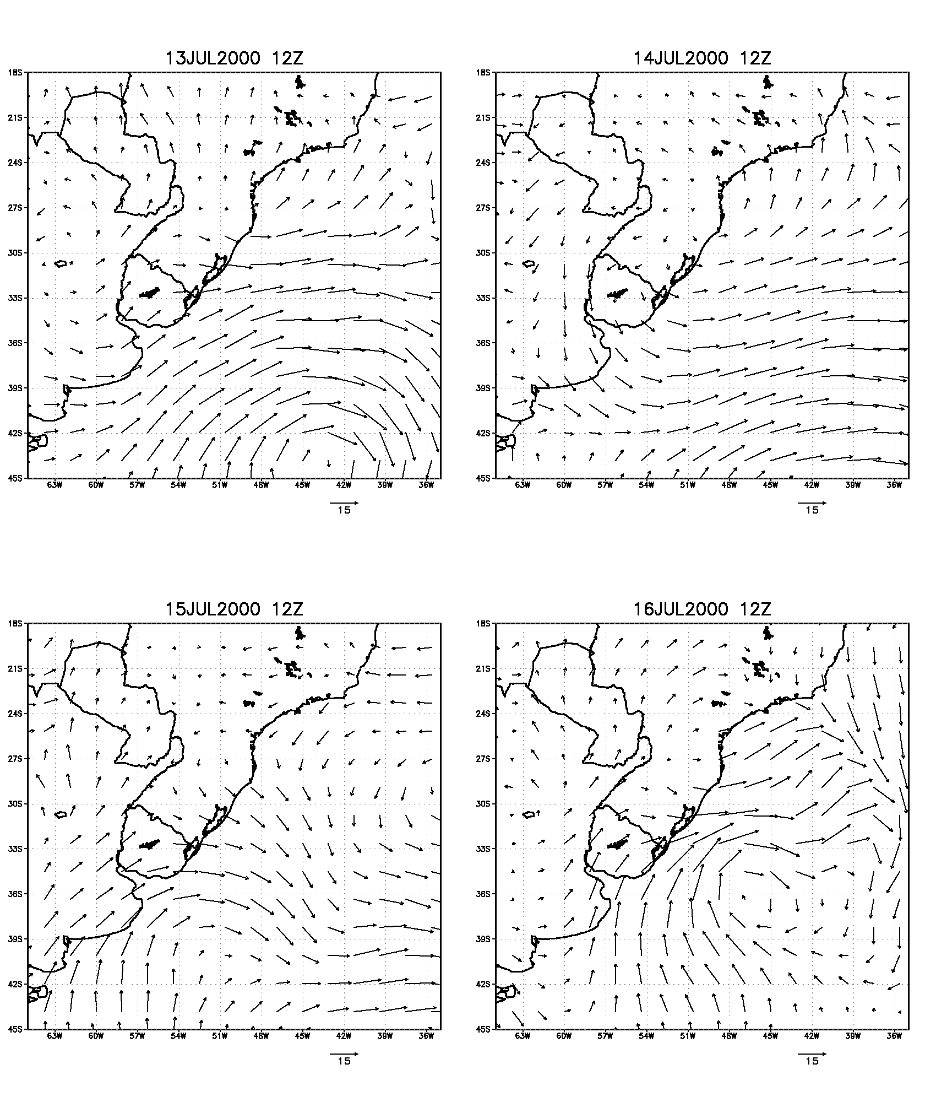

Fig. 1 - Surface winds (m/s) from CPTEC analyzed fields.

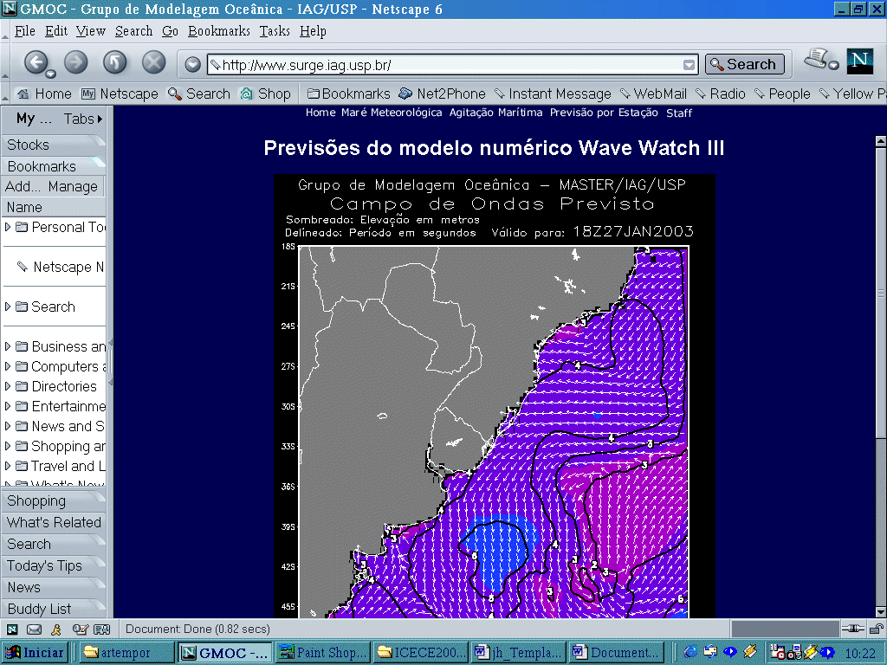  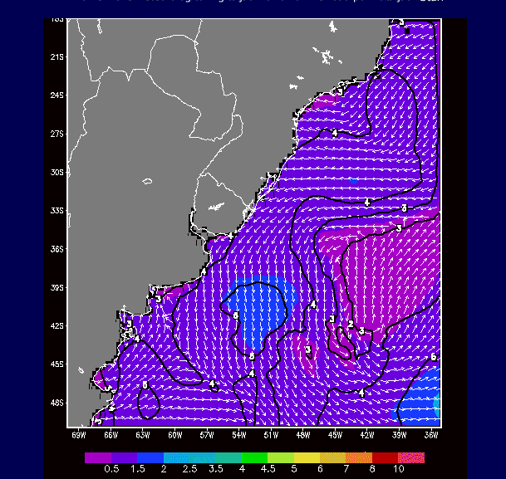 | Fig. 2 – Prediction of wind generated surface waves through the model Wave Watch III,  for 18 Z 27 January 2003 (heights in meters).
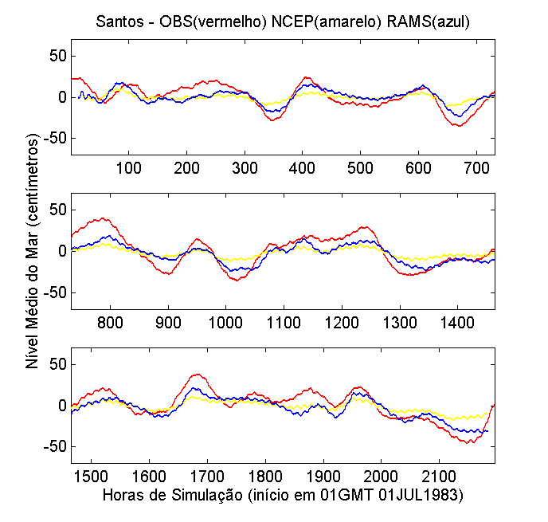
Fig. 3 – Comparing mean sea level oscillations in Santos (SP, Brazil) in the period from July to September 1983: filtered observations (red), results of hydrodynamical model forced by NCEP winds (yellow) and results of the same model forced by RAMS winds (blue)
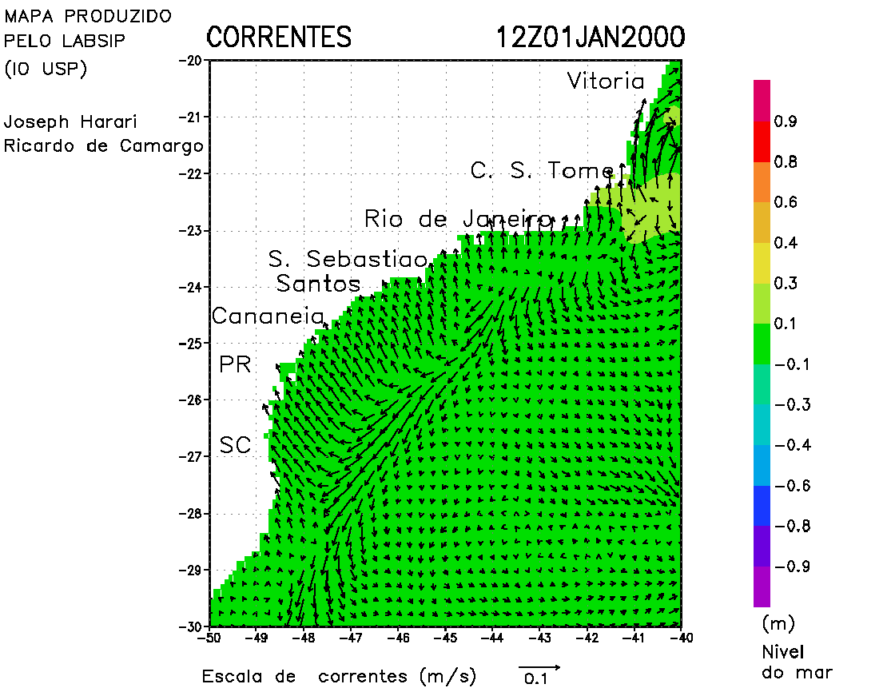
Fig. 4 - Surface currents given by hydrodynamical model forced by winds, density variations, tides and
mean sea level oscillations.
Fig. 5 – Solutions of dispersion models, for continuous substances and particles in the coastal region of Santos (SP, Brazil), subject to tides and NE winds.

Joseph Harari – Institute of Oceanography of the University of Sao Paulo, Sao Paulo, Brazil, joharari@usp.br
2 Ricardo de Camargo - University of Astronomy, Geophysics and Atmospheric Sciences, Sao Paulo, Brazil, ricamarg@model.iag.usp.br

