INTEGRATING ENGINEERING CURRICULUM USING COMPUTER BASED MANUFACTURING TECHNOLOGIES

Vedaraman Sriraman

Abstract ⎯ Pressures due to global competition have forced manufacturers to continually diminish the product development time. In response to this challenge, time compression technologies are being used by industries to speed up the product development time. Time compression is effected through the application of such technologies as rapid prototyping (RP), Computer Aided Design (CAD), Computer Aided Manufacturing (CAM), rapid tooling and various casting and molding processes. It is important to expose engineering students to these computer-based tools. Rather than present these diverse tools in a piece meal fashion, it is important to expose students to the integrated applications of these tools in a capstone fashion. This paper details a National Science Foundation (NSF) funded project that was conducted at Southwest Texas State University (SWT) in which students were made to experience the entire product cycle from design through manufacture, using a "hands-on", integrated laboratory approach featuring the application of several time compression technologies such as rapid prototyping, rapid tooling, CAD and CAE.

Index Terms ⎯ Curriculum Integration, Rapid Prototyping, Rapid Tooling, and Time Compression Technologies.

Introduction
This paper primarily describes an engineering curriculum integration effort that was carried out at SWT with support from NSF. The following summarizes the results of a literature survey that was used to drive our curriculum development efforts.
In a report published by the Society of Manufacturing Engineers (SME) entitled, "Manufacturing Education for the 21st Century: Manufacturing Education Plan" [1], the following competency were identified in current graduate engineers – concurrent engineering, product engineering, CAD/CAM, manufacturability, material selection and application and tooling. A survey conducted by the Mechanical Engineering Department [2] at Seattle University, in which nearly 100 manufacturing companies were asked to comment on current and future manufacturing practices and on curriculum recommendations, revealed that CAD, concurrent engineering and computer simulations were cited amongst the top ten manufacturing technologies. Based on these studies, it was concluded that it was important to teach the applications of rapid tooling and other time-compression technologies that center around RP such as CAD, CAE, CAM, investment casting, and injection molding [3]. Rapid tooling has been defined as tooling constructed from RP machine output and resulting in parts molded from production materials [4]. The concept of rapid tooling is becoming increasingly popular as a method of saving time and money [5].
In their NSF project of 1997 [6], Higley and Kin involved the use of industrial quality equipment to implement integrated design/manufacturing projects in which students could experience the complete product cycle from product inception through recycling. Based on these prior works, it was concluded that SWT's curriculum efforts would focus on:
- inclusion of RP, rapid tooling, CAD, CAM, other computer-based time compression technologies.
- the use of senior-level laboratory projects to provide students the opportunity to experience the entire product cycle. This would be effected by bringing to bear the integrated application of computer tools from several engineering courses to the solution of the senior project.

Once our goals were established, the next stage was the procurement of funds to support this initiative.

Our Approach
The NSF was determined to be a primary funding agency with priorities that were similar to our goals. Therefore, in Fall 1998, a proposal was sent to the NSF that focused on curriculum development and capital equipment.
The project impacted three courses directly. These are TECH 2310 – Machine Drafting, TECH 4330 – Foundry and Heat Treatment, and TECH 4310 – Technical Drafting (now Tool Design).
The lower level machine drafting course was used as a vehicle for introducing the concept of design and rapid prototyping. Other lower level courses such as ENGR 2300 – Materials Engineering and TECH 2332 – Material Selection and Manufacturing Processes provided students background in materials and processing. Once these basics were individually covered in these lower level courses, the upper level classes (TECH 4330 and TECH 4310) permitted students to experience the entire product cycle through the avenue of laboratory projects. Thus, our curriculum development efforts focused on reengineering these existing courses to incorporate the aforesaid innovations.
Curriculum development in turn led to the choice of capital equipment. Accordingly, the following equipment was deemed essential for project implementation:
- Stratasys FDM 3000 Rapid Prototyping Machine.
- Investment Casting Equipment
- Mini-Jector 45 Injection Molding Machine.

The equipment sought through grant funding was complemented by other equipment and facilities that were already available and on hand. These included:
- CAE laboratory with 16 engineering workstations that were loaded with Pro/ENGINEER (for solid modeling), Algor (for Finite Element Analysis) and AFS Solid (for solidification modeling).
- Helisys LOM 1015 RP machine.
- Foundry and Heat Treatment laboratory with general sand casting capabilities.
- Automated Machining laboratory with a three-axis Bridgeport machining center and a Browne and Sharpe coordinate measuring machine (CMM).

The grant was funded in Fall 1999 and lasted until Summer 2001.

Details of Project Implementation
For purposes of convenience, this section is detailed through the medium of one of three courses previously cited, i.e. TECH 4330, to explain how curriculum integration was achieved.
One of the areas in which rapid prototyping and time compression technologies have had a major impact on product lead-time is in metal casting. With the advent of CAD, CAE, RP, and common format file transfer (such as the STL format), it has become very easy to take advantage of many manufacturing engineering applications using a single data base. Just 8 or 10 years ago, castings were typically produced using hand made or hand machined patterns. In just a short time however, advancements in computer based technologies have totally redefined the rules for the metal casting industry.
Students who enroll in this course would have typically completed prior courses in CAD, materials science, quality assurance, RP and fundamentals of manufacturing processes. In this course, lecture and laboratory activities include castings design, heat preparation, spectrographic analysis, the relationship between heat chemistry, cooling rate and microstructure and all of the standard tests that are currently used to provide manufacturing engineering with the ASTM traceability for cast products.
Towards the conclusion of the semester, students are assigned a capstone project wherein they design, analyze, optimize and manufacture a cast part. Students use CAD and CAE tools to design and optimize the castings. RP is used to support manufacturability analysis and generate the pattern/tooling. Students have to deal with issues such as recycling of the casting and molding materials. Thus, they have an opportunity to experience all aspects of the product cycle.

Case Study
An example of a senior design project involved re-engineering a brake drum for a forklift (see figure 1). The brake drum was broken and neither spare parts nor engineering drawings were available. Measurements from the old brake drum were used to create a solid model of the same in Pro/ENGINEER (see figure 2). Students selected a material for the brake drum based on functionability, castability, machinability, and cost.
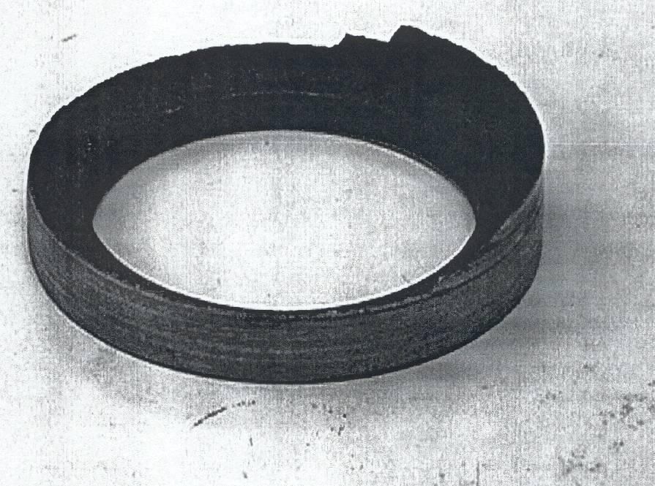
FIGURE. 1
Broken Brakedrum

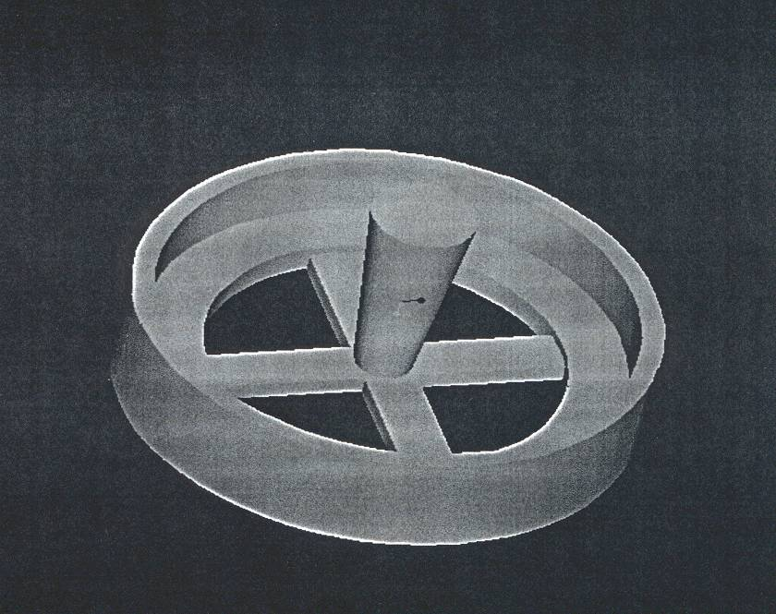
Figure. 2
Parametric Solid Model

Next, a stereolithography (STL) file of the part was generated. This file was used as an input to the RP process (Stratasys FDM machine, see figure 3). Once the prototype was developed, it was evaluated for form, fitness, draft angles, machining allowances and shrinkage allowances.
Subsequently the rigging system was determined, modeled in CAD, and assembled on to the casting. This model was used as an input to AFS Solid to perform a solidification analysis. Upon completion of this analysis, students used outputs such as temperature distribution, solidification time, critical fraction solid, porosity and hot spots to refine the rigging system.

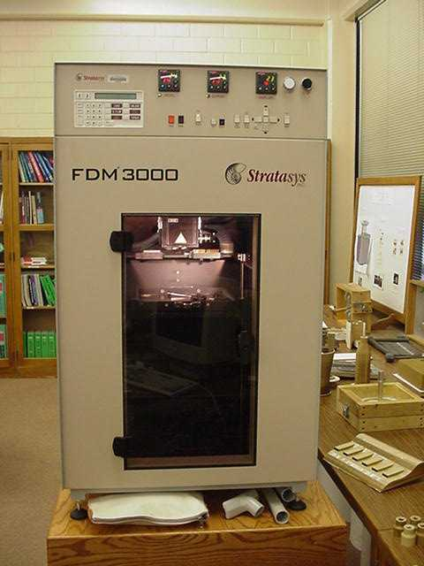
Figure. 3
Stratasys FDM Machine

The next step involved creating a match plate model in Pro/ENGINEER for the brake drum (see figure 4). An STL version of this model was input to the Helisys LOM RP machine, so as to produce the appropriate tooling.

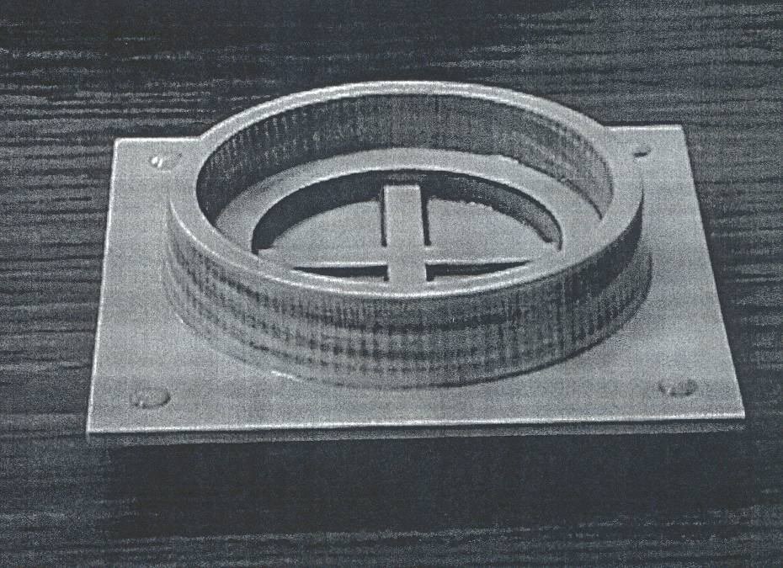
Figure. 4
Rapid Prototype of Tooling

Lastly, the match plate was used in the Metal Casting laboratory to make molds in sand. The mold was poured. Upon solidification the cast part was retrieved. The final product was obtained by machining the cast product in the Material Removal laboratory. At this point in time, students assisted the instructor in recycling the molding sand and excess metal.

Conclusions
Student reactions to the capstone design experience have been very favorable. Many students are able to assemble the pieces of knowledge that they had learned in specific courses towards the solution of a common engineering problem. Thus, a key result of our grant undertaking was that the laboratory project helps students see the "big picture". As engineering and technology knowledge base keeps growing, a significant dilemma confronts engineering educators. On the one hand dedicated courses are required to teach specific bodies of knowledge such as material science, processes, controls, design, etc., while on the other it is important that students "see" the interconnectivity between these specific bodies of knowledge. This paper outlined one such approach to curriculum integration.

Acknowledgement
The author gratefully acknowledges support from the National Science Foundation – Course, Curriculum and Laboratory Improvement Program, DUE #9950816. Drs. G. Winek, R. Habingreither, and J. DeLeon who worked with the author on the NSF grant are also acknowledged.

References
[1] SME. "Manufacturing Education for the 21st Century: Manufacturing Education Plan", Society of Manufacturing Engineers, Dearborn, MI, 1997.

[2] Mason, G. "Results of an Industry Survey on Manufacturing Engineering and Manufacturing Engineering Education", Journal of Engineering Education, V89, n3, July 1998.

[3] Sriraman, V., Winek, G., DeLeon, J., and Habingreither R. "Rapid Tooling and Time Compression Technologies", NSF-CCLI Proposal, DUE # 9950816, Arlington, VA, 1998.

[4] Tait, D.M. "Big Parts, Big Savings: An Economic View", Proceedings of the 1995 Rapid Prototyping and Manufacturing Conference, Dearborn, MI, May 1995.

[5] Sriraman, V., Winek, G., and Habingreither, R. "Tooling Applications of Rapid Prototyping", Journal of Engineering Technology, Vol. 16, No. 1, Spring 1999.

[6] Higley, J.B., and Kin, Y.B. "Computer Integrated Design and Manufacturing Laboratory", NSF-ILI Proposal, DUE # 9750743, Arlington, VA, 1997.

Vedaraman Sriraman, Department of Technology, Southwest Texas State University, 601 University Drive, San Marcos, TX 78666, vs04@swt.edu

