ENHANCING STUDENTS LEARNING IN ELECTRONICS THROUGH THE USE OF COMPUTERS AND LEARNING BOARDS

Smail Djirar

Abstract ⎯ This work uses available software tools to enhance student learning and to improve online delivery by the practical aspect added to the courses. Through the use available and easy to use software packages and applications learning boards online courses can be more interesting and attractive to students. The boards can also used to enhance the students learning outside normal classes. These learning boards are designed for Electronics Engineering courses. They can also be used in different modules of the curriculum. Students will get more skills by the use of more simulation packages such as Electronic Work Bench and Lab View. Through the whole process students get also to use different software applications such as PCB design software, Office applications. Several learning boards have been designed and built already.
Each learning module can consist of but not limited to:
- Construction guidelines of the circuit;
- Computer –based simulation to analyze the circuit;
- Practical activities related to the appropriate topic;
- Mathematical activities.
A set of language activities for developing both written and oral skills, based on the technical content of the module can be added because our students are Arabic speakers.
The online teaching will be improved and the practical aspect is enhanced. The Virtual instruments are generated by Lab View software package. The Virtual Instruments are used for the necessary signal generations and measurements. All signal generations and measurements are done through a data acquisition card.
Once the goals and objectives of each module are specified, the boards can be used in different courses according to their mapping into the curriculum.

Index Terms ⎯ E-learning, E-Lab, Online, Virtual Instruments.

Introduction
This paper describes how the use of software and the introduction of computers (Laptops) have made easier and enhanced the learning of electronics courses.
Learning boards [4] have been developed to be connected to the laptops. The learning boards are give students the opportunity to have an e-lab. The e-lab consists of these learning boards and a virtual instruments software package.
The whole system consists of a set of software applications, a set of vitual instruments, a data acquisition card, and a set of learning boards. The method is then to give students a set of activities in Electronics related to theie courses. In the following sections all these components are described.

Learning Modules

Learning modules are constructed by students on 160 mm over 100 mm printed circuit board. Students are asked to build a practical circuit on a pre-designed printed circuit board. They are are provided with construction guidelines and the necessary components. At this stage, students use also PCB design software (e.g. Niche ).
The other software application, students after the construction of the board , is the use of a simualtion package. The simualtion allows studens to observe the behaviour of the circuit . The comptuer –based simulation for the whole project is Electronics Work Bench [1].
Once the test measuremnts are passed, students are rady to use their boards with laptops.
Each module contains the goals and objectives. Practical activities related to the appropriate topics have been designed.

Elab
The boards can be connected to a computer or a laptop. The connection is done through a data acquisition card. The card used in the project is a National Instruments card [2]. It has channels for analog inputs, anlog outputs, digital inputs and outputs.
Virtual Instruments are available, from National Instruments LabView [3] package, such as variable power supply, function generator , oscilloscope and digital multimeter. These instruments and the learning boards allow students to undertake all the practical activities designed for the learning modules. Figure 1 shows the elab system consisting of a laptop containing adata acquisition card connected to a learning module.

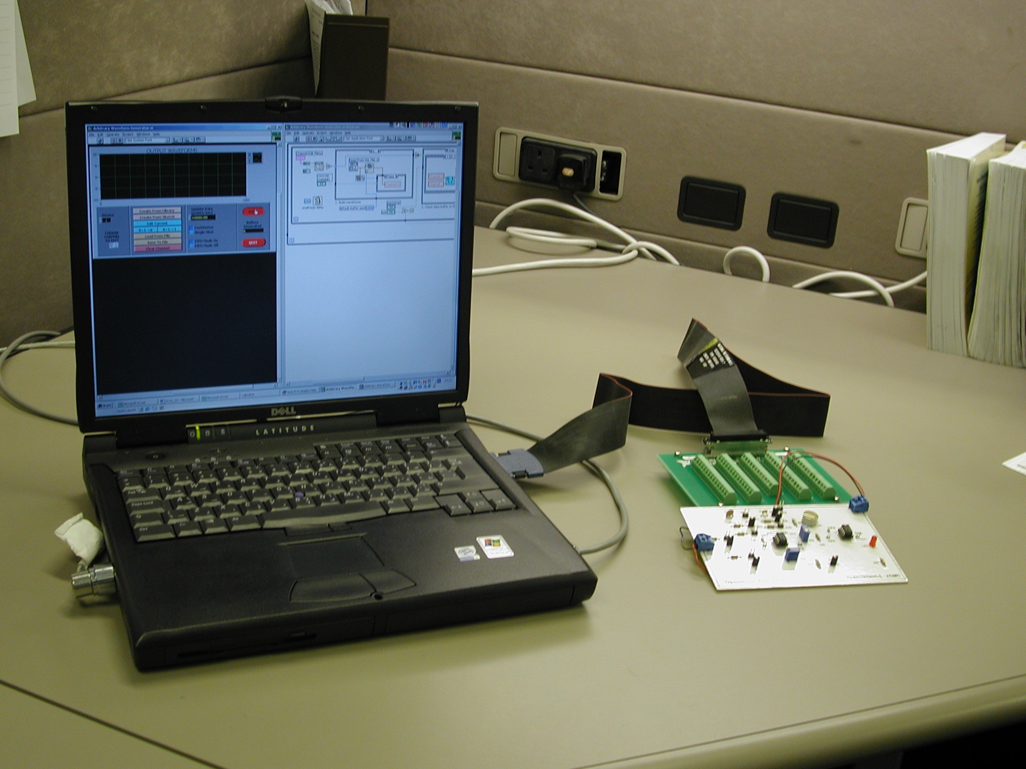
Figure 1: Elab system

The elab will be used soon in an online course. The course is on instrumentation and control fundamentals. One goal of this course is on signal conditioning. Students will be have the opportunity to do practical experiments related to this
topic anywhere and anytime. They will have the possibilty to have more hands on activities outside the normal college hours.

Activities and Corresponding Software
As it was mentioned before, each learning module consist of several activities. Following are the acticities and their associated software:

- Module construction: At this stage students use a PCB design software such as Niche. A pre-designed printed circuit board
- Simulation: Simulation package such Electronic Work Bench helps students to investigate the behavior of the circuit. They can add, modify components. The aim is to get a clear idea about the response of the circuit for a given input.
- Practical activities: Pre-designed practical experiements are undertaken by students through the elab system, described previously.
- Mathematical activities: A maths activity sheet related to essential skills for circuit analysis is alos provided to students. This will give students a better of the theoritical concepts of the circuits.
- Software applications activities: A spreadsheet-based analysis of the circuit is also provided to students.
Extension to online Courses
The Elab system is being extended to be used to online courses. It is being tested in particular with an online course. It is an introduction to instrumentation and control systems. The course investigates the basic principles of instrumentation and control systems, practical laboratories and industrial field trips. Topics include: examples of process control and automation systems, measurement systems, final control elements, signal conditioning systems, piping and instruments diagrams.
The focus is on signal conditioning. The goal is to investigate to the possibilty for students to undertake practical experiments using a laptop, a practical board and some Virtual Instruments as was mentioned previously.

Conclusion
The learning boards were tried with some students and they were very useful. Students enjoyed learning electronics. The main issue is that students were more interested because it applies to students with different learning styles.
The extension to the online course. The students were less confident at the beginnig but later they become more confident as they learned the logging process, and they other features of WebCT. They can build and test the learning boards. The next stage is to try the learning modules with their laptops.

References
- Electronics workbench, Technical, reference manual, by Interactive Image Technologies, 1997.
- DAQ, User Manual , National Instruments, 2000.
- LabVIEW Resources, http://www.ni.com.
- 9705 QTL Summary report, http://imtcsamba.hct.ac.ae
- Djirar, Smail , “Applications boards for Enhancing Students Learning”, Proc. STCEX2002, October 2002.

? Smail Djirar , Faculty of Electronics Higher Colleges of Technology, PO BOX 25035, Abu Dhabi, United Arab Emirates, smadjir@emirates.net.ae

