Effects of Controlled Ramp-Downs/Ups for Cryogenic Processing of Rapid Prototyped Materials

J. Jackson¹, G. Chapple¹, J. Do¹, X. Zhuang¹, M. Mendelson¹, R. Noorani¹, B. Fritz²

Abstract ⎯ Rapid Prototyping (RP) turns a virtual three-dimensional drawing into a solid structure and useable part. Increasing the material properties of RP materials allows rapid prototyped parts to be employed in a wider variety of applications. The major goal of this study is to increase the scope of usage of RP materials through cryogenic processing by optimizing the combination of strength and ductility for the stereolithography photopolymer epoxy resin DSM Somos 8110. The research will investigate (1) the effects of cryogenic processing of prototyped samples, (2) the effects of controlled ramp-downs/ups on the ultimate and tensile strengths of samples,(3) the equipment and procedures used, (4) the results and analysis of the experimental data. Test specimens of RP thermosetting resin (DSM-Somos 8110) were fabricated and cryogenically aged from 10-25 hours. The tensile strength and impact toughness were measured.

Index Terms ⎯ Rapid prototyping materials, cryogenic processing, tensile and ultimate strengths

Introduction

The primary objective of this research is to apply cryogenic processing to Rapid Prototyped materials. Cryogenics is the science and art of producing cold. It started in 1877 when two scientists, Cailletet in Paris and Picet in Geneva, developed a procedure to liquefy oxygen in a laboratory[1-2]. Nowadays, nitrogen and helium are the most common cooling media. Since the normal boiling points of nitrogen and other permanent gases such as helium, oxygen and argon are about 120K (approx. –244 ºF), the cryogenic temperature is generally considered 120K or below [3-4].

Cryogenic processing is one of the most important fields in industry today [4]. It helps to reduce costs for industry and increase industrial efficiency. For example, industrial
application has reported 195% to 817% increase of wear

resistance for standard steel that was cryogenically treated [5]. The cryogenic process consists of 3 stages based on time and temperature variables. This process starts with gradual ramping down of temperature to a specific point, then the temperature is held at that point for a period of time, then the temperature is brought up to room temperature . As a result of this deep cooling and heating cycle, molecular changes occur, binding the atoms in the metal together [4].

Over the last 10-20 years, not much research has been conducted on cryogenic processing. Most research that was done on cryogenics was on metals. Rapid Prototyping (RP) is a new technology that takes information from a computer-aided design file and makes a 3D part by building it one layer at a time [5]. When RP was first introduced in the late 80’s, the materials used to produce the parts had low yield strength. Our research attempts to show that the strengths of RP materials can be increased by cryogenically processing the samples before its industrial applications. As mentioned before, in all the cryogenic work, the scientists and engineers basically lowered the temperature of the sample to cryogenic condition very fast, held it to the temperature for a few hours and then ramped up the temperature as fast as possible [4,5]. Two years ago, the author did research on the cryogenic processing of both ABS plastic from Fused Deposition Modeling (FDM) and DSM SOMOS 8110 using Stereolithography Apparatus (SLA)-250 machines. While the cryogenic processing did not have much effect on ABS plastic, the yield strength of DSM SOMOS was increased between 25-50% [6]. The author believes the ramp-down and ramp–up conditions might make a significant contribution to the increase in strength of the polymer samples.

The author has recently developed a Data Acquisition System (DAS) using LabVIEW from National Instruments that provides us the programming power for the ramp-down and ramp-up conditions. The conventional and proposed cryogenic processes are shown in Figures 1and 2.

¹J. Jackson, NSF Research Experiences for the Undergraduate (REU), Loyola Marymount University, Los Angeles, CA, USA
¹G. Chapple, NSF Research Experiences for the Undergraduate (REU), LMU, Los Angeles, CA, USA
¹J. Do, NSF Research Experiences for the Undergraduate (REU), LMU, Los Angeles, CA, USA
¹X. Zhuang, , NSF Research Experiences for the Undergraduate (REU), LMU, Los Angeles, CA, USA
¹M. Mendelson, NSF Research Experiences for the Undergraduate (REU), LMU, Los Angeles, CA, USA
¹R. Noorani, , NSF Research Experiences for the Undergraduate (REU), LMU, Los Angeles, CA, USA
²Boris Fritz, Northrop Grumman Corporation, El Segundo, CA, 90045

NSF REU PROGRAM AT LMU
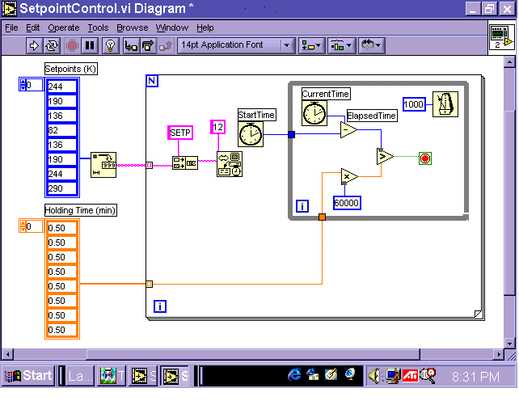
LMU received an NSF grant two years ago to establish a research experience for undergraduates (REU) site. The objective of the proposed REU site program is to provide, each year, 20 community college students and four LMU students the opportunity to engage in engineering research on meaningful projects during a ten week summer period. Community college participants are recruited from the twenty community colleges in closest proximity to LMU. A further objective is to attract students from those groups traditionally under-represented in the engineering profession. The work is conducted under the guidance of two faculty who has much successful experience in directing undergraduate students in research work. The results of the research are published in journals and reviewed conference proceedings. The goal of the program is to inspire the students to complete their undergraduate study and go on to participate in research at the graduate level.
Figure 4. Temperature Setpoint vi Diagram
Experimental Procedure
Equipment and Process
The following major equipment was used in this research.

- Northrop Grumman SLA-250 RP Machine
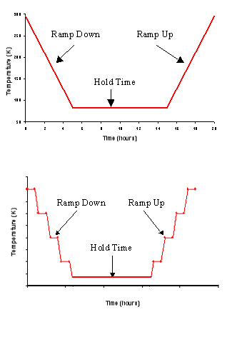
- Cryogenic Treatment Equipment
- Instron Tensile Testing Machine
- Izod Impact Tester
- Scanning Electron Microscope (SEM)

The experimental setup if shown in Figure 3.

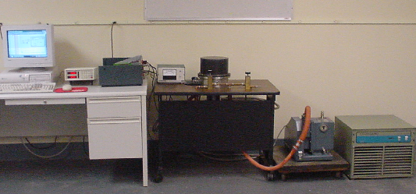
Cryogenic Chamber
Temp Control
Vacuum Pump
Cryogenic Pump
Figure 1 Conventional Cryogenic Processing
Figure 3. Experimental setup for cryogenic processing.

The following outlines the steps used in the experimental process that was used to design, fabricate, test and analyze the samples.
Figure 2 Proposed Cryogenic Processing
      - Design Dog Bone and V-Notch Samples
      - RP Machine Builds Parts from Design
      - Expose Parts to Cryogenic Treatment with Liquid He.
      - Tensile and Impact Testing

The programming of the temperature controller using LabVIEW 6i is shown in Figure 4.

Designing and Prototyping the Samples

Drawings of the dog bone and v-notch shaped samples were created using AutoCAD (Figs. 5A and 5B) and these were saved as separate .DWG files. These files were then converted into STL format for use with stereolithography software. SLA-250 (Northrop Grumman) RP machines was then used to rapid prototype the parts.

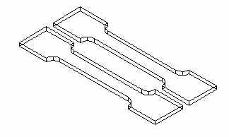
Figure 5A. Two dog bone-shaped samples.

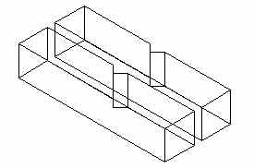

Figure 5B. Two v-notch-shaped samples.

Cryogenic Treatment
The following process was used to cryogenically treat each sample.

- All samples except the baseline went through cryogenic treatment before testing. The samples were prepared at Northrop Grumman, and cryogenically aged at Loyola Marymount University.
- The cryogenic process is characterized by three parameters: ramp-down time from room temperature to 88K (–300ºF), hold time at 88K, and ramp-up time from 88K to room temperature.
- Preliminary experiments were performed on cryogenic treatment. The ramp-down time of 14 hours was used. Three holding times of 10, 15 and 20 hours, and ramp up times of 14 hours were used.
Samples are labeled as follows: XX-XX-XX. The numbers represent the ramp-down time, holding time and ramp up time, respectively, in hours. (e.g: 14-10-14 means that the samples were ramped-down in 14 hours, cryogenically aged 10 hours, and then ramped-up in 14 hours.)
Tensile Testing and Izod Impact Testing

The yield and ultimate strengths of the samples were measured using the Instron Universal Testing Instrument 4500. The cross-head speed of the test machine was 0.0212 mm/s. The interface with the machine was performed using the front panel and a software program running on a desktop computer. Izod impact testing is performed to determine the toughness of a material. The sample is made with a centered v-shaped notch. During the impact testing, the sample is subjected to a quick and intense blow by a hammer pendulum. The impact test evaluates the material’s resistance to crack propagation. The impact energy absorbed by the sample during failure is determined by calculating the difference in potential energy of the hammer.

Results and Discussion
Tensile and Impact Testing

The results of the yield strength and ultimate strength vs. cryogenic treatment time (0-20 hours) are shown in Figures 6A, 6B. In both cases, the strengths appear to be affected by aging time. To verify these results, the data were statistically analyzed using multiple t-testing, which compared the means of two treatments at-a-time at a 0.05 level of significance [7]. A one-way analysis of variance (ANOVA) could not be used, because the variances of the treatments were unequal. For the yield strength data (Figure 6A), it was determined with 95% confidence that the means of the treatments were statistically insignificant. Due to the large variances at 15 and 20 hours, we can say that there was no significant increase in the yield strength with aging time.

For the ultimate strength (Figure 6B) vs. aging time, the data were analyzed in the same way. Again, one-way ANOVA could not be used. Multiple t-testing on the treatment means showed that for 95% confidence two conclusions were reached: (1) the mean strengths at 0, 10 and 20 hours were equivalent, and (2) the mean strength at 15 hours was significantly lower than that at 10 and 20 hours. Hence, aging time produced a drop in the ultimate strength between 10 and 15 hours. Otherwise, there was no significant effect of cryogenic aging on the ultimate stress.

The effects of ramp-up times on the yield strength and ultimate strength are shown in Figures 7A and 7B. In both cases, the strengths appear to be negatively affected.

Figure 6A. Yield Strength vs. Cryogenic Aging Time.

Figure 6B. Ultimate Strength vs. Cryogenic Aging Time.

Figure 7A. Yield Strength vs. Ramp-DOWN Time

Figure 7B. Ultimate Strength vs. Ramp-DOWN Time

Conclusions and Recommendations

Based on the findings from our research, the following conclusions and recommendations can be made:
1. DSL-Somos 8110 test specimens were fabricated by stereo-lithography using SLA-250 RP equipment. The specimens were laser cured by pulling the specimens parallel to the tensile axis.
2. The test specimens were cryogenically treated by a ramp-down cycle from room temperature to 88K in 14 hours, a hold cycle of 10 - 20 hours, and then a ramp-up cycle from 88K to room temperature in 14 hours.
3. Due to large data scatter, the yield strength and impact energy were not affected by cryogenic aging treatment. Only the ultimate strength exhibited a significant decrease with aging treatment from 10 to 15 hours.
- The yield strength of slower ramp-down decreased exponentially while the ultimate strength did not show any positive increase, indicating that the slower ramp-down did not have any effect on the cryogenic processing of DSM SOMOS 8110.
5. It was expected that the wide data scatter was caused by microscopic steps and their associated defects at the fillet radius of the tensile specimens. Samples with steps and defects had lower strengths, and those without steps and flaws had high strengths. The variability in the surface texture of the fillet radius caused a wide variability in the tensile strength and impact energy.
6. For future work, it is recommended that the SLA specimens be rapidly prototyped normal to the face of the dog-bone specimen. This will hopefully reduce the data scatter, which currently masks any potential effect of cryogenic aging time on the tensile strength and impact energy.

Acknowledgements

The work was partially funded by an NSF Grant under Research Experiences for Undergraduates (REU). The authors also appreciate the support provided by the Northrop Grumman Corporation.

References

[1] Scurlock, R.G., “History and Origins of Cryogenics,” Institute of Cryogenics, University of Southampton, UK. Oxford: Clarendon Press. 1992.

[2] Chhabra, V., “Ingenious Cryogenics: Gainsville Inventor Frank Masyada Brings the Future to Our Fingertips,” Business, July, 1994.

[3] Hartwig, G., “Polymer Properties at Room and Cryogenic Temperatures,” Plenum Press, New York and London.

[4] Askeland, D.R., “The Science and Engineering of Materials,” Third Edition, PWS Publishing Company, Boston, 1995. [4] Askeland, D.R., “The Science and Engineering of Materials,” Third Edition, PWS Publishing Company, Boston, 1995.

[5] Noorani, R. Gerencher, P. Mendelson, M. Es-Said, O and Dorman, S. “Impact of Rapid Prototyping on Product Development”. Proceedings of the International Conference on Manufacturing Automation, Hong Kong, April 28-30, 1997.

[6] R. Noorani, K. Golda, W. Guan, A. Morrow, D. Trung, I. Wong, B. Fritz, J.Foyos. “Effects of Cryogenics on Rapid Prototyping Materials”, Procedings of the 5th Engineering Systems Design and Analysis Conference, Montreux, Switzerland, July 10-13, 2000, pp. 689-695.

[7] Montgomery, D.C., Runger, G.C., and Nubele, N.R., 2000, “Engineering Statistics,” 2nd Edition, John Wiley & Sons Inc., New York.

