HYBRID GENERATION OF COLLABORATIVE LEARNING OBJECTS IN PIAGET

Ismar Frango Silveira, Maria Alice Grigas Varella Ferreira

Abstract ⎯ This work discuss the process of hybrid authoring of pedagogical content over PIAGET (Platform-Independent, Adaptive, Generic Environment for Teaching), a three-dimensional tool used in distance learning projects that involve knowledge building based on social interactions. More than a virtual environment for three-dimensional chatting with avatars, PIAGET combines several kinds of interaction in a way that virtually simulates many of the more frequent real interactions among teachers, apprentices and the objects inside a virtual classroom. Through a distributed virtual reality environment, PIAGET allows teachers and students to generate learning objects – like solids, blackboard or notebooks - in a hybrid, collaborative way, while they interact among them and with such objects as they were in a real classroom.

Index Terms ⎯ Collaborative Learning, Distributed Objects, 3D Interfaces, Hybrid Authoring.

Introduction
When analyzing actual tools that can be used to support collaborative learning process over a multi-user, networked environment, it can be seen that the greater part of them consists into toolkits for building or managing pre-built, usually static, pedagogical content. In some cases, these toolkits reach very high degrees of completeness, in order that they can supply a very large range of academic management services that go since statistical control of page views – that can be used, for instance, to measure the specific points of the pedagogical content that had received more visits, through a large quantity of tools for e-evaluation and videoconferencing, among others.
However, two points deserve deeper discussions: first, the lack of interaction possibilities on these tools, since they barely go beyond chat or videoconferencing as the unique ways of doing synchronous collaboration. Second, even though they usually support a wide range of new technologies, they are commonly used to support static content that are the basis for expositive pedagogical strategies, rarely supporting interaction-based ones, like constructivism.
In this paper, it will be shown how a tool with a different approach of interaction can be used in order to support the process of hybrid authoring when building and managing pedagogical content. It is organized as follows: the next section will present an overall view of PIAGET. Following, the authoring processes will be discussed, detailing the hybrid authoring process as an extension of static and dynamic authoring. To conclude, a brief explanation about PIAGET’s learning objects will take place, as well as some final considerations.

PIAGET
PIAGET [4][5][6][7] stands for Platform-Independent, Adaptive and Generic Environment for Teaching, being an inter-institutional project that consists in building a three-dimensional, distributed environment for using on a distance learning context.
Some kinds of interaction that are usually taken in a classroom are very diffuclt to be metaphorized onto a bidimensional screen, specially those ones that are based on three-dimensional elements whose manipulation might be essential for some teaching-learning context. This fact can be verified in common real situations that can vary from architecture, where students are meant to exchange scale models, through medicine, in those situations that require corpse manipulation in anatomy classes. These kinds of element, in fact, are very hard to be represented in a HTML document. Therefore, their creation, manipulation and sharing are features even difficult to be achieved.
Although some sollutions might be designed over proprietary techonologies, or even using open standars, like VRML, most of them are ad hoc, even if they are very effective in doing what they are meant to do. Besides, these technologies and standards usually fails in providing a multiuser, multiplatform solution.
PIAGET represents a solution that try to solve some of these problems, in order that it represents a proposal for a platform for interaction through a three-dimensional, multi-user interface built over a distributed objects-based architecture.

Content Authoring
Since knowledge building process involves far more aspects than simply to accumulate pedagogical content, the manner by which content’s authoring process is done can either limit or extend the range of pedagogical possibilities of its use.
There are different ways to classify the authoring proccess. In this work, we will consider the classifications according to creation, presentation and sharing of pedagogical content.
Classical hypermedia systems tend to supply a very large range of toolkits for elaborating pedagogical content, often with high levels of elaboration and detail. Nowadays, this fact can be easily observed since the adoption of DHTML standard, with the use of layers, CSS, Javascript and Java, besides a vary of proprietary technologies that are meant to bring a greater kind of interaction in a user-friendly way. However, these tools barely offer interaction means enough in order to fullfill all the requirements CSCL systems usually have.
By means of its creation, pedagogical content can be basically built over three different ways of authoring. First, the static authoring, that names all content that is usually pre-built, often over an HTML basis, using or not supporting tools for this task. Such kind of content is surely the most used for building and deploying of web-based pedagogical content. Even though its spread use, the main problem with static content lies on the fact that it supports a classical, expositive pedagogical strategy, under which the student is meant to follow a guided tour or indexed schema to browse the contents that are exposed to him, and from this he is expected to built his own knowledge.
Figure 1, extracted from [1], presents an UML Use-case diagram that shows the roles that are played by actors when doing static authoring of pedagogical content.
Teacher / Expert
<<depends>>
Web Engineer
<<depends>>
Instructional Design
<<depends>>
Content Development
Modelling
Implementation
Tests

Figure. 1
Use-case Diagram for Static Authoring

It must be noted how such diagram preserves some characteristics that are common to classical process of Experts Systems modeling: the Teacher -which plays the Expert’s role- is responsible for the use cases related to the Instructional Design [10], the Content Development and Tests. Moreover, the Web Engineer has as responsibilities to model and implement that content developed by the Teacher, also acting in the Tests use case.
In other hand, we have those contents that are generated while the interaction among students, like chat sessions, or even some content that are created generally from reasoning about some subject, e.g., forum messages and mails exchanged in a group. All these content must be also considered as a part of the course’s content, since it is referred to an externalizable part of knowledge building process. This way of obtaining new, on-demand content is named dynamic authoring, and a use-case diagram that contains the actors and the roles played by them during the dynamic authoring process is shown on Figure 2.
Teacher / Expert
Dynamic authoring
Apprentice
<<implements>>
Synchronous authoring
Post messages on forums, newsgroups & public lists
<<implements>>
Asynchronous authoring
<<implements>>
Exchange messages on chats
Send content by e-mail

Figure. 2
Use-case Diagram for Dynamic Authoring

The thoughts of Jean Piaget [8] reinforced the need for knowledge building by own, but this building was intended to be done through the interaction among students and subject. In other hand, Lev Vygotsky [9] proposed that such building must be taken through social interaction among learning agents. Based on this, the PIAGET Project is meant to support inter-agents interactions, as well as interactions among learning agents and learning objects or even agent-environment interactions. Clearly, those interactions would only have meaning under an authoring scenario that supports dynamic content..
In spite of the importance of this sort of knowledge, which reflects the way the information that is given to the students is transformed into knowledge, some supporting tools for learning do not comprise it as a part of the formal content for a given course. This is more evident on exposition-based learning programs, since interaction among students is not an important matter to these programs.
The hybrid authoring is achieved when dynamic authoring can be done over static, commonly pre-built, pre-deployed content. However, this way of authoring also includes the dynamic insertion of new content into some learning context.
This kind of authoring is generally obtained by mixing classic static authoring tools with CSCL systems in order to allow the organization and management of pedagogical content, integrating static and dynamic content in a well-structured, concise context.
However, it must be pointed that hybrid authoring is not solely a sort of juxtaposing of static and dynamic authoring, since this kind of authoring brings new possibilities referred to the collaboration among learning agents through the sharing of learning objects. Figure 3 shows a scenario for dynamic authoring, in which static and dynamic authoring whole scenarios are encapsulated into single use cases, in order to assure more clearness.

Hybrid Authoring
Collaborative content sharing
Dynamic Authoring
<<implements>>
<<depends>>
Static Authoring
Collaborative content deployment
Apprentice
Teacher/Expert
Web Engineer

Figure 3
Use-case Diagram for Hybrid Authoring

Another way to classify authoring is according to the content’s presentation. In a more general way, authoring can be done even over a textual basis, involving or not graphical user interfaces. (Here, it is necessary to point that the content is meant to be textual, not the tools for doing it under this kind of authoring.)
Most of the available contents nowadays are deployed over two-dimensional, WIMP user interfaces [3], largely using hypermedia resources. PIAGET, however, brings a mixed proposal of a WIMP-based interface to control a three-dimensional world that serves as environment where interaction among learning agents might occur. The reason for mixing two distinct paradigms together was based in a Jakob Nielsen’s article [2], in which he points the lack of expertise students and teachers have about manipulating a 3D interface with non-appropriated devices, like mouse and screen, as limiters to the possibilities of using a whole three-dimensional interface for interaction systems. The interface that was used for early PIAGET versions [4] had to have some of their 3-D related metaphors translated to button-triggered actions in order to improve the users’ performance, since the metaphors being used seemed barely familiar to students, since it diverged from classical WIMP standard. Figure 4, adapted from shows this mixed-mode interface through a screenshot of PIAGET.
WIMP-style 2-D widgets
(Java Swing Components)

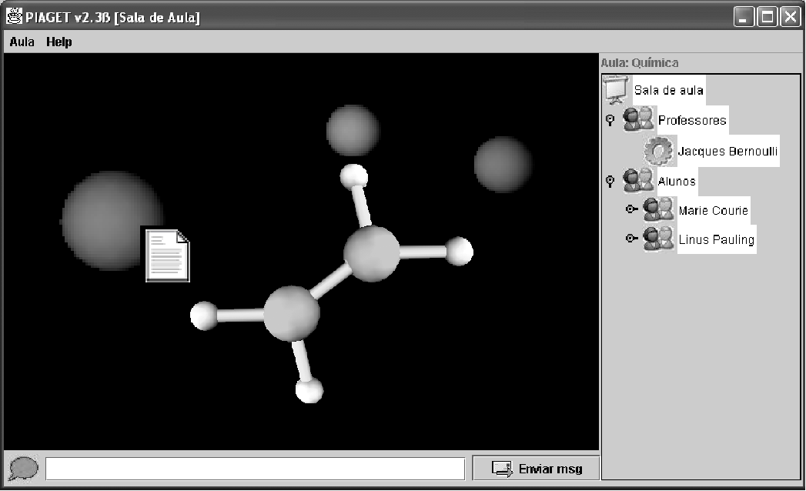
HTML link to a pre-built webpage
3-D elements

Avatar

Learning object (solid) dynamically inserted by a student during the interaction

Figure 4
Mixed-mode Piaget’s interface
Figure 4 showed a screenshot of PIAGET, with some avatars, representing learning agents sharing a learning object during a chemistry class. The use of three-dimensional metaphors to represent learning objects is based on the fact that some kinds of learning objects are intrinsically better represented by three-dimensional elements that can be handled and shared by learning agents.
Collaboration is another way for authoring classification. It could be said that static authoring would lead to a non-collaborative authoring, but collaboration can occur beyond computers’ limits, since a group of teachers can collaborate among themselves in order to elaborate pedagogical content.
However, by means of collaboration through a networked, computer-based environment, authoring can be done in ways that goes from stand-alone authoring, which means no collaboration at all, through collaborative authoring in a bi or even multilateral way.
Figure 5 shows an “authoring cube”, which is used for classifying collaborative learning systems according to the authoring processes supported by them.

hybrid
PIAGET
creation
dynamic
static
Multimedia
Textual
VR
interaction
multilateral
bilateral
unilateral
collaboration

Figure 5
Authoring Cube

Although the term “collaboration” might be interpreted in several ways, it is not meant to be a synchronous task, in order that it can be done in an asynchronous mode. In this paper, we will consider as collaborative learning every task of knowledge building that is done by two or more learning agents over learning objects shared through the learning environment.

PIAGET’s Learning Objects
In PIAGET, every learning agent can contribute with their own learning objects, which can be pre-built content or some kind of content made on-the-fly. The PIAGET’s metaphor set contains representations for the following allowed learning objects:
- Image2D objects, representing two-dimensional raw images that can be inserted into the three-dimensional world (normally as textures for thin rectangle parallelepipeds), and thus shared among the learning agents.
- Solid objects, which are three-dimensional elements (Java3D objects, VRML worlds or another supported format). PIAGET interface has some resources for their handling –rotation, translation, zooming, etc., although its execution might demand some kind of expertise when used with improper devices. It is important to note that, since PIAGET’s architecture was built in a high level of abstraction, it is completely device-independent.
- Blackboard is a teacher’s exclusive object, representing a metaphor for a place where teachers –or another learning agent with similar permissions- place pre-built content. A Blackboard object is merely a metaphor for representing a place where content is placed by the teacher, being a container for other objects with a more refined control over their sharing.
- Register is an object that represents annotations done by teacher during the interaction time, with limitations for sharing – it can be shared only among teachers, and is not visible by students.
- Notebook, which represents personal annotations done by students, which can be shared among another learning agents. A notebook is also a container for other learning objects.
- Message objects represent textual messages that are exchanged during interaction time. A set of all Message objects that are created during a virtual class can be serialized for a better control.

Since PIAGET’s architecture is completely open-source, more learning objects can be added to the metaphor set simply using inheritance, given that its basis are entirely object-oriented. In fact, the ability for expansion can be seen at any tier of its architecture, since its interface, until the data tier. More details about PIAGET architecture can be seen at [5] and [7].

Conclusions
This work presented hybrid authoring of pedagogical content as a way to support collaborative learning through the use of PIAGET, a three-dimensional tool that is meant to cover a representative range of the steps that are taken for knowledge building.
Hybrid collaborative authoring process is expected to cover the most important aspects of social interaction that commonly occurs in a physical classroom, which is reached by the simulation of those interactions, at the same time that the possibilities for such interactions can be expanded at a limit imposed only by virtual reality technological issues.
At the moment this article had been written, PIAGET was being implemented with some beta-releases being tested under controlled situations. Therefore, future works points to a continuous optimization of PIAGET, which includes the use of ontology for managing large quantities of learning objects that can be shared in a real learning situation.

References
- Araújo Jr., C.F, Silveira, I.S. and Amaral, L.H. “A Framework for Developing and Managing Resource-Based Distance Learning Content in Higher Education”. E-Learn 2002 (Proceedings). Montréal, Canada, 2002.
- Nielsen, J. “2D is better than 3D”. Available on Internet at <http://www.useit.com/alertbox/981115.html>. Last visit at November 30, 2002.
- Rocha, H. V. and Baranauskas, M. C. C., “Design e Avaliação de Interfaces humano-computador”. São Paulo, Brazil: IME-USP, 2000.
- Silveira, I. F. and Ferreira, M. A. G. V., “Distance Learning – The PIAGET Project”. ICECE 2000 – International Conference on Engineering and Computer Education (Proceedings). São Paulo, Brasil, 2000.
- Silveira, I. F. and Ferreira, M. A. G. V. “PIAGET – Um Ambiente De Realidade Virtual Distribuída Aplicada À Aprendizagem Colaborativa”. V Symposium on Virtual Reality (Proceedings). Fortaleza, Brazil, 2002
- Silveira, I. F. and Ferreira, M. A. G. V. “Implementando Vygotsky com PIAGET: Autoria Híbrida de Conteúdo Didático em um Ambiente Virtual Distribuído de Apoio à Aprendizagem Colaborativa a Distância”. XIII Simpósio Brasileiro de Informática na Eucação (Proceedings). São Leopoldo, Brasil, 2002.
- Silveira, I.F. and Ferreira, M. A. G. V. “PIAGET - Uma ferramenta de suporte à aprendizagem colaborativa a distância”. X Congreso Iberoamericano de Educación Superior en Computación (Eletronic proceedings). Montevideo, Uruguay, 2002.
- Vérillon, P., “Revisiting Piaget and Vygotsky: In Search of a Learning Model for Technology Education”. Journal of Technology Studies, v.26, n. 1, (Winter/Spring 2000).
- Vygotsky, L.S., “A formação social da mente: o desenvolvimento dos processos psicológicos superiores”. São Paulo, Brazil: Editora Martins Fontes, 1998.
- Wiley, D. A., “Learning objects”. In: Educational Technology: An Encyclopedia. Santa Barbara, United States: ABC-CLIO, 2002.

Ismar Frango Silveira, Universidade Cruzeiro do Sul, Av. Dr. Ussiel Cirilo, 225, 08060-070, Sao Paulo, Brazil, ismarfrango@uol.com.br
Maria Alice Grigas Varella Ferreira, Universidade de Sao Paulo – Escola Politecnica.

