AN EDUCATIONAL APPROACH FOR THE ANALYSIS OF PMD AND SOME LINEAR EFFECTS IN OPTICAL COMMUNICATION SYSTEMS

Josias de Lima Bernardes, Breno Luiz Lima Santos2, Maurício Silveira3, José A. Justino Ribeiro4

Abstract ⎯ With the high transmission rate that the optical communication systems require nowadays, the reduction of Polarization Mode Dispersion – PMD effect is strongly considerate. The main purpose of this paper is to show how to simulate the influence of PMD effect and other linear effects. The great Companies involved in the sector of telecommunications have tested the efficiency of optical devices, using sophisticated surrounding computational tools of simulation before these can be implemented. The PMD studies, in their majority, have been idealized in simulation laboratories, which brings a considerable economy allowing them to optimize each enlace of communication. It can be used in the sizing of many parts of the system, over all, in those for long distances and in the global mapping of a determined network system, through an efficient computational surrounding of simulation - the Virtual Photonic Incorporated - VPI, considered the best and more advanced software in simulation of optical transmission systems in the world.

Index Terms ⎯ Attenuation, Dispersion Compensation, Polarization Mode Dispersion, and DWDM systems.
Introduction
The attenuation, was one of the first properties of optical fibers intensely to be studied. Actually, just the optical fiber appearance with losses inferior to 20 dB/km invokes a strong use for the information transport, having the attenuation been the main limiter to the increase of the capacity of the systems during many years. However, with the development of the technology of the production of optical fibers added to the sprouting of the optical amplifiers a great technological advance it was obtained.
Though with the advent of systems with raised transmission rate, demanding the use of very short pulses, making with that the widening of the pulses provoked for the dispersion becomes the main limiting factor to increase the capacity of the systems. Several techniques have been used, with the objective to control this dispersion.
The continuous exertion in increasing the transmission rate and the length of the link imposes appearance of new restrictive factors, known as non-linear effects. In addition, in high rates the birefringence of optical fibers brings some due to fact of the light does not keep its polarization when spreading through the fiber.
Attenuation
The attenuation quantifies the loss of energy of the optical signal during the propagation. If $P_{\text{in}}$, is the optical input power applied at the input of a fiber with L_{t} length, in the output we have $P_{\text{out}}$, satisfying:
$$P_{\text{out}}=P_{\text{in}}⋅\text{exp}\left(−{αL}_{t}\right)$$ |  | (1)
where $α$ is the attenuation constant. The equation (1) indicates that the optical power decays with an exponential law. Ordinarily, the losses of the fiber are quantified in dB/km.
The losses of the fiber are dependents of several factors, known as absorption, diffusion and radiation. In optical fibers, the electrical field recovers all regions between the nucleous and the covering, being the losses an average of those presented in each layers of the fiber.
It is verified that the losses have strong dependence of the wavelength in optical communication systems. The silica optical fibers present several windows of transparency comprehended between the wavelengths of 600 - 2000 nm.
The losses for absorption can have origin in the following phenomena: the intrinsic absorption, the extrinsical absorption and the absorption for atomic defects. The intrinsic absorption is a characteristic of the used material, which in this case is the silica. This absorption is less than 0,03 dB/Km for wavelengths between 1300 – 1600 nm. The extrinsical absorption must to have the presence of impurities in the fiber. Owing the sophisticated methods used in the manufacture of fibers currently, we can see that the extrinsical absorption is dominated by the presence of a very small amount ions of (OH)⁻ and they are strong responsible for the fiber attenuation curve form as a function of the wavelength.
The absorption for atomic defects, as itself name indicates, must includes irregularities in the fiber atomic structure. In normal conditions, the absorption due to these irregularities is worthless, comparatively to the total absorption. However, it can be significant if the fiber will be exposed in the strong radiation that provoked some the alterations in its atomic structure. The losses for diffusion must to have the microscopic variations of the material density, and result in its amorphous nature.
In microscopical variations in the density of the material, some microscopic fluctuations of the refractive index are created, that gives an origin to the diffusion of Rayleigh. This diffusion is a basic limit for all losses of the fiber, transferring part of the contained optical energy in guided modes of propagation to ways not guided. For the current processes of manufacture, the extrinsical absorption due to ions of (OH)⁻ and the diffusion of Rayleigh are the dominant phenomena for the attenuation of optical fibers.
When microcurvatures are present or curvatures with much closed angles, the losses for radiation appear through the long of the passage fiber. These curvatures can occur at the macrocospic level, due to the passage that the fiber covers, or at the level microscope (microcurvatures), proceeding from the introduction at the fiber in the handle, twist or stress. These losses generally are quantified jointly with those due to the use of connectors and amendment in the fiber, having assigned losses in the handle. These have strong dependence on the installation and the cabling

configuration of the optical communication system.
The effect of the attenuation in the fiber can be simulated, leading in consideration the input and output powers. One notices that when the input power is increased the output power also increases, which implies that the gain curve has a notable fall. The attenuation can be solved with the use of an optical doped amplifier (EDFA), as it is shown in Fig. 1.
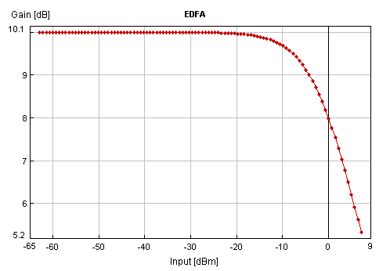
Fig.1 Attenuation Graphic
In the Fig. 2, we can see the used diagram block-type in VPI’s simulation.

Fig.2 Attenuation Simulation Circuit

Dispersion
The development of the amount of data and the appearance of new services of telecommunication have forced continuously the increase of the capacity of transmission in all link of optical fibers. The attenuation and the dispersion of the fiber are the main obstacles in this process. The appearance of the EDFA already eliminated the barrier imposed for the attenuation.

However for the dispersion, specific strategies of compensation must be adopted in the link it order to be able to operate in rates greater than 10 Gbit/s.
The dispersion is a transmission characteristic that represents the widening of the transmitted pulses. This widening determines the bandwidth of the optical fiber, specified in (MHz.km) and is related with the capacity of transmission of information in the fibers. The dispersion effects are divided in modal dispersion and chromatic dispersion.
In Fig.4 and Fig.5, by using the VPI platform, it can be proven that the pulse through the long of the fiber suffers a temporary widening, as already cited above.
This effect was simulated taking into consideration a length of 100 (Km) of multimode fiber and with attenuation factor equal the zero (dB/Km).
In the Fig. 3, we can see the used diagram block-type in VPI simulation.

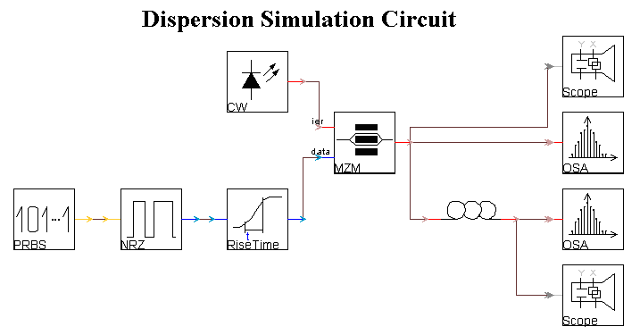
Fig.3 Dispersion Simulation Circuit

Modal Dispersion
This type of dispersion exists in multimode fibers step and gradual, being provoked for some possible ways of propagation that the light could have in the nucleous. In a step fiber, all modes travel with the same speed, therefore the refractive index is constant in the nucleous. Soon, the modes of high order, that in general cover a longer way, will delay more time to leave the fiber that low order modes. In this type, the difference between the arrival times is given by $τ=Δ⋅t_{1}$, where $t_{1}$is the time of propagation of the low order mode and Δ is the percentual difference of refractive index between the nucleous and the covering given by Δ = (n₁-n₂)/n₂.
The modal dispersion does not exist in fibers
monomode therefore only one mode will be guided through the fiber.

Chromatic Dispersion
This appears due to the fact of the light to be composed for radiation of diverse wavelengths, and during the transmission, all differences in the propagation speed determine the diversity of beams of the light.
This type of dispersion depends on the wavelength and is divided in two types: material dispersion and dispersion of waveguide.
Material Dispersion
As the refractive index depends on the wavelength and as existing luminous sources are not ideal, or either, they possess a certain finite spectral width $Δλ$, we have that each wavelength is related with a different value of the refractive index in a determined point. Soon each wavelength travels in the nucleous with different speed, provoking a time difference of passage and causing the dispersion of the luminous pulse.
Dispersion of Waveguide
This type of dispersion is provoked by variations in the dimensions of the nucleous and variations in the profile of the refractive index through the long of the optical fiber and depends on the wavelength. This dispersion is observed in monomodes fibers that have material dispersion reduced.

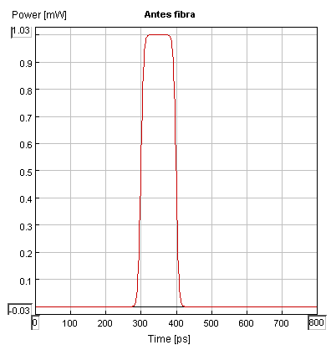
Fig.4 Signal in the input fiber

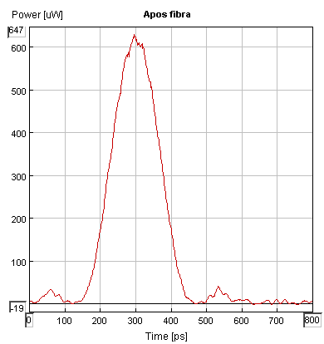
Fig.5 Signal in the output fiber
Polarization Mode Dispersion – PMD
The PMD is a fundamental effect presents in all fibers (Dispersion Shifted - DS) and systems operating in the region next to zero-dispersion, where the contribution of the first orders (group delay) increases. Due to the birefringence of the fiber, it is possible to get many different modes of propagation.

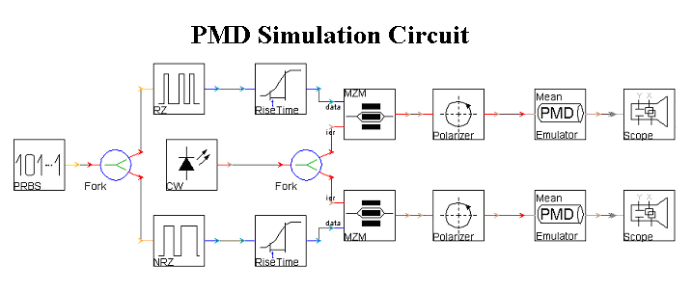
Fig.6 PMD Simulation Circuit

The interaction between these modes provokes the delay of a distinguished group, making with that the signal propagates in different speeds, exhausting itself. The main effect caused in the optical system is the intersimbolic interference.

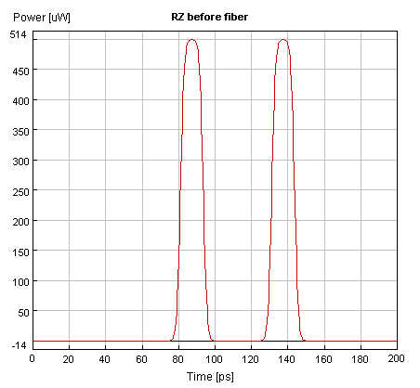Fig.7 RZ before the fiber
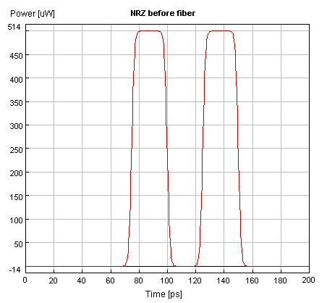Fig.8 NRZ before the fiber
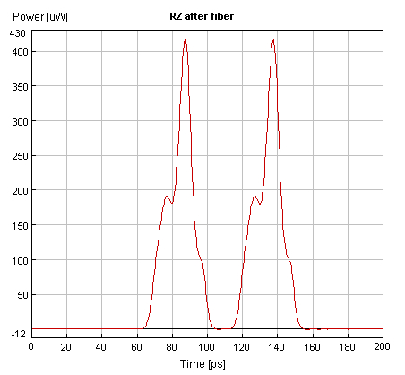Fig.9 RZ after the fiber
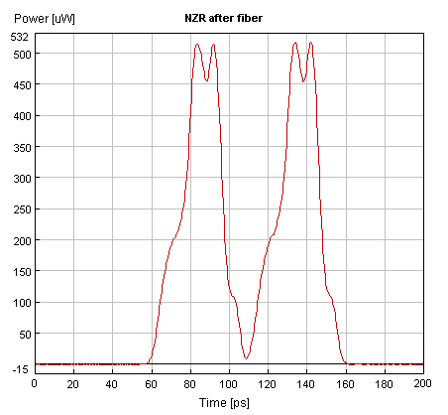Fig.10 NRZ after the fiber
Conclusion
In this paper, the analysis of linear and the PMD effects in optical fibers can degrade the signal in optical communication system with high transmission rate. Practical simulations using the efficient numerical platform VPI had allowed to visualize the consequences in all transmissions that use the multiplexing with high-density wavelength (DWDM).
Despite of some evidences that make progress with the simulations, this work detached the efficiency of the use of RZ codification in comparison with the NRZ one, related with the PMD effect, using an EDFA to compensate the attenuation and, widening transmitted pulses provoked by the dispersion.
References
[1] | Ramaswami, R., Sivarajan, K., Optical Networks: A Practical Perspective, Morgan Kaufmann Publishers 2nd Ed. 2001.
[2] | Keiser, G., Optical Fiber Communications, McGraw Hill 3rd Ed. 2000.
[3] | Agrawal, G. P., Fiber Optic Communication Systems, Wiley Interscience 2nd Ed. 1997.
[4] | Ribeiro J.A.J, Fundamentals of Optical Comunications, National Institute of Telecom - INATEL, Santa Rita do Sapucaí, MG, Brazil. 2002.
[5] | VPI Transmission Maker™ WDM Users Manual, VPI Systems™ 2001.
[6] | VPI Transmission Maker ™ GUI Manual, VPI Systems ™ 2001.
[7] | Lachs, G., Fiber-Optic Comunications, McGraw Hill, New York, 1998.
[8] | Stern, T. E., Bala, K., Multiwavelenght Optical Networks: A Layered Aproach, Prentice Hall, 2000.
[9] | Cameron, D., Optical Networking: A Wiley Tech Brief, Wiley Computer Publishing, 2002.
[10] | Black, U., Optical Networks: Third Generation Transport Systems, Prentice Hall, 2002.

Josias de Lima Bernardes, INATEL, National Institute of Telecom, Av. João de Camargo, 510, ZC 37540-000 - Santa Rita do Sapucaí – MG, Brazil, josiasl@inatel.br
2 Breno Luiz Lima Santos, INATEL,brenol@inatel.br
3 Maurício Silveira, INATEL, msilveira@inatel.br
4 José Antônio Justino Ribeiro, INATEL, justino@inatel.br

