AN EDUCATIONAL COMPUTER TOOL TO ANALYZE THE CORRELATOR

Luciano L. Mendes, Daniel Mazzer, Arley H. Salvador³ and José S. G. Panaro4

Abstract ⎯ Today, the knowledge about techniques of digital signals transmission is fundamental for telecommunications engineering students. As another time the COMPACT DISC substituted the vinyl, nowadays the analog transmission links are being replaced by digital ones. In digital communication systems, there are some devices that are used to optimize the signal to noise ratio in the receiver. This procedure improves the performance of the system, reducing the bit error rate. The most common technique used to receive digital signal is the correlator, which is an optimum method to detect digital signals in Additive White Gaussian Noise channels. The purpose of this paper is to show a didactical approach to analyze the correlator, using a computer program to presents each step in the detection of a digital signal.

Introduction
In the digital communication links, the most important factor of the system is the reliability. However, there is a trade-off between reliability and transmitted power. The bit error rate (BER) [1] is the main parameter used to measure the reliability of the system. When a signal is transmitted on an Additive White Gaussian Noise (AWGN) channel, the interference of the noise in the transmitted signal depends on the signal to noise ratio (SNR). To minimize the BER, it is necessary to improve the SNR in order to reduce the effects of the noise in the received signal. The SNR can be improved by increasing the transmitted power or by reducing the effects of the noise in the receiver. The correlator is a device used in the reception of digital signals that maximizes the SNR by reducing the interference of the noise. Because of it, it is important to analyze and to study this technique. In this paper, the correlator will be simulated in a program based on block structures, named VisSim®, which facilitates the apprenticeship of this issue.

AWGN Channel
The AWGN is an undesired signal that cannot be avoided [1][2]. The random nature of this signal makes necessary to analyze it based on stochastic processes, where the mean value and the variance are the main parameters to determine the behavior of the signal. The mean value represents the DC voltage of the random signal, while the variance represents the power of the AC component [1]. The standard deviation of the random signal, defined as the square root of the variance, represents the RMS voltage of the signal. Figure 1 shows a gaussian signal with zero mean and unity variance, while figure 2 shows a bipolar signal, or non-return to zero (NRZ) perturbed by an AWGN.

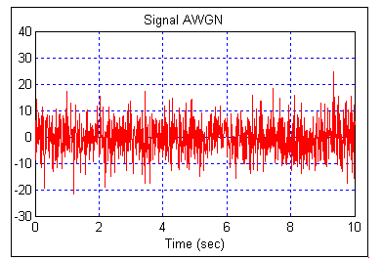
Figure 1
Gaussian noise

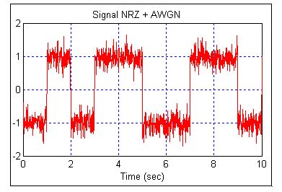
Figure 2
Bipolar Signal with gaussian noise

In Figure 2, the noise may introduce errors in the transmitted data when its amplitude assumes absolute values greater than unity.
Orthogonalization of Signals
The transmission of digital data is based on a set of waveforms of finite size. These waveforms can be represented as functions of the orthogonal bases of the set.
In this session, the Gram-Schmidt process [1][2] will be presented. This process is used to define the bases of the waveforms set.
Suppose a set of M waveforms {s₁(t), s₂(t), ..., s_{M}(t)}. Accepting the signal s₁(t) as an orthogonal signal, the function of the first base φ₁(t) will be

$$s_{\text{11}}=\sqrt{E_{1}} ⇒ φ_{1}(t)=\frac{s_{1}(t)}{\sqrt{E_{1}}}$$ | (1)

Where E₁ is the energy of the signal s₁(t).
The second orthogonal bases, φ₂(t), can be obtained using the signal s₂(t) and the first orthogonal bases found by (1), φ₁(t).

$$s_{\text{21}}=\int{s_{2}(t)φ_{1}(t)\text{dt}}$$
$$g_{2}(t)=s_{2}(t)−s_{\text{21}}φ_{1}(t)$$ | (2)
$$φ_{2}(t)=\frac{g_{2}(t)}{\sqrt{\int{g_{2}^{2}(t)\text{dt}}}}$$

The procedure above must be repeated to identify the N orthogonal bases of the set, as shown in (3).

$$s_{\text{ij}}=\int{s_{i}(t)φ_{j}(t)\text{dt}}, g_{i}(t)=s_{i}(t)−\sum_{j=1}^{i−1}{s_{\text{ij}}φ_{j}(t)}$$
(3)
$$φ_{i}(t)=\frac{g_{i}(t)}{\sqrt{\int{g_{i}^{2}(t)\text{dt}}}}$$

Where $i=1,2,3,\text{.}\text{.}\text{.},N$ e $j=1,2,3,\text{.}\text{.}\text{.},i−1$.
The number of orthogonal bases (N) can be equal or less than the number of waveforms of the set (M). If the signals {s₁(t), s₂(t),..., s_{M}(t)} are linearly independent (orthogonal), then N = M. If the signals s₁(t), s₂(t),..., s_{M}(t) are not linearly independent, then N < M.
Any waveform from the set can be represented as a linear combination of the N orthogonal bases, thus the transmitter and the receiver do not have to handle with M waveforms, but only with N waveforms.
The waveforms can be geometrically represented in a vector diagram, where the axes are the orthogonal bases found in the Gram-Schmidt process. For the geometric representation of the signals, each orthogonal base must be normalized to unitary energy. Finally, any signal, s_{i}(t), can be expressed as shown in (4).

$$s_{i}(t)=\sum_{j=1}^{N}{s_{\text{ij}} φ_{j}(t)}, \begin{aligned}\left\{0≤t≤T | \right.\left\{i=1,2,…,M | \right.\end{aligned}$$ | (4)
Where the coefficients s_{ij} represent the projection of the signal s_{i}(t) over the base φ_{j}(t) and can be obtained by (5).

$$s_{\text{ij}}=\int{s_{i}(t) }φ_{j}(t) \text{dt}, \begin{aligned}\left\{ i=1,2,…,M | \right.\end{aligned}$$ | (5)

Thus, it is possible to represent any signal from the set as a linear combination of the orthonormal bases, as shown in Figure 3.

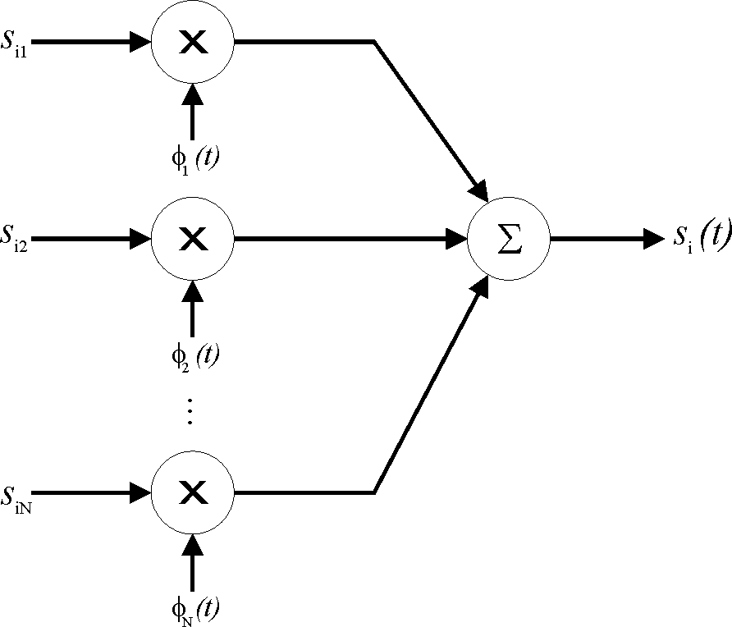
FigurE 3.
Linear Combination of the Orthonormal Bases.

It is also possible to geometrically represent the signals from a set, where the number of orthogonal bases is three or less. Figure 4 shows a example of a set with three signals and two orthonormal bases (N=2 and M=3).

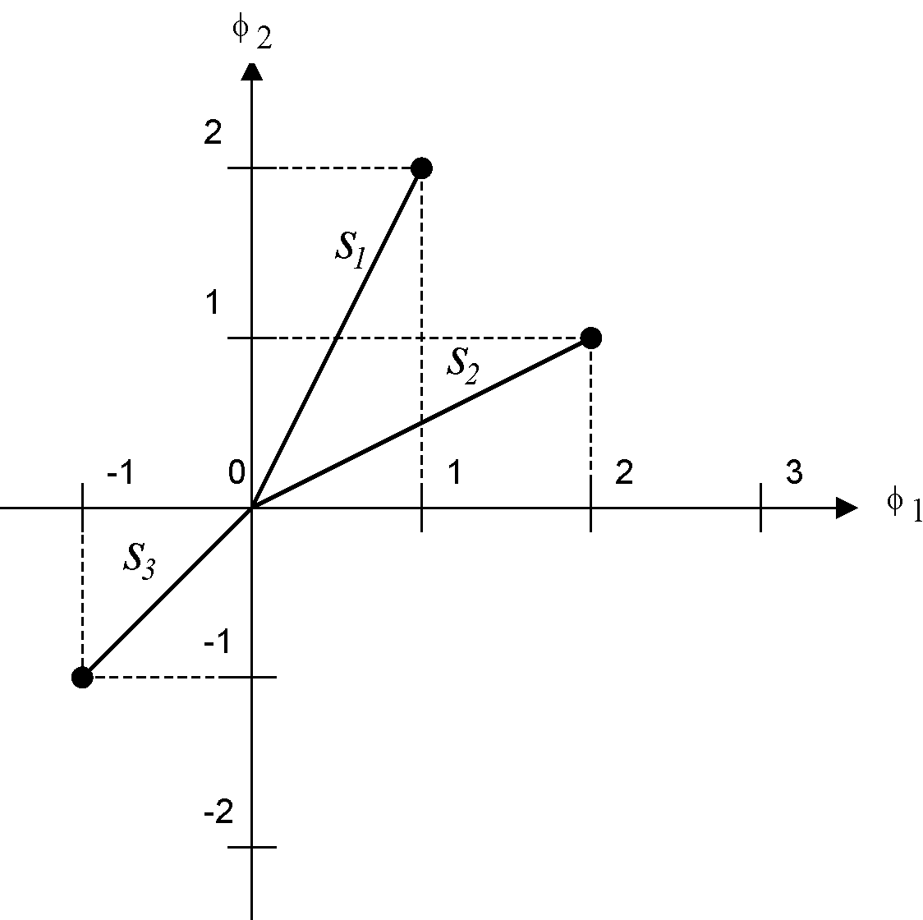
FigurE. 4
Geometric Representation of Signals
Constellations of Digital Modulations
In digital communications, the symbols are represented as waveforms and are transmitted as functions of the orthogonal bases. In phase and/or amplitude modulations, the orthogonal bases usually are the sine and cosine with the same frequency. For example, the QPSK (Quadrature Phase Shift Keying) modulation [1][2] has four possible symbols that can be defined by the combination of two bits. Figure 6 shows the constellation of this modulation technique, where M=4 and N=2. The orthogonal bases are defined by (6).

$$φ_{1}(t)=\text{cos}(ω⋅t)$$
(6)
$$φ_{2}(t)=\text{sen}(ω⋅t)$$

Where ω is the angular frequency of the carrier.
Any symbol s_{i}(t) can be defined as a linear combination of these two bases, as shown by (7).

$$s_{1}(t)\text{=+}\text{cos}(ω⋅t)+\text{sen}(ω⋅t)$$ | (7)
$$s_{2}(t)=−\text{cos}(ω⋅t)+\text{sen}(ω⋅t)$$ | (7)
$$s_{3}(t)=−\text{cos}(ω⋅t)−\text{sen}(ω⋅t)$$ | (7)
$$s_{4}(t)\text{=+}\text{cos}(ω⋅t)−\text{sen}(ω⋅t)$$ | (7)

FigurE. 6
QPSK Constellation.
Correlator
In a digital communication link, the received link is corrupted by the AWGN. To minimize the number of errors introduced by the channel, it is necessary to maximize the signal to noise ratio. The correlator represents one technique that realizes this operation. Figure 7 shows the block diagram of the transmission and reception of signal from a set of M waveforms and 2 orthogonal bases.

FIGURE 7.
Block Diagram of a Digital Communication Link.

The transmitted bits are mapped in two orthogonal signals (i(t) and q(t)) that have $\sqrt{M}$ possible levels. These two signals are multiplied by the orthogonal bases of the set and then applied in the communication channel. The received signal, r(t), is multiplied by the bases and integrated at each symbol time (T), generating the estimated signals i’(t) and q’ (t). These signals are applied to a decision device that estimates the transmitted data sequence m’(t). It is desirable to have a received data sequence equal to the transmitted data sequence.
Simulation
In this session, a simulation based on the block diagram of figure 7 will be presented. Figure 8 shows the transmission simulator, while figure 9 shows the receiver simulator.

Figure 8
Transmitter Simulator

Figure 9
Receiver Simulator

In this simulation, three bipolar signals are transmitted using three orthogonal bases that are sine functions with frequencies f1=1Hz, f2=2Hz and f3=3Hz. Figure 10 shows the added signals at the output of the AWGN channel.

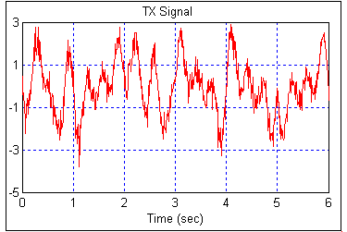
Figure. 10
Received Signal

The received signal is applied to three correlators, one for each transmitted signal. First, the received signal is multiplied by the orthogonal bases. Figure 11 shows the received signal multiplied by the first orthogonal base.

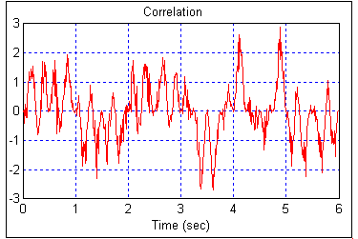
Figure 11
Detection of the received signal

The second step of the receiving process is to integrate the signal during the symbol duration, T. In this simulation, the symbol rate is one symbol per second. Thus, the symbol time is one second. Figure 12 shows the output of the first integrator.

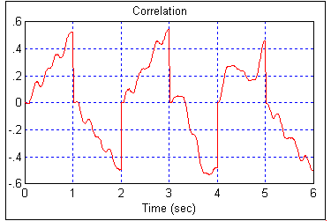
Figure 12
Integrator Output.

The decision device samples the integrated signal at each T seconds and, for each received signal, decides for bit 1 if the sample is positive, and for bit 0 if the sample is negative. Figure 13 shows the output of the sampler while figure 14 shows the output of the decision device.

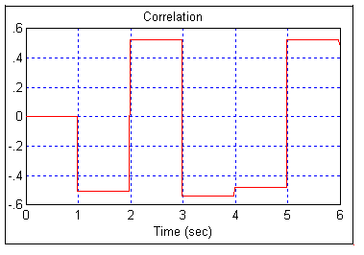
FigurE 13
Output of the Sampler.

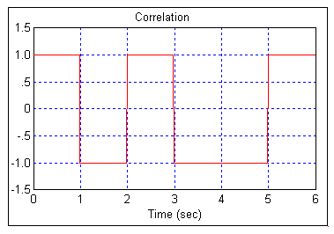
FigurE. 14
Output of the Decision Device
Conclusion
The optimum receiving process is a very important issue in digital communications studies and must be clearly presented to Telecommunication Engineering students. This paper presented an educational approach to analyze the correlator, using a computer tool to show each step of the transmission and receiving processes. Thus, the students are able to verify how a transmitted data signal behaves in the communication block diagram.
References
- Haykin, S, Communications Systems, 2nd Edition , Wiley, 2000.
- Sklar, B, Digital Communications Fundamentals and Applications, Prentice Hall, 1988.

Luciano Leonel Mendes, INATEL, Av. João de Camargo, 510, 37540-000, Santa Rita do Sapucaí, MG, Brazil, lucianol@inatel.br
Daniel Mazzer, INATEL, Av. João de Camargo, 510, 37540-000, Santa Rita do Sapucaí, MG, Brazil, daniel_mazzer@inatel.br ³ Arley Henrique Salvador, INATEL, Av. João de Camargo, 510, 37540-000, Santa Rita do Sapucaí, MG, Brazil, arley_henrique@inatel.br ⁴ José Santo Guiscrafé Panaro, INATEL, Av. João de Camargo, 510, 37540-000, Santa Rita do Sapucaí, MG, Brazil, panaro@inatel.br

